Product Details___________________________________________________________
ITEM HALAL Fully Cooked Italian Style Breaded Veal Patties

CODE # 61005

DESCRIPTION Fully cooked Breaded Veal Patties

INGREDIENTS Veal, Water, Texture Vegetable Protein (Soy), Cracker Meal, Sodium Phosphate, Garlic Powder, Onion Powder, Spices. BREADED WITH: Bleached Wheat Flour, yeast, sugar, salt, Enriched wheat flour (enriched with niacin, reduced iron, thiamine mononitrate, riboflavin, folic acid), salt, spice. Breading set in Non-Hydrogenated Soybean Oil.

Pack Specification________________________________________________________
Case Weight 10 lbs.
Bag Case 1
Unit Weight 3.0 oz
Unit Bag 53
________________________________________________________________________________________________
Shelf Life
Total Shelf Life 1 year from production

Storage
STORAGE Frozen
SHIPPING REQUIREMENTS Keep Frozen

Claims/Certifications
CLAIMS Fully Cooked
No Preservatives
0g Trans Fat/Serving
No Hormones Added
KOSHER/HALAL Halal

REGULATORY USDA Inspected
Good Manufacturing Practices

Physical Properties
 |  | Monitoring | Target | Reject/Fail Criteria
 | Color | Ongoing Visual | Light Golden Brown  A or B on Color Chart | Out of spec
 | Aroma/Flavor | QA Sampling | No off odor/flavor | An off odor/flavor
 | Metal Detection | Ongoing | Ferrous Standard: 2.5 mm  Non-Ferrous Standard: 2.5 mm  Stainless Steel Standard: 4.0 mm | Out of spec
 | Net Weight | Constant Monitoring | USDA Requirements | Less than USDA standards
 | Patty Shape | QA Test | Plate determines shape | Wrong plate utilized
 | Patty Size | QA Test | 3.0 oz. | Wrong plate utilized
 | Texture | QA Test | No off texture | Off texture
 | Batter/Breading | QA Test | 18% | + / - 2%

Microbiological Properties
Test | Limits
Aerobic plate count | <100
Listeria Spp. | Negative
Salmonella | Negative
E.Coli | Negative
Allergens
ALLERGENS Does contain Soy, Gluten.

Labeling
LABELING Case label contains the flowing:
- Inspection Legend: P-8813
- Item description:
- Net Weight of Case: 30 Lbs.
- Keep Frozen
- Ingredients
- Manufactured By: Golden Platter Foods, Newark, NJ 07114
- Production Date

LOT/DATE CODE Product must have clearly printed, proper Lot/Date Code on label.
CONSUMER INFORMATION Product contains Heating Instructions
UPC UPC Printed on Package

Formulation
INTERNAL FORMULATION # CN-FC- 003WG
FORMULATION Proprietary

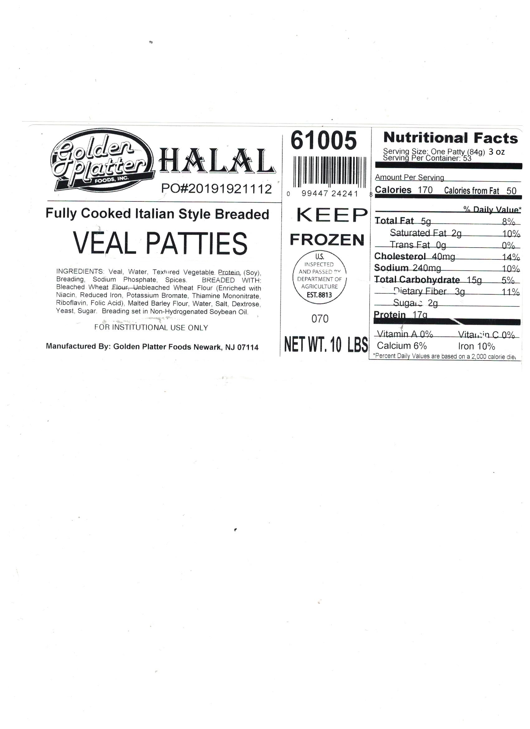
Nutritional Information

