- Purpose
  - This SOP defines the requirements for proper sanitization and Wet cleaning of the AMS Filler and Canco Seamer as well as the auxiliary equipment (scales, bins, scoops)
- Scope
  - This procedure covers the proper cleaning sanitization of the AMS Filler/Canco Seamer as well as the auxiliary equipment and the responsibilities of the Operator during the cleaning and sanitization.
  - This Sanitization Procedure is incredibly important for the protection of the food safety of the product being filled. Any residue or debris from previously run product is a potential source of contamination for the following production run. Prevention of unintentional adulteration must be handled with the utmost care.
  - An internal training of the SOP should be conducted after creation of the SOP and after changing or revising of the SOP for all concerned employees. An internal training of the SOP should be done with new employees, as well as once a year for all other concerned employees.

- Equipment
  - PPE: Closed-toe shoes, safety goggles and a hairnet/beard cover, rain suit,pants, N-95 Respirators
  - Saran Wrap or plastic bags to cover Effytec electrical connectors
  - Hose with hot water and adjustable fine spray nozzle
  - Bin with attached drain hose
  - Brushes with short metal bristles
  - Alpha Bac Sanitizer solution
  - Alpha Bac Sanitizer spray bottle
  - Hydrion Paracetic Acid Strips
  - Hydrion Quat test Strips
  - Neutral Scrub Cleaner D
  - Washing Sponge/Brushes
  - Drying Rack for Effytec components
  - Microfiber Towels
  - Inspection Mirror with LEDs
  - Squeegee
  - Broom
  - Mop
  - Small fan
  - Rework Bucket
  - Long bin with notch (for emptying hopper)
  - Brass Punch
  - Mallet

- Definitions
  - SOP Standard Operating Procedure (SOP): The set of written instructions that document routine or repetitive activities. SOPs provide employees with the information to perform a job properly and consistently, producing a quality final product or result.

  - PPE Personal Protective Equipment (PPE): Clothing or equipment designed to protect workers from physical hazards. During the production of food, PPE also protects product from the introduction of worker-associated contaminants, such as hair.

- Responsibilities
  - The AMS Filling Machine Operator is responsible for following this SOP as described for proper cleaning and sanitization of the filling machine.

  - The Quality Manager is responsible for ensuring that this SOP is followed precisely and for verifying that the AMS Filling Machine is completely and adequately cleaned and sanitized.
    - Responsible for swabbing according to the Microbiological Sampling Procedure (PMI-USA-SOP-003), and the associated Equipment Sanitization Audit (PMI-USA-SR-039)
    - Responsible for making procedural changes that improve the efficiency, safety, and overall quality of the products and procedure.
    - Responsible for initiating the Corrective and Preventive Action Process (PMI-USA-004) as necessary in response to Equipment Santization Audit findings (i.e., residue and/or moisture on filler surfaces, high bacterial/fungal counts on sanitized components,etc.).
- Frequency
  - The equipment shall be Cleaned and Sanitized at least according to the following schedule:
    - Before a product changeover occurs.
    - As needed according to filling issues (i.e. jammed auger, caking product, can spills)
Note: Due to the limited production in the Canco machine, the maximum allowed period for the Canco machine to run without performing a complete wet clean when the same bulk powder is being used will be a maximum of a 30 day period. If at the end of the shift there is powder remaining in the hopper and no production is scheduled for the following day, the machine operator should empty the hopper to avoid any increase in the water activity or contamination.

- Procedure
Emptying the AMS Filler and Auger
- Ensure that proper Personal Protective Equipment (safety goggles, rain suit), clothing (pants and close-toed shoes), and disposable hygiene wear (shoe covers and hairnets/beard nets) are worn prior to starting.
- Take out sieve from hopper and clean with machine parts
- Scoop out most of the remaining product in the hopper and place into the 6-gallon white Rework Bucket. Ensure the rework bucket has all the relevant information labeled on it (product, lot code, expiration, and time of placement in the bucket).
- Place bucket under hopper
- Remove stop cover from under the hopper by loosening 3 bolts with a wrench
- Empty hopper by using the reverse jog button
- Disassemble funnel
- Next, remove attachment for removing excess powder (connected to the JET vacuum)
- Remove the screw and attached circle plate (stop Shute)
- Take auger out by pushing it up and to the right
- Loosen bottom set of 3 screws to loosen auger sleeve
- Remove auger sleeve and clean with machine parts
- Loosen the ¾ inch bolt behind the funnel
- Loosen wingnuts and move J hooks outward away from the machine
- Remove funnel
- Push pin out of the conveyor belt with a hammer and tapper tool
- Take conveyor belt off by turning on the conveyor through the LCD screen

Cleaning and Sanitizing the AMS Filler
- Place a large plastic waste bin underneath the AMS filler to catch the wash water and Perasan A and Perafoam solution.
- Prepare Foamer by filling with prescribed dilution of water, Perasan A and Perafoam through the Lafferty Gemini ‘Two Part Mixer’ and into Foamer.
- Verify that the final concentration of the mixture is at least 160 ppm but less than 500 ppm using the” Hydrion Paracetic Acid Strips” with a target of 300 ppm and record the result in the designated PMI-USA-SR-038 . If the concentration is below 160 ppm or above 500 ppm, operator should stop the wet cleaning process and immediately notify Quality Assurance for corrective actions.
- Apply Foaming Perasan A solution to interior/exterior of the AMS Filler, using the Foam Wand attachment. With a Bottom to Top and Side to Side motion Cover the Sides and Interior & Exterior of the AMS Filler and tube with a thick layer of foam and let stand for 10 to 15 minutes. If appropriate, run the AMS Filler to enhance the cleaning activity. Do not allow solution to stand more than 15 minutes.
- Using a low-pressure Rinse Drop rinse the AMS Filler from Top to Bottom and rinse to drain
- Before applying the sanitizer solution, Quality takes swab samples according to the Microbiological Sampling Procedure for the Equipment Sterilization Audit (PMI-USA-SOP-003). and the associated Equipment Sanitization Audit (PMI-USA-SR-039)
- Place the small fan at the top of where the Auger tube meets the metal box at top and position it to blow down the auger tube. NOTE: This step is essential to ensure that all residual moisture will be gone before the start of another product filling run, otherwise clumping and caking will occur upon initial operation, and the machine will need to be dissembled to remove debris to prevent jamming.
Verify the concentration of the Alpha Bac Sanitizer (Quat) in the “sanitize” compartment located in the 3- compartment sink using the “Hydrion Quat Test Strips”. The limits should be not less than 150 ppm and no more than 400 ppm, with a target of 200 ppm, record the result in the designated PMI-USA-SR-038 . If the concentration is below 150 ppm or above 400 ppm, operator should stop the wet cleaning process and immediately notify Quality Assurance for corrective actions.
- Using the Alpha Bac Sanitizer Spray Bottle and clean Microfiber Towels, completely spray and wipe all the surfaces of the Hopper, Staging tables, AMS filler, both conveyors, and the Canco Seamer. Ensure that an adequate amount of Quat Solution is used to visibly coat the entirety of the surfaces. The seamer however doesn’t get coated with the spray, just wiped off.
- Allow the Quat Solution to air-dry. DO NOT FURTHER WIPE OR DRY THE QUAT SOLUTION. The Quat Solution must dry naturally and leave a protective residue to ensure proper sanitization.
- Using the Alpha Bac Sanitizer spray bottle and clean Microfiber Towels, completely spray and wipe all the surfaces of the inner-AMS components. Ensure that an adequate amount of Quat Solution is used to visibly coat the entirety of the surfaces.
- Allow the Quat Solution to air-dry. DO NOT WIPE OR DRY THE QUAT SOLUTION. The Quat Solution must dry naturally and leave a protective residue to ensure proper sanitization.

Cleaning and Sanitizing the AMS Filler Components in the Three-Compartment Sink:
- Start by filling the right side of the 3-compartment sink, the Sanitizing Solution Section, with the Alpha Bac Sanitizer. Use a Hydrion Quat Test Strips to measure the Quat concentration. The limits should be not less than 150 ppm and no more than 400 ppm, with a target of 200 ppm. Adjust with more Quat or water as necessary.
- While the Sanitizing Solution Section fills, begin rinsing and washing (with the Neutral scrub cleaner) the filler components with a soapy towel or brush. Wash them thoroughly to remove all product residue and debris. Note: It may take three or more times passing the towel over the area and rinsing to remove all the product.
- Scrub and brush the filler parts as needed, paying close attention to the crevices and component connections where residue can hide.
- Once a component is adequately washed, rinse the soap off into the second section of the sink, the Rinsing Section.
- Before applying the sanitizer solution, Quality takes swab samples according to the Microbiological Sampling Procedure for the Equipment Sterilization Audit (PMI-USA-SOP-003). and the associated Equipment Sanitization Audit (PMI-USA-SR-039)
- Once rinsed, completely immerse the filler component in the Sanitizing Solution for a minimum duration of 10 seconds.
- Remove the component from the Sanitizing Solution without touching any of the inner surfaces that make direct contact with food product.
- Carefully place the components onto the designated Drying Rack.
- Continue process until all filler components are cleaned and sanitized. The auxiliary equipment (scoops) will be cleaned following this procedure.

Cleaning the Canco Seamer
- Set a bucket under the chain on the back side of the machine
- Turn Canning machine on so the chain is rotating
- Lightly run water over the chain into the bucket until all the product is removed
- Wipe down any free-standing product from canner
- Wipe any oil/grease from machine with 99% alcohol
- Spray chain with food grade silicon spray
Cleaning the Remainder of the Room
- Sweep the room directly surrounding the Filling Room, then mop the floor using the Alpha Bac Sanitizer solution.
- Clean area surfaces with the same solution
- Clean and sanitize the auxiliary equipment (Scale, Bins) using a clean rag moistened with Alpha Bac Sanitizer ( Quat) and allow then to air dry.

Cleaning the Vacuum Cannister and Hose
- Disconnect the large vacuum hose from the top of the side of the AMS Filler.
- Check the powder level in the bag and record on the production log
- Disconnect the large vacuum hose from the vacuum and spray out with hot water
- Dispose of waste and re-use bag if possible, otherwise replace with a new bag.
- Once every other month disassemble vacuum motor assembly and use a Shopvac to vacuum excess powder out
8.0 Attachments:
8.1 Photos of AMS Filler and Canco Canner Components (numbered from left to right)
8.1.1 Hopper Bottom
8.1.2 Auger Bottom
8.1.3 Conveyor Drop
8.1.4 Large Funnel Cover
8.1.5 Transfer Sleeve/ Rubber
8.1.6 Conveyor Drop Cover
8.1.7 Stirrer
8.1.8 Auger
8.1.9 Hopper Bottom Cap
8.1.10 Small Funnel Cup
8.1.11 Stop Shut Plate
8.1.12 Auger Shaft
8.1.13 Large Blue Bucket Scoop
8.1.14 Funnel Cover Plate
8.1.15 Hopper Hatch Lid
8.1.16 Large Blue Bucket Scoop
8.1.17 Large Funnel
8.1.18 Sieve 1 Inch
8.1.19 Sieve 5 mm
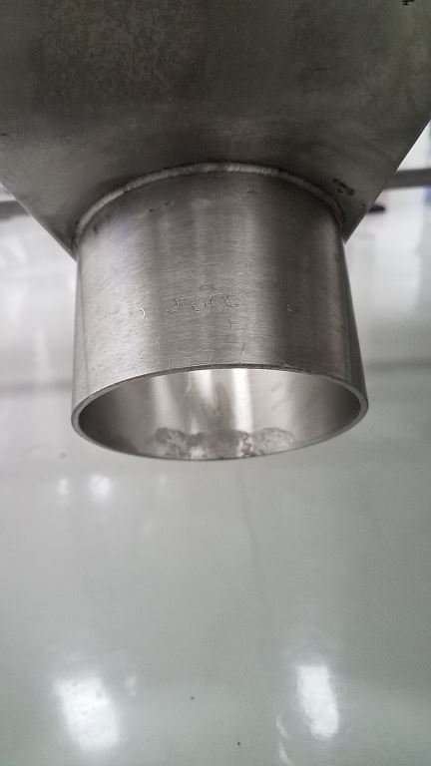
8.1.1 8.1.2 8.1.3
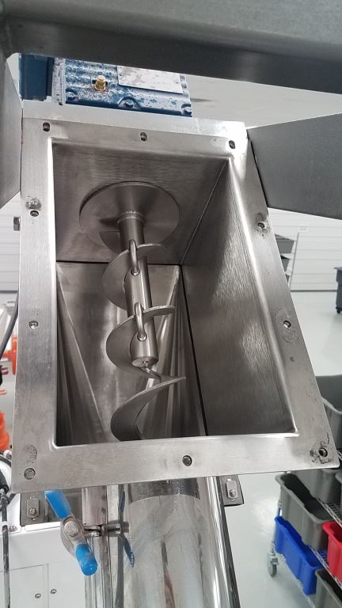
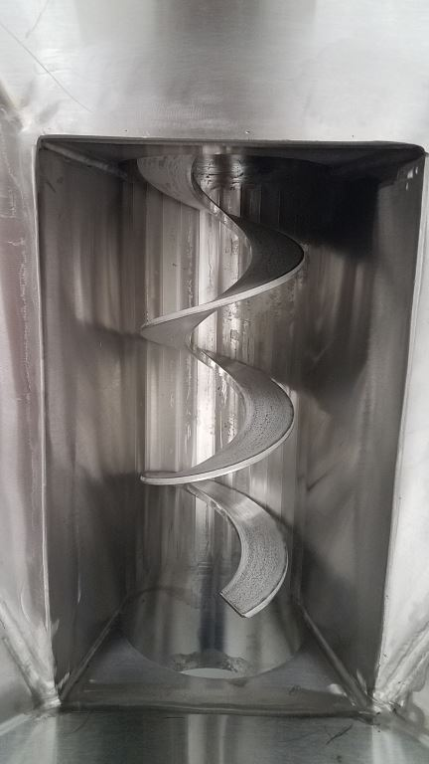

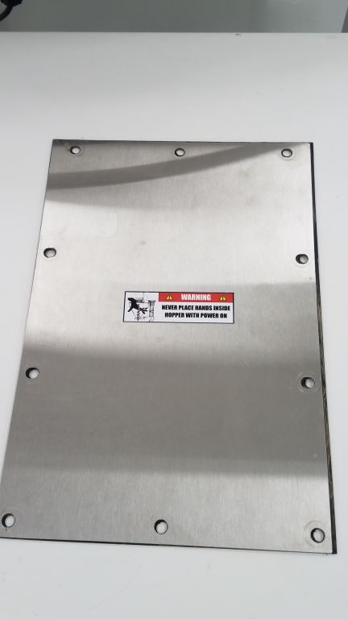
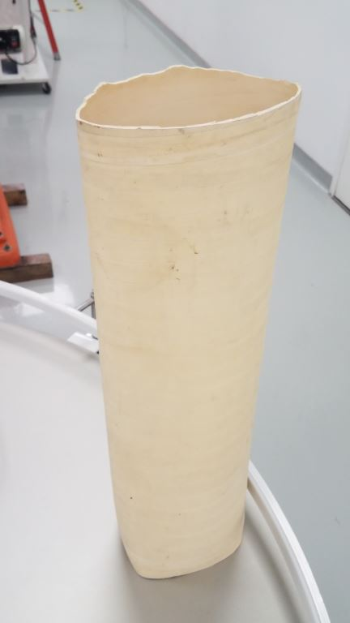
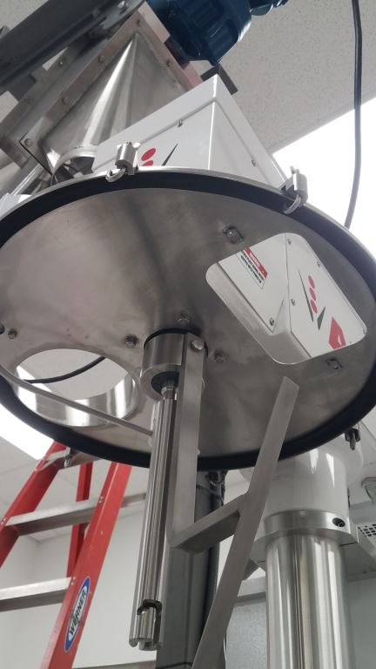
8.1.4 8.1.5 8.1.6

8.1.7 8.1.8 8.1.9
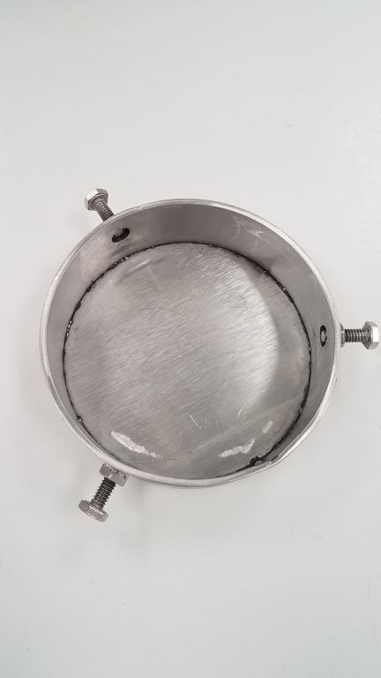
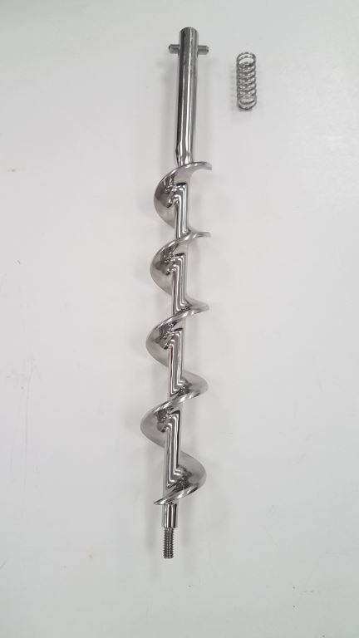
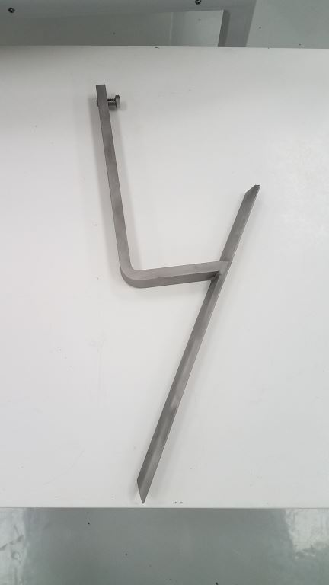

8.1.10 8.1.11 8.1.12
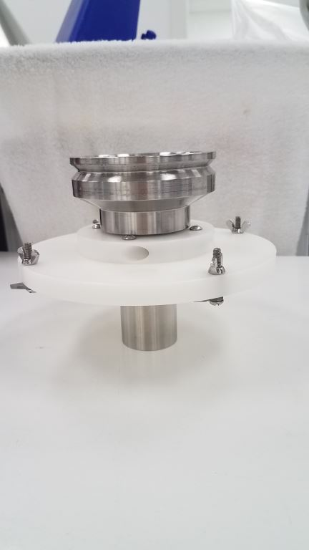
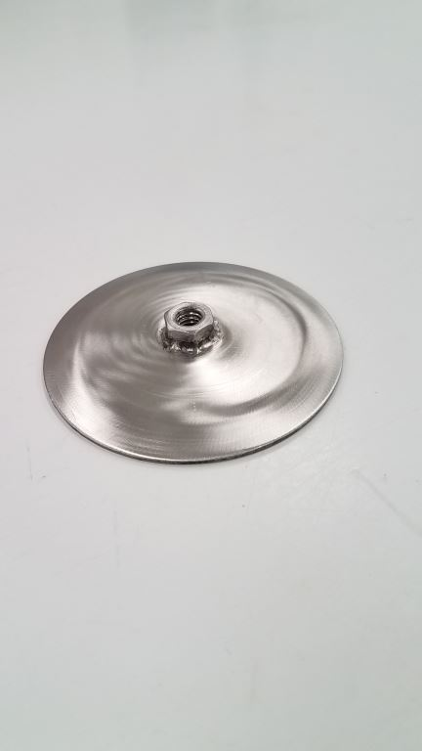
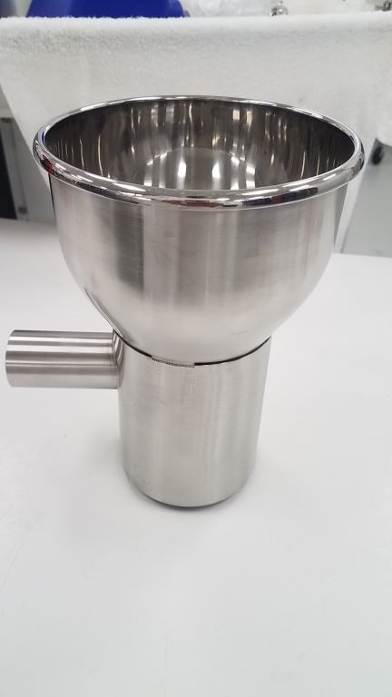

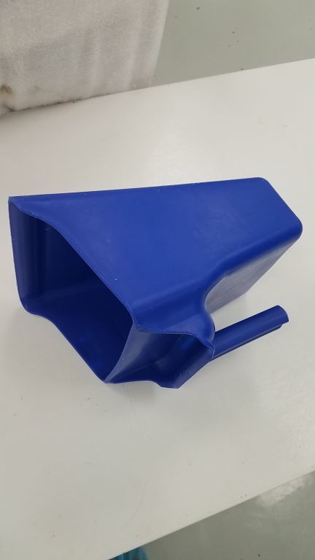
8.1.13 8.1.14 8.1.15
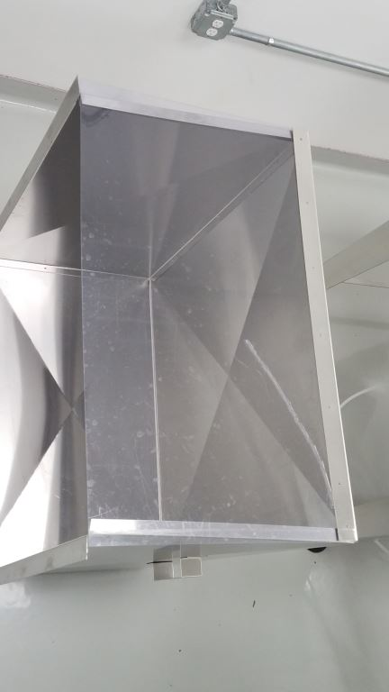
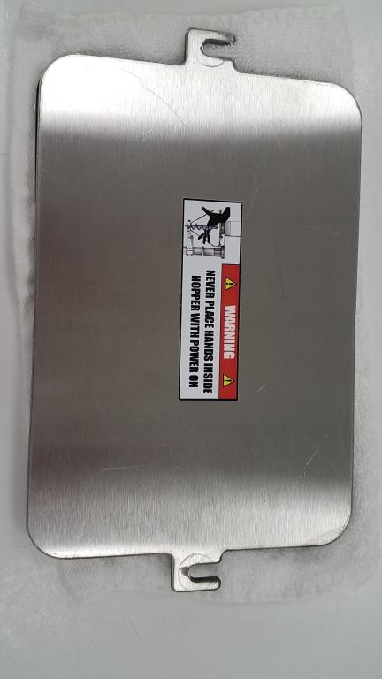

8.1.16 8.1.17 8.1.18

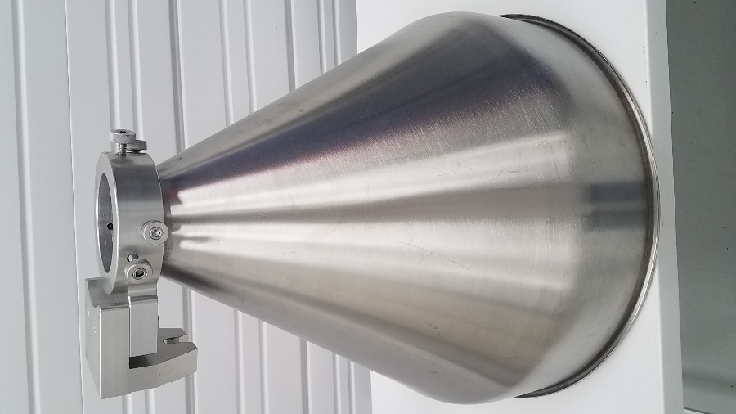
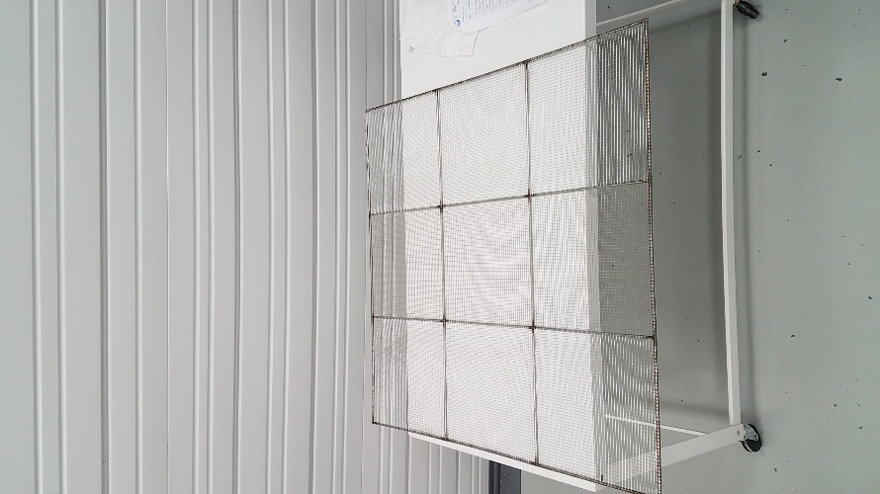
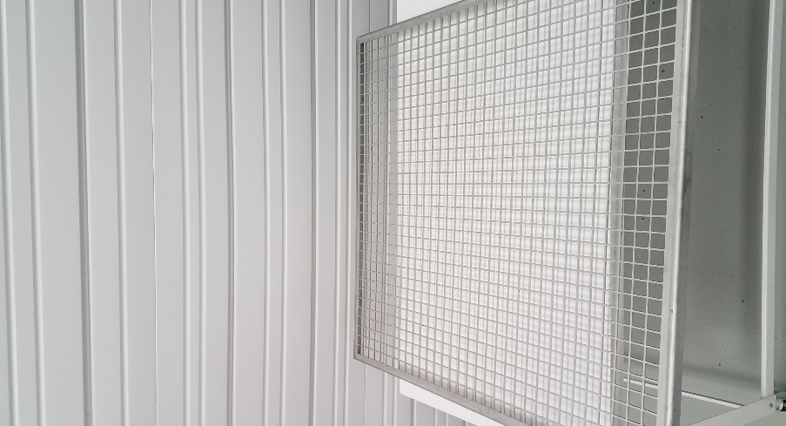

- References

  - PMI-US-SOP-003 - Microbiological Sampling Procedure for the Equipment Sterilization Audit
  - PMI-USA-SOP-004 – CAPA Program
  - PMI-US-SR-039 - Equipment Sanitization Verification Record for the AMS Filler and Canco Canner
9.0 History of Changes
Revision | Date Approved | Authorized Representative | Changes
1.0 | 31-Jul-2020 | S. Fitzgerald | New document
1.1 | 24-Aug-2020 | P. Ardila | Updated cleaning procedures to include new chemicals to use- Perasan A and Perafoam solution, Alpha Bac Sanitizer and Neutral Scrub Cleaner.
1.2 | 16-March-2021 | P. Ardila | - Updated section 3.1 to add as part of the required PPE the N-95 Respirator
1.3 | 14-Jul-2021 | P. Ardila | Updated section 6.0 to include the maximum period allowed for the machine to run without a wet clean.
1.4 | 08-Oct-2021 | P. Ardila | Updated in the section 7.0 that if the limits established for the concentration of PerasanA plus Perafoam as well as the Alpha Bac Sanitizer are not met , Quality should be contacted immediately.  Updated in section 7 that the swabs performed by quality should be completed prior to spraying the Alpha Bac solution.  Added section 8 (Attachments) to include the photos of the AMS and Canco Machine components.
1.5 | 14-Sep-2022 | P. Ardila | Updated section 1 and section 2 to include the auxiliary equipment as part of the wet cleaning procedures.  -Updated section 7 to clarify that the scoops will be included in procedure  As well as the bins and scale as part of the wet cleaning routine.

