
H A C C P PROGRAM

PROCESS FLOW SHEET FOR DURUM WHEAT, SEMOLINA, FLOUR & BY-PRODUCTS

Reviewed October 2022

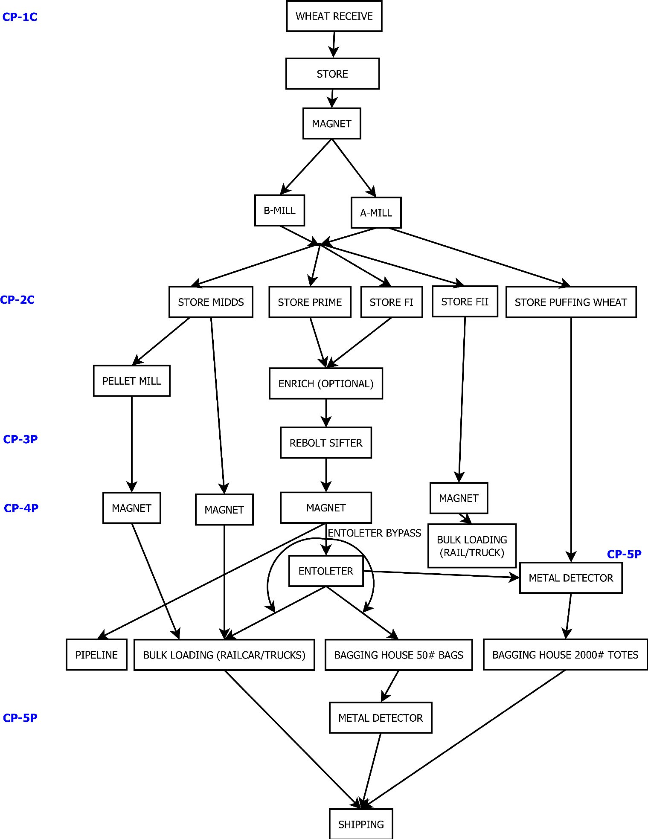P

