Product Details
ITEM CN Fully Cooked Halal ABF Chicken breaded Patties

CODE# CN-18001

DESCRIPTION CN labeled Fully Cooked ABF Chicken Patties whole grain breaded.

CN CREDIT 2 OZ MMA & 1 OZ Grain Equivalent Per Serving 4 OZ.

INGREDIENTS Halal ABF Chicken Breast Meat, Dry Whole Egg, Water, Sea Salt.
Batter/Breaded With (Whole Wheat Flour, Enriched Wheat Flour, (Enriched with Niacin, Reduced Iron, Thiamine Mononitrate, Riboflavin, Folic Acid), Water, Wheat Gluten, Modified Corn, Starch, Salt Dextrose, Leavening (Sodium Acid Pyrophosphate, Sodium Bicarbonate) Less Than 2% Of Each Of The Following: Yeast Extract, Garlic Powder, Onion Powder, Sugar, Salt, Soybean Oil As Processing Aid).

Pack Specifications
CASE WEIGHT 30 lbs.
UNITS/BAG 120

Palletization
Ti 9
Hi 6
CASES PER PALLET 36
CASE DIMENSIONS 17 Length x 10 Wide x 4.5 High
CASE CUBE 0.44

Shelf Life
Total Shelf Life 1 year from production

Storage
STORAGE Frozen
SHIPPING REQUIREMENTS Keep Frozen

Claims/Certifications
CLAIMS Fully Cooked
All Natural
No Antibiotics used ever
No Additives
No Preservatives
0g Trans Fat/Serving
No Hormones Added
SQF Certified SQF
KOSHER/HALAL Halal
REGULATORY USDA Inspected
Good Manufacturing Practices

Physical Properties
 | Min Temp | Target | Reject/Fail Criteria
Color | Ongoing Visual | Light Golden Brown  A or B on Color Chart | Out of spec
Aroma/Flavor | QA Sampling | No off odor/flavor | An off odor/flavor
Foreign Material | Ongoing | Avoided | Out of spec
Metal Detection | Ongoing | Ferrous Standard: 2.5 mm  Non-Ferrous Standard: 2.5 mm  Stainless Steel Standard: 4.0 mm | Out of spec
Net Weight | Constant Monitoring | USDA Requirements | Less than USDA standards
Patty Shape | QA Test | Plate determines shape | Wrong plate utilized
Patty Size | QA Test | 3 oz. | Wrong plate utilized
Batter/Breading | QA Test | 20-22% | + / - 2%

Microbiological Properties
Test | Limits
Aerobic plate count | <100
Listeria Spp. | Negative
Salmonella | Negative
E.Coli | Negative

Allergens
ALLERGENS Contains Wheat, Eggs

Labeling
LABELING Case label contains the flowing:
- Inspection Legend: P-8813
- Item description:
- Net Weight of Case: 30 Lbs.
- Keep Frozen
- Ingredients
- Production Date

LOT/DATE CODE Product must have clearly printed, proper Lot/Date Code on label.

CONSUMER INFORAMTION Product contains Heating Instructions

UPC UPC Printed on Package

Nutritional Information
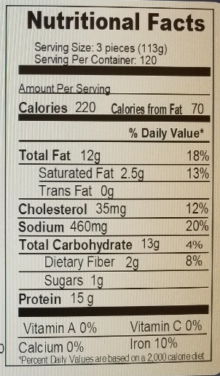

HEATING INSTRUCTIONS

CONVENTIONAL OVEN: Preheat oven to 400 degrees F. Bake 8-10 min, turning once during cooking cycle. Appliances vary-adjust accordingly.

