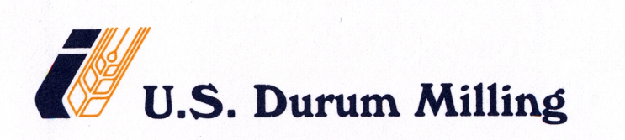

RAIL CAR PRELOAD (PRESSURE) CLEANING PROCEDURE

We use dedicated rail cars to ship the flour products from the mill to our customers. After unloading the product at the customer end, when the rail car returns back to the mill, it is normal to notice a small amount of product inside of the rail car at the bottom hoppers. Before reloading the product into the rail car, the following preload cleaning procedure is followed:

- Pressurize the car and bring it up to the desired pressure level, 14 psi.
- Apply pressure to the aerator pads to help vibrate the product
- Open and close the gate valve on the hopper 3 to 4 times so that the vibrated product is forced out or the car by the pressure movement
- Process repeated thru each hopper until the car is empty
- Close all hoppers and blow any excess product out of main product line
- Product is diverted to feed bins

Then the rail car is handed over to the loading crew. Before loading the product, each rail car is subject to a set of internal and external inspections by the loading crew as per the “RAIL CAR PRELOAD CHECKLIST”. They are as follows:

INTERNAL INSPECTION EXTERNAL INSPECTION
- Ceiling clean Top clean
- Walls clean Swing gate clean
- Pad checked Unload valve checked
- Inside hatch clean All gaskets checked
- Liner checked Hatch knobs secured
Old seals removed
New seals attached

Loading crew will check against each of the above internal and external inspection processes and will check mark against each item on the check list. With all other relevant information the form is filled out and signed and the sheet is filed for future reference.

