- Purpose: The purpose of the Sanitation SOP’s is to provide Miller sanitation personnel the procedures to safely and effectively clean the facility and equipment.

- Scope: Alkar Ovens 1, 2, and 3

- Definitions
  - None

- Responsibilities
  - Sanitarian: Clean, rinse, and sanitize the ovens
  - Maintenance: Hand clean inside of control cabinets quarterly.
  - Pre-op Personnel: Visually inspect, swab, reclean if necessary
  - VP of Production: Assure adherence to sanitation SOP’s and related documentation. Review and update as necessary.

- Procedure (daily)
  - Squeegee food debris from oven floors and surrounding areas into pile and discard.
  - Rinse walls, doors, temperature probes, and floors of ovens with low pressure, hot water.
  - Foam walls, doors, temperature probes and floor with Enrich 299 at the recommended concentration.
  - Clean walls and doors with brush.
  - Clean temperature probes with single use scratch pad.
  - Rinse walls, temperature probes and doors with low pressure, hot water.
  - Squeegee water on the floors to the drains.
  - Visual inspection using flashlight to ensure the cleanliness of equipment’s and parts before sanitizing. (If found food residues, reclean as needed)
  - Sanitize temperature probes with Multi-Quat

- Procedure (weekly)
  - Squeegee food debris from oven floors and surrounding areas into pile and discard.
  - Rinse walls, doors, temperature probes, and floors of ovens with low pressure, hot water.
  - Foam walls, doors, temperature probes and floor with Enrich 299 at the recommended concentration.
  - Clean walls and doors with brush.
  - Clean temperature probes with single use scratch pad.
  - Rinse walls, temperature probes and doors with low pressure, hot water.
  - Fill Cleaning Tank:
    - Use small diaphragm pump mounted to the wall in the chemical storage room to pump 22 gallons of Dominate 286 into the Cleaning Tank with 300 gallons water.
    - 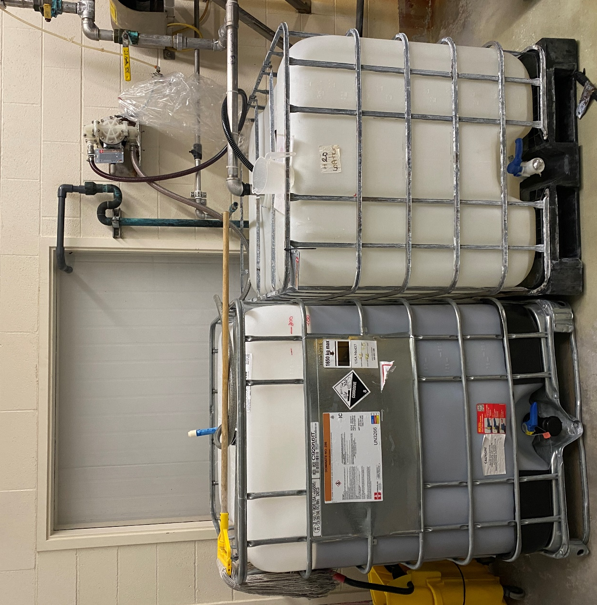
Cleaning Tank
Dominate 286
Diaphragm Pump
    - Use white hose mounted on the Rinse Tank to fill the cleaning tank. Stick hose in top of tank far enough that won’t flop out when the water is turned on.
    - Open the hot water valve which is the red valve located on the wall. Then slowly open the yellow handled valve where the white hose connects to the piping.
    - 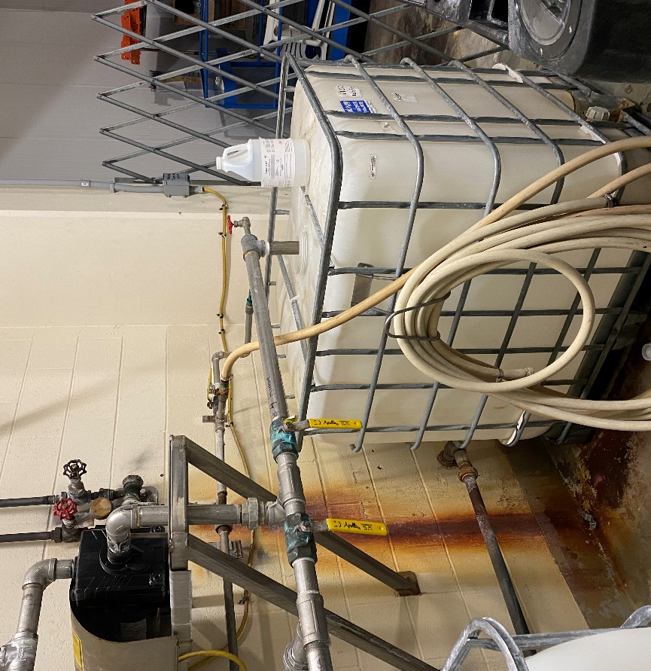
Rinse Tank
Hot Water Valve
Rinse Tank Valves
    - Monitor the fill level in the cleaning tank and close the yellow handled valve at the hose connection when the tank is full.
    - Return the white hose to its holder on the Rinse Tank.
  - Fill Rinse Tank
    - Open the yellow handled valve along the wall.
    - When the tank is full close the yellow handled valve along the wall.
  - Cleaning Cycle
    - Start cleaning cycle on all Alkar 1-2-3 ovens at the computers in the Oven Room and verify all are up to temperature. Return to the chemical storage room.
    - Turn on pump before opening any valves to the Alkar Ovens. Turn on the pump at a switch near the cage in the chemical storage room.
    - Valve Opening Sequence in the Chemical Storage Room
      - At floor level, open valve#3 for soap/cleaning solution.
      - Above the pump, open valve #2. To prime the pump, it may be necessary to open and close the yellow handled valve that is the same height as the pump. Open and close this valve slowly. When you have good suction at the pump leave this valve a little open.
      - 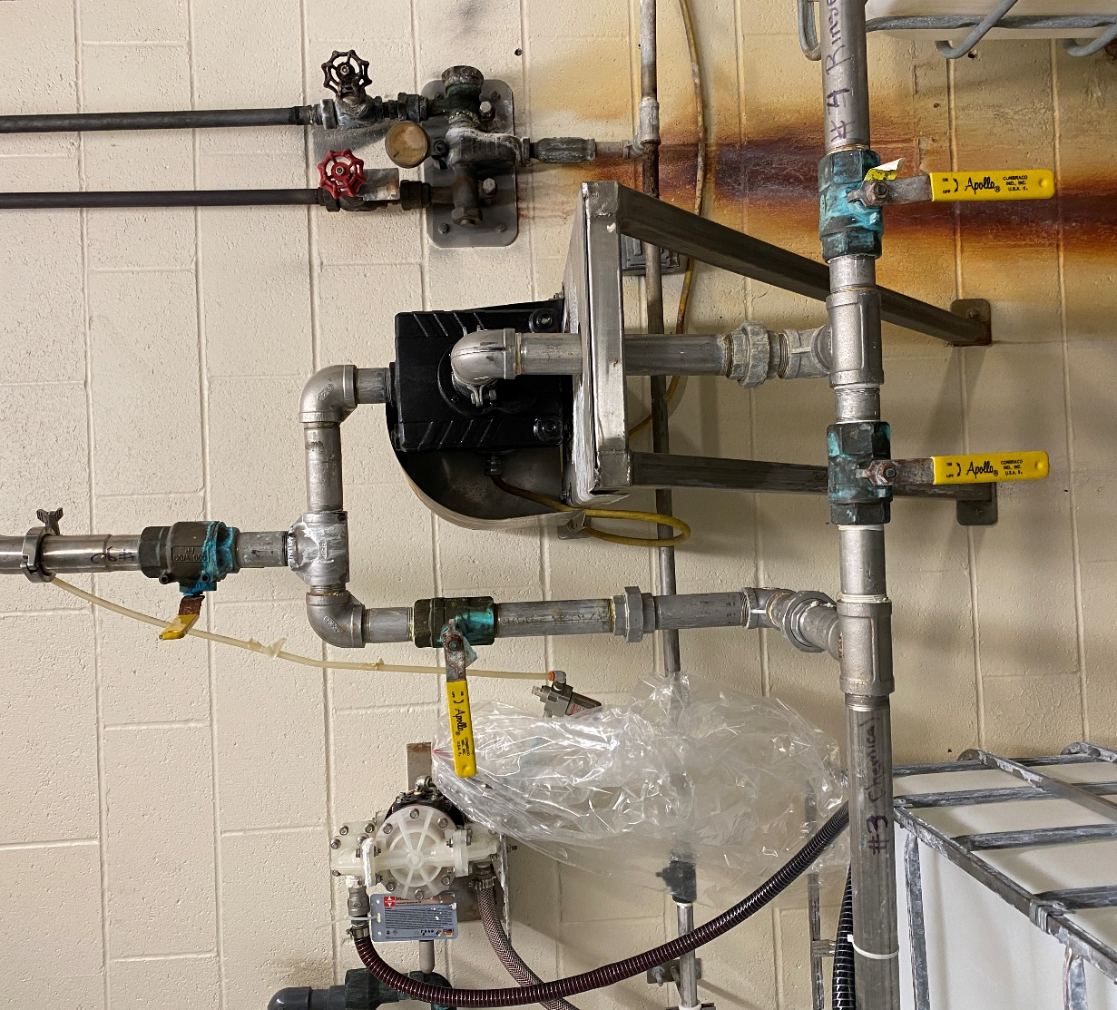
Pump
Prime
V4
V3
V2
    - Valve Opening Sequence at Alkar#1:
        - 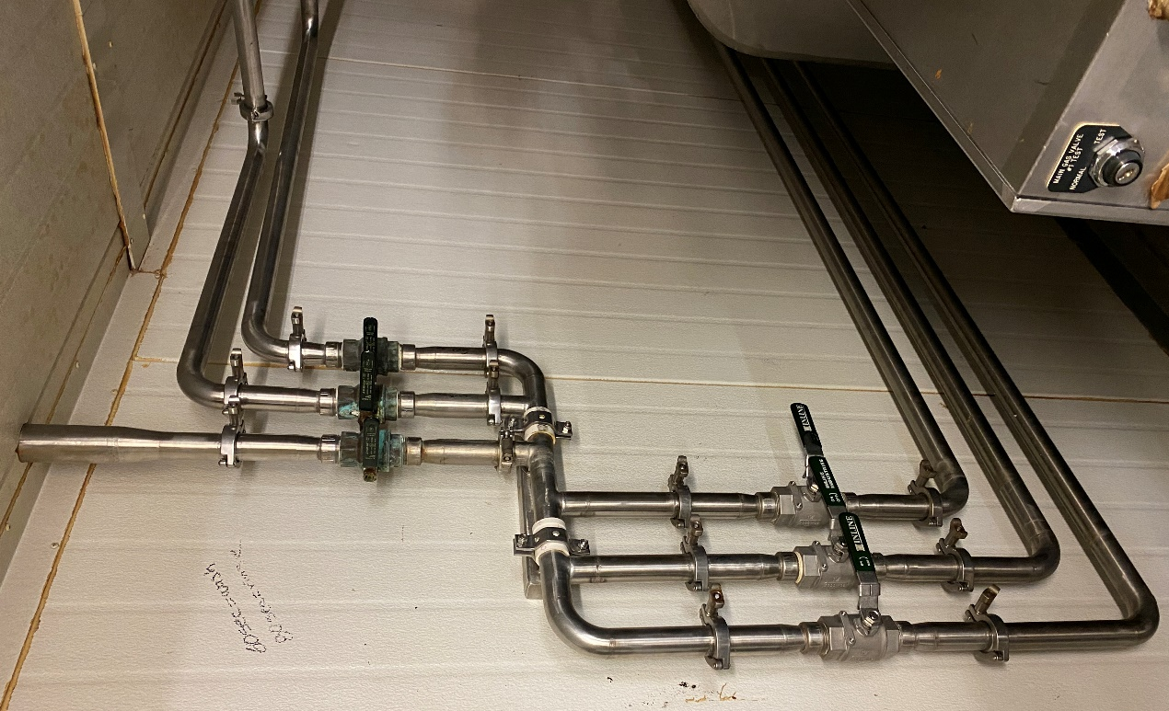
Main
        - Open the main valve first. This is the valve for the pipe coming out of the ceiling.
        - Open the valves for the piping that runs to Alkar Oven. There are five of them.
          - Open one valve at a time. The order does not matter.
          - Wait 60 seconds before opening the next valve.
          - Continue opening and waiting 60 seconds until all five valves are open.
          - Move to Alkar #2
    - Valve Opening Sequence Alkar #2:
      - 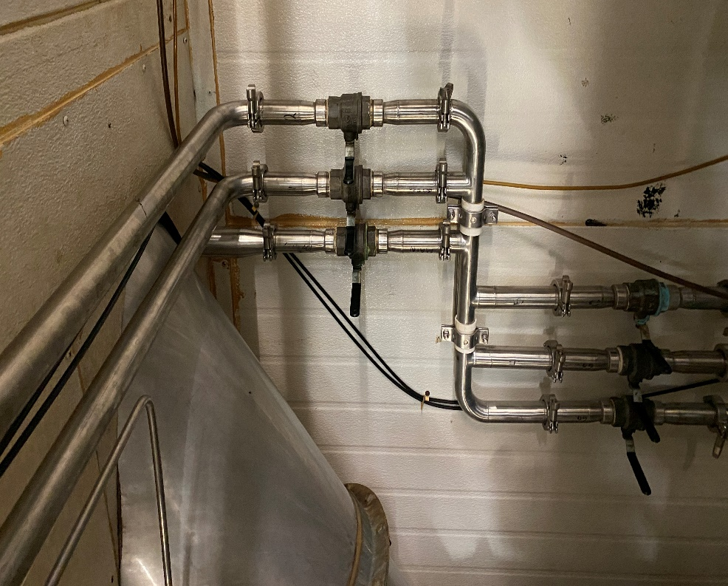
Main
      - Valve opening process and number of valves is the same as Alkar #1.
        - Open main valve first which is for the piping coming out of the ceiling.
        - Repeat the opening and waiting process that was completed for Alkar #1 for the five valves with piping going to Alkar #2.
        - Move to Alkar #3
    - Valve Opening Sequence Alkar #3:
      - Alkar #3 only has three valves.
      - 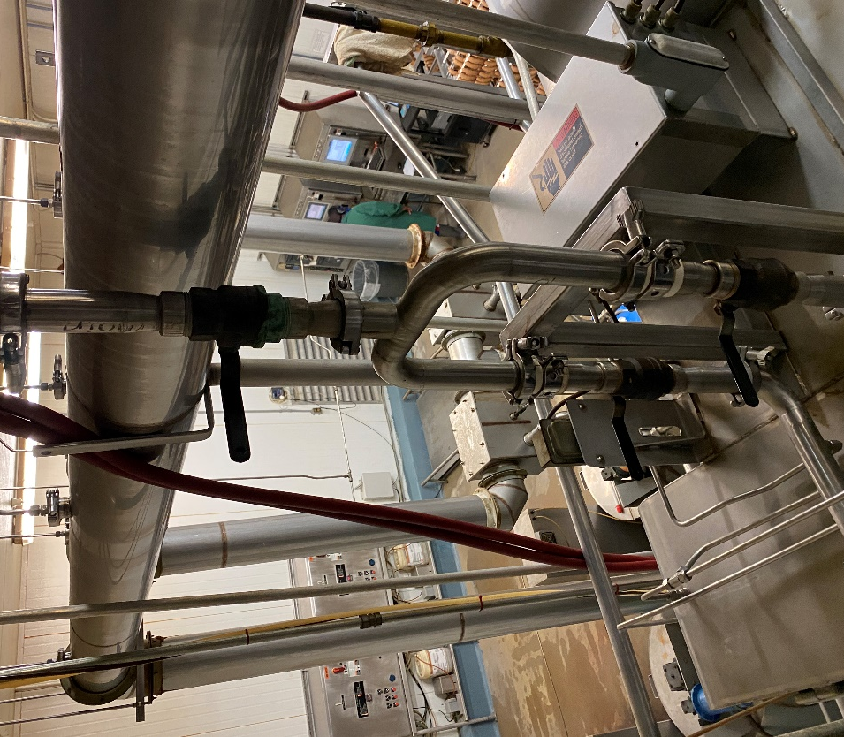
Main
        - Open the main valve which is labeled “Main” and is located just below the smoke generator duct work.
        - Open one of the two valves below two feet below and wait 60 seconds.
        - Open the second valve.
    - Return to the chemical storage room and close the valve at the same height as the pump. This will stop the small amount recirculation to the chemical tank.
    - Continue running cleaning sequence until it is ready to move to the rinse sequence.
    - Return to the chemical storage room to start the rinse water flow.
  - Rinse Cycle
    - Start rinse cycle by closing valve #3 halfway and slowly opening valve #4 to the Rinse Tank.
    - When you have good suction from the Rinse Tank, close valve #3 all the way.
    - Continue running the rinse sequence on all Alkar ovens. When the rinse sequence is complete, return to Alkar #1 and slowly close the main valve to the Alkar which is the pipe coming from the ceiling.
    - Then close each of the five valves for the piping that runs to the Alkar.
    - Repeat the same procedure for Alkar#2.
    - At Alkar#3 close the valve near the smoke generator duct work and then the two valves running into the top of the Alkar.
    - Return to the chemical storage room and turn off pump.
  - Drain Sequence
    - After turning off the pump, rinse water should drain back through valve #2 above the pump and valve #4 below the pump into the Rinse Tank.
    - When the water has stopped draining back, close valve #2 above the pump and valve #4 below the pump.
  - Return to Alkar ovens.
  - Rinse interior of Alkars with low pressure, hot water.
  - Squeegee water on the floors to the drains.
  - Sanitize interior of Alkar ovens with Multi-Quat

- Records
  - Sanitation Master Plan
  - Pre-op checklist.

- Document History
REVIEWED: | PROPOSED CHANGE:
Roland Pilar Dated:12/6/2021 | Removed Indosan 485 changed to Multi-Quat.  Added Visual inspection using flashlight to ensure the cleanliness of equipment’s and parts before sanitizing. (If found food residues, reclean as needed)
Roland Pilar Dated 12/22/2021 | Removed the following.  1.Close the red handled valve on the wall.  2. Flow into the Rinse Tank can be controlled with the red handled valve above the Rinse Tank.  3.The red handled valve.  Added the following.  Procedure (weekly)  6.1 to 6.6
Roland Pilar / Alfredo Robles 3/15/2023 | Added SSOP number

