Product Details
ITEM Fully Cooked Halal Chicken Breaded Patties

CODE# 21020

DESCRIPTION Labeled Fully Cooked Halal Breaded Chicken Patties.

INGREDIENTS White Chicken, Water, Texture Vegetable Protein (Soy), Salt, Sodium, Phosphate and Spices. BREADED WITH: Bleach Wheat Flour, Unbleached Wheat Flour (Enriched with Niacin, Reduced Iron, Potassium Bromate, Thiamine, Mononitrate, Riboflavin, Folic Acid), Malted Barley Flour, Water, Salt, Dextrose, Yeast, Sugar. Breading set in Soybean Oil.

Packing Specification____________________________________________________
Case Weight 10 lbs.
Bag/Case 1

Shelf Life
Total Shelf Life 1 year from production
Minimum Shelf Life 10 months
To Warehouse

Storage
STORAGE Frozen
SHIPPING REQUIREMENTS Keep Frozen

Claims/Certifications
CLAIMS Fully Cooked
No Preservatives
0g Trans Fat/Serving
No Hormones Added

KOSHER/HALAL Halal

REGULATORY USDA Inspected
Good Manufacturing Practices

Physical Properties
 | Min Temp | Target | Reject/Fail Criteria
Color | Ongoing Visual | Light Golden Brown  A or B on Color Chart | Out of spec
Aroma/Flavor | QA Sampling | No off odor/flavor | An off odor/flavor
Foreign Material | Ongoing | Avoided | Out of spec
Metal Detection | Ongoing | Ferrous Standard: 2.5 mm  Non-Ferrous Standard: 2.5 mm  Stainless Steel Standard: 4.0 mm | Out of spec
Net Weight | Constant Monitoring | USDA Requirements | Less than USDA standards
Patty Shape | QA Test | Plate determines shape | Wrong plate utilized
Patty Size | QA Test | 3 oz. | Wrong plate utilized
Batter/Breading | QA Test | 20-22% | + / - 2%

Microbiological Properties
Test | Limits
Aerobic plate count | <100
Listeria Spp. | Negative
Salmonella | Negative
E.Coli | Negative

Allergens
ALLERGENS Product contains SOY, WHEAT

Labeling
LABELING Case label contains the flowing:
- Inspection Legend: P-8813
- Item description:
- Net Weight of Case: 10 Lbs.
- Keep Frozen
- Ingredients
- Manufactured By: Golden Platter Foods, Newark, NJ 07114
- Production Date

LOT/DATE CODE Product must have clearly printed, proper Lot/Date Code on label.

CONSUMER INFORMATION Product contains Heating Instructions

UPC UPC Printed on Package

Nutritional Information

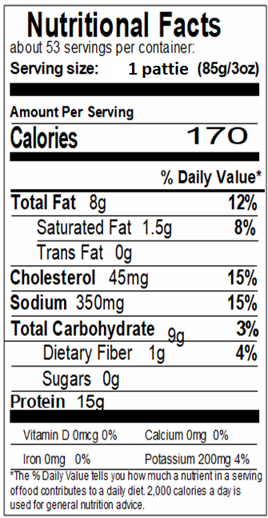

Formulation
INTERNAL FORMULATION # FC- 003WG

FORMULATION Proprietary

