ANIMAL FOOD SAFETY PLAN
FOR VEGETABLE PROTEIN BLENDS
AGPACK, LLC.
9700 Robin Rd, Disputanta VA 23842

__________________________________________________ _____________________
Owner, Operator or Agent in Charge of the Facility Date

§ 507.206 Additional requirements applying to the food safety plan. The owner, operator or agent in charge of the facility must sign and date the food safety plan upon initial completion and upon any modification.

TABLE OF CONTENTS
Page
Background Information . . . . . . . . . . . . . . . . . . . . . . . . . . . . . . . . . . . . . . . . . . . . . . . . 2
Process Flow Diagram . . . . . . . . . . . . . . . . . . . . . . . . . . . . . . . . . . . . . . . . . . . . . . . . . 4
Hazard Analysis . . . . . . . . . . . . . . . . . . . . . . . . . . . . . . . . . . . . . . . . . . . . . . . . . . . . . . . 5
Preventive Controls Management Components . . . . . . . . . . . . . . . . . . . . . . . . . . . . 15
Recall Plan . . . . . . . . . . . . . . . . . . . . . . . . . . . . . . . . . . . . . . . . . . . . . . . . . . . . . . . . . . . 18
Reanalysis . . . . . . . . . . . . . . . . . . . . . . . . . . . . . . . . . . . . . . . . . . . . . . . . . . . . . . . . . . . 19
History . . . . . . . . . . . . . . . . . . . . . . . . . . . . . . . . . . . . . . . . . . . . . . . . . . . . . . . . . . . . . . 19

BACKGROUND INFORMATION
Facility Overview:
- Agpack, LLC. Disputanta, VA has been in operation for approximately 3 years.
- Agpack, LLC. Disputanta, VA facility manufactures approximately 10,000 tons of finished products each year. The facility manufactures feed additives for the poultry and dairy industry and is a non-animal proteins facility.
- The feed production facility in Disputanta manufactures finished goods with utilization of vegetable and grain by products as ingredients. Incoming ingredients arrive by tractor trailer, and are formulated and mixed proportionately to satisfy our customers’ nutritional specifications.
- The facility operates five days per week, excluding national holidays or days for scheduled maintenance. Finished products are manufactured on one shift with 5-8 people within the manufacturing area. Additional support personnel are employed as needed.
- The facility utilizes bulk and bagged ingredients for manufacturing finished products. A majority (85-100%) of finished products are sold as bulk products. This facility ships to customers in semi tractor trailers and shipping containers to be used in animal food.
- Raw materials received include but are not limited to: Soybean Meal, Corn Gluten Meal, Fish Meal, Myco-Curb (a preservative), Biolyse (lysine) Petox (a preservative), Methionine, and Soy Isolates.
- See the process flow diagram for more information about the manufacturing processes.

Animal Food Safety Team:

- The animal food safety team is comprised of five people from the following areas:
  - Director of Quality
  - Quality Assurance Manager
  - Plant manager
  - Plant Supervisor
  - Quality Control Technician

- The animal food safety team is changed as needed. The plant manager is a permanent committee member. At least one member of the animal food safety team is to be a PCQI.

Product Description:

- Agpack, LLC. Disputanta, VA, manufactures vegetable protein blends for the poultry and dairy industry for further processing. All products are manufactured using the same equipment while implementing processes and procedures to ensure finished product safety.
- Master formula files are maintained for each product with labeling information developed to comply with Association of American Feed Control Officials (AAFCO) requirements and other federal requirements.

Process Description:

- Ingredients are blended per requirements of recipe (formulas) as defined in written procedures and processes.
- An Easy Automation system is used for manufacturing.
- Finished products are delivered via shipping containers and bulk trailers.

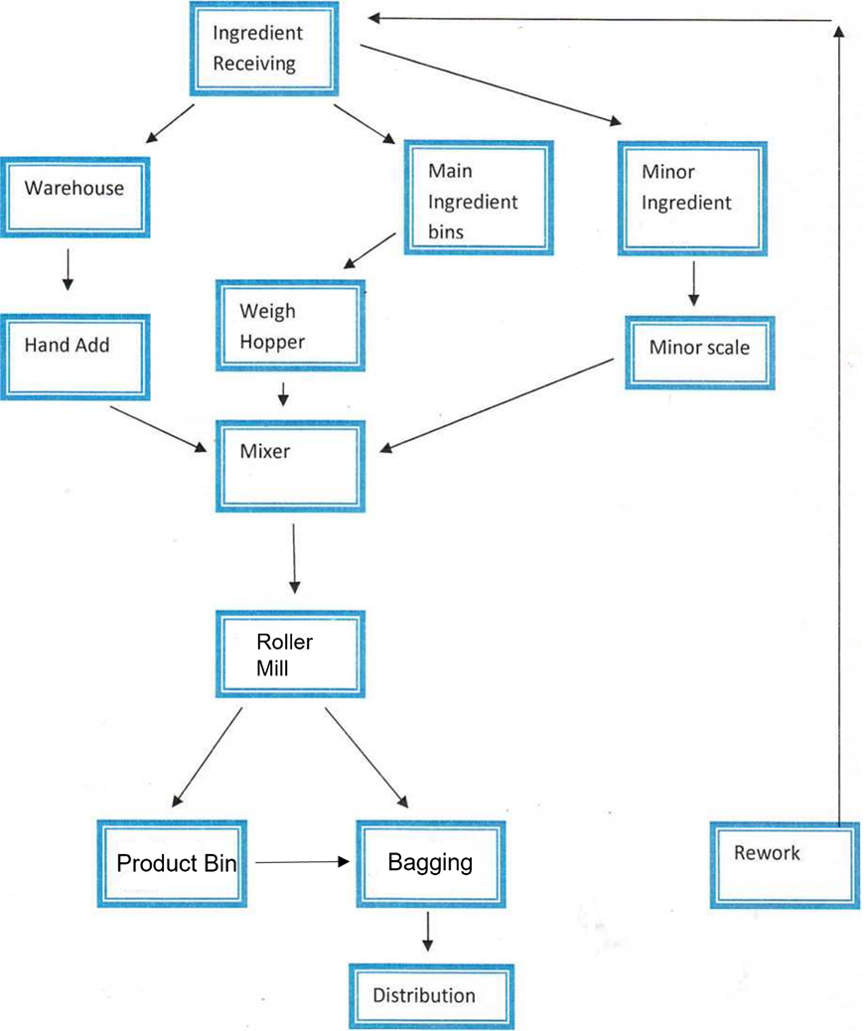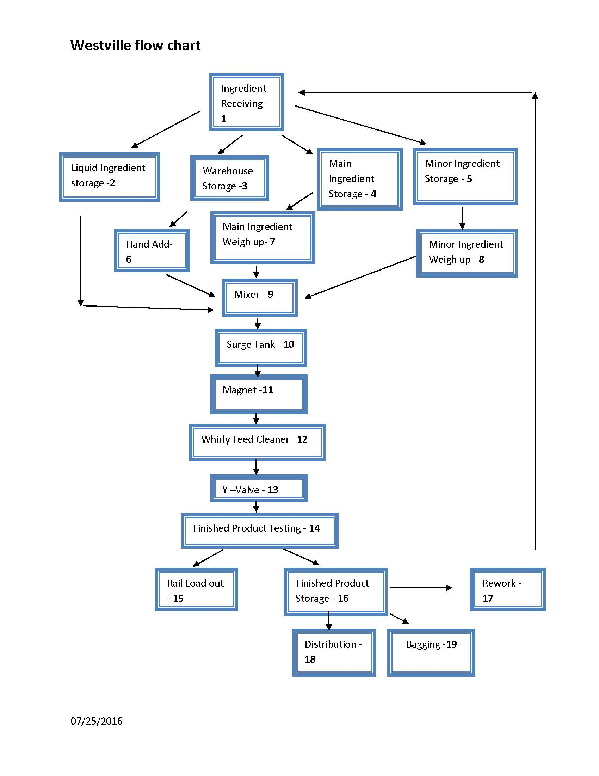

HAZARD ANALYSIS AND RISK-BASED PREVENTIVE CONTROLS
The Animal Food Safety Team completed a hazard analysis for the production of finished products manufactured by Agpack, LLC. Disputanta. All finished products are manufactured using the same equipment and processes. Thus, hazards from all ingredients and processes were considered for all finished products. The hazard analysis was based on experience, illness data, scientific reports, and other information. Summaries of animal food safety team meetings are maintained and provide additional information about the hazard analysis.

Information about the hazard analysis and risk-based preventive controls for Agpack Disputanta Vegetable Protein Blends is shown in Table 1. There are nine columns within the table:

Column 1 - Ingredient/Processing Step:
The column identifies the ingredients used by the facility or processing steps from the process flow diagram that is presented here.

Column 2 - Identify Known or Reasonably Foreseeable Animal Food Safety Hazards (B, C, P):
The hazard analysis assessed all potential animal food safety hazards that could be introduced within the production process flow. Hazards that were determined to be known or reasonably foreseeable hazards are listed within Table 1. Hazard identification considers those that may be present in the food because the hazard occurs naturally, the hazard may be unintentionally introduced, or the hazard may be intentionally introduced for economic gain.

B = Biological hazards including bacteria, viruses, parasites and environmental pathogens
C = Chemical hazards, including radiological hazards, food allergens, substances such as pesticides and drug residues, natural toxins (e.g. mycotoxins), decomposition and unapproved food or color additives
P = Physical hazards including potentially harmful extraneous matter (e.g. plastic, metal or wood pieces) that may cause choking, injury or other adverse health effects

As required by FSMA, the hazard evaluation considered the following on safety of the finished animal food for the intended animal:
- The formulation of the animal food;
- The condition, function, and design of the facility and equipment;
- Raw materials and other ingredients;
- Transportation practices;
- Manufacturing/processing procedures;
- Packaging activities and labeling activities;
- Storage and distribution;
- Intended or reasonably foreseeable use;
- Sanitation, including employee hygiene; and
- Any other relevant factors such as the temporal (e.g., weather-related) nature of some hazards (e.g., levels of some natural toxins).

Column 3 - Determine the Severity for the Animal Food Safety Hazard:
The severity of each known or reasonably foreseeable animal food safety hazard was determined. Severity is assessed among five categories:
- Insignificant
- Customer Complaint
- Product Recall
- Serious Illness
- Fatality

Column 4 - Determine the Probability for the Animal Food Safety Hazard:
The probability/likelihood of each known or reasonably foreseeable animal food safety hazard was determined. Probability is assessed across five levels:
- Very Unlikely
- Not Expected
- Could Occur
- Known to Occur
- Common

Column 5 - Determine the Risk Assessment for the Animal Food Safety Hazard:
A risk assessment was assigned to the known and reasonably foreseeable hazard based on the severity and probability assigned. Risks are categorized as Minimal, Low, Moderate, High, and Significant. See the following chart:

Column 6 - Does the Hazard Require Preventive Controls?
It must be determined whether preventive controls are needed for known or reasonably foreseeable hazards. Based on the hazard assessment for severity and probability, no preventive controls were identified.

Column 7 - Justify the Response in Column 6:
A brief justification for the decision on whether the hazard requires a preventive control is needed. Information provided was based on (facility) experience, illness data, scientific reports and/or other information.

Column 8 - Appropriate Control for Hazards Requiring a Preventive Control:
Processes or procedures taken to prevent, minimize or eliminate the known or reasonably foreseeable animal food safety hazard should be provided for hazards requiring preventive controls. The hazard analysis for the products manufactured within this facility determined that no hazards required preventive controls.

Column 9 - Assigned Preventive Control (PC) number:
Each preventive control for a hazard is assigned a number for traceability and identification within the process controls. With no preventive controls identified, no assigned preventive control numbers were created

Agpack, LLC. Disputanta, VA
ANIMAL FOOD SAFETY PLAN FOR BLENDED VEGETABLE PROTEINS DIS-A-100.1
TABLE 1. HAZARD ANALYSIS & RISK BASED PREVENTIVE CONTROLS
IDENTIFICATION |  |  | EVALUATION |  |  |  |  | PREVENTION
[1] | [2] |  | [3] | [4] | [5] | [6] | [7] | [8] | [9]
Ingredient or Processing Step | Identify known or reasonably foreseeable food safety hazards (B,C, P) |  | Determine the severity for the food safety hazard | Determine the probability for the animal food safety hazard | Determine the risk assessment for the food safety hazard | Does the hazard require preventive controls? | Justify the response in column 6 | Appropriate control for Hazards Requiring a Preventive Control (PC) | Assigned Preventive Control (PC) number
1. Ingredients and Ingredient Receiving | B | Salmonella | 4 | 3 | 12 (Moderate) | No | Anitox T8 formaldehyde application. Entero and T8 recovery testing program.
1. Ingredients and Ingredient Receiving | B | Animal DNA | 5 | 1 | 5 (Low) | No | Vegetable only products. Compliance Forms, Preferred Vendor Program, Trailer Inspections, Truck Wash out policy, last hauled information.
1. Ingredients and Ingredient Receiving | C | Pesticides, Fertilizers, Mold | 3 | 2 | 6 (Low) | No | Preferred Vendor Program, Trailer Inspections, Truck Wash Out Policy, Last Hauled information, and pesticide testing program.
1. Ingredients and Ingredient Receiving | P | Foreign Material: Metal, Glass, Plastic, Wood, Bone, Off Spec, Pests | 2 | 3 | 6 (Low) | No | Visual trailer inspections, Truck wash out policy, last hauled information, receiving grates, magnet, Screeners, visual inspection while unloading and taking of samples, and no historical significance.
2. Liquid Ingredient Storage | B | No foreseeable hazard | N/A | N/A | N/A | N/A | N/A
2. Liquid Ingredient Storage | C | No foreseeable hazard | N/A | N/A | N/A | N/A | N/A
2. Liquid Ingredient Storage | P | Contaminated Product, Weight Discrepancy | 1 | 1 | 1 (Minimal) | No | Preferred Vendor Program, Visual Inspections, Employee Training, Batch records, no historical significance.
3. Warehouse Storage | B | No foreseeable hazard | N/A | N/A | N/A | N/A | N/A
3. Warehouse Storage | C | Mold | 2 | 2 | 4 | No | Employee training, FIFO program.
3. Warehouse Storage | P | Foreign Material: Metal, Glass, Plastic, Wood | 2 | 3 | 6 (Low) | No | Glass and Brittle Plastic Program, Visual Inspections, SOP training, magnets, and feed cleaner.
4. Main Ingredient Storage (Bulk Bins) | B | No foreseeable hazard | N/A | N/A | N/A | N/A | N/A
4. Main Ingredient Storage (Bulk Bins) | C | Lubricating Fluids | 1 | 1 | 1 | No | Preventive Maintenance, Food Grade Grease, and external bearings.
4. Main Ingredient Storage (Bulk Bins) | P | Wet Product, Pests | 2 | 1 | 2 (Minimal) | No | Preventive Maintenance, Bin Inspections, Pest Control Program.
4. Main Ingredient Storage (Bulk Bins) | P | Foreign Material: Metal | 1 | 3 | 3 (Low) | No | Preventive Maintenance, Bin Inspections, Magnet, and Feed cleaner
5. Minor Ingredient Storage (Micro Bins) | B | No foreseeable hazard | N/A | N/A | N/A | N/A | N/A
5. Minor Ingredient Storage (Micro Bins) | C | Lubricating Fluids | 1 | 1 | 1 (Minimal) | No | Preventive Maintenance, Food Grade Grease, and external bearings.
5. Minor Ingredient Storage (Micro Bins) | P | Wet Product, Pests | 2 | 1 | 2 (Minimal) | No | Preventive Maintenance, Bin Inspections, Pest Control Program.
5. Minor Ingredient Storage (Micro Bins) | P | Foreign Material: Metal | 1 | 3 | 3 (Low) | No | Preventive Maintenance, Bin Inspections, Magnet, and Feed cleaner
6. Hand Add | B | No foreseeable hazard | N/A | N/A | N/A | N/a | N/A
6. Hand Add | C | No foreseeable hazard | N/A | N/A | N/A | N/A | N/A
6. Hand Add | P | Foreign Material: Glass, Wood, Plastic, Metal | 2 | 2 | 4 (Low) | No | Glass and Brittle Plastic Program, Visual Inspections, Magnets, and Feed cleaner.
7. Main Ingredient Weigh Up | B | No foreseeable hazard | N/A | N/A | N/A | N/A | N/A
7. Main Ingredient Weigh Up | C | Lubricating Fluids | 3 | 1 | 3 (Low) | No | Food Grade Grease
7. Main Ingredient Weigh Up | P | No foreseeable hazard | N/A | N/A | N/A | N/A | N/A
8. Minor Ingredient Weigh Up | B | No foreseeable hazard | N/A | N/A | N/A | N/A | N/A
8. Minor Ingredient Weigh Up | C | Lubricating Fluids | 1 | 1 | 1 (Minimal) | No | Food Grade Grease
8. Minor Ingredient Weigh Up | P | No foreseeable hazard | N/A | N/A | N/A | N/A | N/A
9. Mixer | B | No foreseeable hazard | N/A | N/A | N/A | N/A | N/A
9. Mixer | C | Weight Discrepancy | 1 | 2 | 2 (Minimal) | No | Calibration  Monthly bucket tests
9. Mixer | P | Foreign Material: Metal, Glass, Plastic, Wood | 2 | 2 | 4 (Low) | No | Glass and Brittle Plastic Program, Magnet, and Feed Cleaner.
10. Surge Tank | B | No foreseeable hazard | N/A | N/A | N/A | N/A | N/A
10. Surge Tank | C | No foreseeable hazard | N/A | N/A | N/A | N/A | N/A
10. Surge Tank | P | Foreign Material: Metal | 1 | 3 | 3 (Low) | No | Preventive Maintenance, Magnet, Feed Cleaner.
11. Magnet | B | No foreseeable hazard | N/A | N/A | N/A | N/A | N/A
11. Magnet | C | No foreseeable hazard | N/A | N/A | N/A | N/A | N/A
11. Magnet | P | Foreign Material: Metal | 1 | 5 | 5 (Low) | No | Daily check and cleaning of the magnet, magnet tester, Preventive Maintenance program, and feed cleaner.
12. Roller mill | B | No foreseeable hazard | N/A | N/A | N/A | N/A | N/A
12. Roller mill | C | Lubricating Fluids | 3 | 1 | 3 (Low) | No | Food Grade Grease
12. Roller mill | P | Foreign Material: Plastic, Fiberglass | 1 | 3 | 3 (Low) | No | Roller Mill cleaned and checked weekly, screens and paddles changed as needed.
12. Roller mill | P | Foreign Material: Metal | 1 | 5 | 5 (Low) | No | Roller Mill cleaned and checked weekly, screens and paddles changed as needed.
13. Y-Valve | B | No foreseeable hazard | N/A | N/A | N/A | N/A | N/A
13. Y-Valve | C | No foreseeable hazard | N/A | N/A | N/A | N/A | N/A
13. Y-Valve | P | Foreign Material: Metal | 1 | 3 | 3 (Low) | No | Preventive Maintenance, Visual Inspections.
14. Finished Product Testing | B | No foreseeable hazard | N/A | N/A | N/A | N/A | N/A
14. Finished Product Testing | C | No foreseeable hazard | N/A | N/A | N/A | N/A | N/A
14. Finished Product Testing | P | No foreseeable hazard | N/A | N/A | N/A | N/A | N/A
15. Rail Load Out | B | BSE | 5 | 1 | 5 (Low) | No | Private Lease Fleet, Visual Inspections.
15. Rail Load Out | C | Pesticides, Fertilizers, Mold | 3 | 2 | 6 (Low) | No | Railcar cleaning SOP, Railcar visual inspection, Private Lease Cars or previous load information
15. Rail Load Out |  | Foreign Material: Metal, Plastic, Wood, Glass, Off Spec, Pests | 2 | 3 | 6 (Low) | No | Glass and Brittle Plastic Program, Visual Inspections, and product testing.
16. Finished Product Storage | B | No foreseeable hazard | N/A | N/A | N/A | N/A | N/A
16. Finished Product Storage | C | No foreseeable hazard | N/A | N/A | N/A | N/A | N/A
16. Finished Product Storage | P | Foreign Material: Metal, Wet product | 1 | 2 | 2 (Minimal) | No | Preventive Maintenance, Bin Inspections, and Pest Control.
17. Rework | B | No foreseeable hazard | N/A | N/A | N/A | N/A | N/A
17. Rework | C | No foreseeable hazard | N/A | N/A | N/A | N/A | N/A
17. Rework | P | Off Specification | 1 | 4 | 4 (Low) | No | Laboratory Testing, Visual Inspections, Finished Feed Specifications, Product Release Flow
18. Truck Distribution | B | BSE | 5 | 1 | 5 (Low) | No | Approved Carriers, Trailer Inspections, Truck Wash Out Policy, and Last Hauled Information,
18. Truck Distribution | C | Pesticides, Fertilizers, Mold | 3 | 2 | 6 (Low) | No | Approved Carriers, Trailer Inspections, Truck Wash Out Policy, and Last Hauled Information,
18. Truck Distribution | P | Foreign Material: Metal, Glass, Plastic, Wood, Bone, Off Spec, Pests | 2 | 3 | 6 (Low) | No | Approved Carriers, Trailer Inspections, Truck Wash Out Policy, and Last Hauled Information,
19. Bagging | B | Animal DNA | 5 | 1 | 5 (Low) | No | DNATesting
19. Bagging | C | Tote Coating | 3 | 1 | 3 (Low) | No | FDA approved totes
19. Bagging | P | Foreign Material: Pest | 2 | 2 | 4 (Low) | No | Pest Control

PREVENTIVE CONTROLS MANAGEMENT COMPONENTS
Preventive controls for animal food safety hazards require proper monitoring and recording to demonstrate control of the hazard. Based on the hazard analysis, no preventive controls were needed to control hazards within the Animal Food Safety Plan for Agpack, Disputanta. All identified hazards have or are being controlled by either prerequisite programs or CGMPs. As the Animal Food Safety Plan is reviewed and updated, preventive controls may be needed. If so, information about preventive controls shall be maintained in Table 2. The following items will be reported:

Column 9 - Assigned Preventive Control (PC) number:
Each preventive control for a hazard is assigned a number for traceability and identification within the process controls. This is the same number as reported in Table 1.

Column 10 -Type of Preventive Control (PC):
There are four types of preventive controls, which impacts the information needed. Identify the type of preventive control implemented as a process control, sanitation control, supply-chain-applied control or other control.

Column 11 - Parameters (if applicable):
The tolerable limits for the preventive control of the hazard are identified. Parameters may not be applicable as the assessment may be qualitative.

Column 12 - Monitoring:
Monitoring information is provided, which includes:
- “What” is monitored to ensure control is maintained
- “How” the preventive control is monitored
- “Frequency” the preventive control is monitored
- “Who” completes the monitoring

Column 13 - Corrective Action(s) and/or Correction(s):
Describe the corrective action(s) or correction(s) taken when parameters are exceeded or preventive control fails.

Column 14 Records:
Describe the records maintained to ensure the effectiveness of preventive controls.

TABLE 2. DESCRIPTIONS OF PREVENTIVE CONTROLS
(9) | (10) | (11) | (12) |  |  |  | (13) | (14)
Assigned Preventive Control (PC) Number | Type of Preventive Control | Parameters (if applicable) | Monitoring |  |  |  | Corrective Action | Records
Assigned Preventive Control (PC) Number | Type of Preventive Control | Parameters (if applicable) | What | How | Frequency | Who | Corrective Action | Records

The FSMA animal food rule requires verification activities be completed for preventive controls. This includes validation and verification of monitoring activities. The current Animal Food Safety Plan for Agpack, Westville did not identify any preventive controls. Thus, no validation or verification activities were noted. As the current Animal Food Safety Plan is reviewed and updated, preventive controls may be needed. If so, information about validation and verification activities shall be maintained in Table 3. The following items will be reported:

Column 2 - Identify Known or Reasonably Foreseeable Animal Food Safety Hazards:
This is a repeat from information within Table 1. This identifies hazards requiring a preventive control.

Column 9 - Assigned Preventive Control (PC) number:
Each preventive control for a hazard is assigned a number for traceability and identification within the process controls. This is the same number as reported in Table 1.

Column 15 Activity:
The type of preventive control that is implemented impacts the activities that are completed. Activities include validation, verification, verification of Implementation and effectiveness, and corrective actions/corrections.
Column 16 Description of Activity:
Describe the activity to ensure the preventive control is consistently and effectively minimizing or preventing the hazard requiring a preventive control. This includes activities such as record review, establishing appropriate validation, and reanalysis of the Animal Food Safety Plan.
As there were no preventive controls identified within this food safety plan, there is no verification activities reported.

TABLE 3. DESCRIPTIONS OF VALIDATION AND VERIFICATION ACTIVITIES FOR PREVENTIVE CONTROLS
Identify known or reasonably foreseeable food safety hazards (B, C, P) |  | Assigned Preventive Control (PC) Number
(2) |  | (9)
Activity | Description of Activity
(15) | (16)

RECALL PLAN
The FSMA animal food rule requires a facility to maintain a written recall plan for animal food with a hazard requiring a preventive control. The Agpack Westville did not identify the need for any preventive controls; however a Recall Plan was already in place before the development of this Animal Food Safety Plan. As the current Animal Food Safety Plan is reviewed and updated, preventive controls may be needed, and thus, requiring a recall plan. Procedures for conducting a recall are found in “Agpack Recall Program”. Recall processes are applicable to all products manufactured by Agpack Disputanta and assessed within the Animal Food Safety Plan.

REANALYSIS
Agpack Disputanta will conduct a reanalysis of its Animal Food Safety Plan as follows:
- As a whole, at least once every three years
- Whenever a significant change in the activities conducted at your facility creates a reasonable potential for a new hazard or creates a significant increase in a previously identified hazard
- Whenever the facility becomes aware of new information about potential hazards associated with the animal food
- Whenever appropriate after an unanticipated animal food safety problem
- Whenever a preventive control, combination of preventive controls, or the food safety plan as a whole is found to be ineffective

HISTORY

Date | Change or Update | Version
4/20/2021 | New document – first version of the Animal Food Safety Plan developed by the Animal Food Safety Team | 00
5/7/2021 | Reviewed by PCQI – no changes needed | 00
5/7/2021 | Corporate Ownership change made by PCQI | 01

