P-242 Good Manufacturing Practices
PURPOSE
- This procedure describes the process for ensuring that Good Manufacturing Practices (GMPs) are adopted and maintained throughout the organization and facility.

RESPONSIBILITY
- The SQF Practitioner ensures the implementation and maintenance of GMPs and operates premises hygienically for safe food production.

PROCEDURE
- The facility, grounds, and equipment are designed, constructed, and maintained under the supervision of the SQF Practitioner to support safe food production. They are evaluated against SQF Good Manufacturing Practices Module requirements, with initial and subsequent assessments conducted to ensure compliance.
- The SQF Practitioner develops an F-FM floor map (refer to module P-243 Food Safety Plan) detailing process flow, employee movement, waste routes, and plant areas, providing a comprehensive overview to maintain process integrity and food safety.
- The SQF Practitioner identifies and evaluates relevant Good Manufacturing Practices (GMPs) to control food safety hazards, prevent contamination, and manage hazard levels. These procedures align with Module 11 documentation requirements.

Premises and building exterior inspection procedure
Site operations
Personnel hygiene and welfare
Personnel processing practices
Water and compressed air supply
Receipt, storage, and transport
Control of foreign material contamination
Waste disposal

VERIFICATION
- The SQF Practitioner validates the effectiveness of the following PRPs yearly: personnel GMPs; pest control programs; equipment calibration and preventive maintenance programs; sanitation programs and waste programs. This is achieved by reviewing trends of non-compliance and by maintaining employee training records (see P-290 Training).
- Once annually, the internal audit team led by the QAM audits all module 11 documents and tours the facility to ensure that the site follows SQF requirements (refer to P-254 Internal Audits).

DOCUMENT APPROVAL
Food Safety Code: Food Manufacturing, Edition 9. FSC 19: Food Ingredient Manufacturing & FSC 25: Repackaging of Products Not Manufactured On Site |  | 2.4 Food Safety System  2.4.2 Good Manufacturing Practices
Prepared by  Bill Wiedmann  SQF Practitioner | Signature  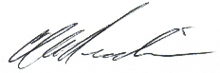 |  | Date of preparation of the new version  April 10, 2024
Approved by  Marty Parisien  CEO  Bill Wiedmann  COO | Signature  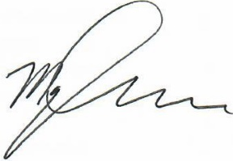 |  | Date of approval of the new version  April 10, 2024

DOCUMENT CHANGE HISTORY
Date of previous version | Previous  Version | Date of new version | New  Version | Reason for Change
November 28, 2022 | A | April 10, 2024 | B | The document P-242 Good Manufacturing Practices was updated to include the following sections: List of applicable procedures for Module 11 and verification procedures to ensure compliance with SQF Food Manufacturing, Edition 9 guidelines.

