- Purpose
  - This SOP defines the requirements for proper sanitization and Wet cleaning of the Effytec Powder Filling Machine and the Flexicon Auger as well as the auxiliary equipment (scales, bins, scoops)
- Scope
  - This procedure covers the proper cleaning and sanitization of the Effytec Powder Filling Machine and the Flexicon Auger as well as the auxiliary equipment and the responsibilities of the Operator during the cleaning and sanitization.
  - This Sanitization Procedure is incredibly important for the protection of the food safety of the product being filled. Any reside or debris from previously run product is a potential source of contamination for the following product. Prevention of unintentional adulteration must be handled with the utmost care.
  - An internal training of the SOP should be conducted after creation of the SOP and after changing or revising of the SOP for all concerned employees. An internal training of the SOP should be done with new employees, as well as once a year for all other concerned employees.
- Equipment
  - PPE: Closed shoes, safety goggles, a hairnet/beard cover, rain suit, pants, N-95 Respirator
  - Saran Wrap or plastic bags to cover Effytec electrical connectors
  - Hose with hot water and adjustable fine spray nozzle
  - Bin with attached drain hose
  - Brushes with short metal bristles
  - Alpha Bac Sanitizer solution
  - Alpha Bac Sanitizer spray bottle
  - Hydrion Paracetic Acid Strips
  - Hydrion Quat test Strips
  - Neutral Scrub Cleaner D
  - Washing Sponge/Brushes
  - Drying Rack for Effytec components
  - Microfiber Towels
  - Inspection Mirror with LEDs
  - Squeegee
  - Broom
  - Mop
  - Small fan
  - Rework Bucket
  - Long bin with notch (for emptying hopper)
  - Brass Punch
  - Mallet
- Definitions
  - SOP Standard Operating Procedure (SOP): The set of written instructions that document routine or repetitive activities. SOPs provide employees with the information to perform a job properly and consistently, producing a quality final product or result.
  - PPE Personal Protective Equipment (PPE): Clothing or equipment designed to protect workers from physical hazards. During the production of food, PPE also protects product from the introduction of worker-associated contaminants, such as hair.
- Responsibilities
  - The Effytec Filling Machine Operator is responsible for following this SOP as described for proper cleaning and sanitization of the filling machine.

  - The Quality Manager is responsible for ensuring that this SOP is followed precisely and for verifying that the Effytec Filling Machine is completely and adequately cleaned and sanitized.
    - Responsible for swabbing according to PMI-USA-SOP-003 (Microbiological Sampling Procedure), and the associated Equipment Sanitization Audit (PMI-USA-SR-001)
    - Responsible for making procedural changes that improve the efficiency, safety, and overall quality of the products and procedure.
    - Responsible for initiating the Corrective and Preventive Action Process (PMI-USA-SOP-004) as necessary in response to Equipment Santization Audit findings (i.e., residue and/or moisture on filler surfaces, high bacterial/fungal counts on sanitized components,etc.).
- Frequency
  - The instrument shall be Cleaned and Sanitized at least according to the following schedule:
    - Before a product changeover occurs.
    - As needed according to filling issues (i.e. jammed auger, caking product)

- Procedure
Emptying the Effytec Filler and Flexicon Auger
7.1 Ensure that proper Personal Protective Equipment (safety goggles, rain suit), clothing (pants and close-toed shoes), and disposable hygiene wear (shoe covers and hairnets/bear nets) are worn prior to starting.
7.2 Scoop out most of the remaining product in the hopper and place into the 6-gallon white Rework Bucket. This powder will need to be weight and disposed.
7.3 Place the 3-gallon bucket with notch under the Flexicon hopper. Take the clamp and the cover off the bottom of the Flexicon hopper and remove the remaining product using the scoop. Once empty, remove the 3-gallon bucket and dump into the Rework Bucket for proper weigh and disposal.
7.4 Turn on the machine and the panel on the wall.
7.5 Turn the key and hit the Reset button.
7.6 On the wall panel, hit the Stop button(red) then hit the Reverse button(black). This will empty the Flexicon Auger into the hopper.
7.7 Lightly tap on the auger tube to loosen the remaining product.

- Disassemble the Effytec Filling Funnel, Hopper, Stirrer and Auger
8.1 Loosen the safety/position nut using the old bent ratchet.
8.2 Using the hand crank, raise up the hopper up to the black line on the post.
8.3 Take off the Funnel with Vibrator by loosening the nut on the back and push in the valve to release the air hose.
8.4 Place a towel under the hopper, over the hole.
8.5 Place the long bin with a notch underneath the hopper.
8.6 Remove the Stop-Shut by loosening nut. Place in the designated container.
8.7 Remove the Neck piece by twisting and pulling down. There are no threads. It may require some tapping downwards using the red mallet to knock it loose.
8.8 Remove the Collar piece by rotating it to the left (counterclockwise). This will likely require tapping using the Brass Punch and the mallet to loosen.
8.9 Remove the Stirrer by detaching the 3 hexnuts that secure it to the Effytec Hopper Cover underside.
8.10 Remove the Effytec Auger from the cover by tamping the auger upwards where the auger attaches to the cover.
- Place components on top of the designated stainless-steel lab cart for cleaning and sanitizing in the three-compartment sink.
- Remove the two air filters from the vents on the back and right sides of the Effytec Filler. Use a flathead screwdriver to carefully remove the vent covers, then clean the filters thoroughly with hot water and let sit until completely dry.
- Use Saran Wrap or plastic bags to carefully and completely cover the filler’s electrical connections to protect them from water damage prior to starting the water spraying
- Ensure that the Hot Water Heater is set to at least 135F prior to starting this procedure.
- In the Effytec Powder Filling Room, place the “reservoir box with drain hose” underneath the Flexicon Hopper and place the drain hose into an open drain.

Cleaning and Sanitizing the Flexicon Auger and Conveyor Tube:
- Place a large plastic waste bin underneath the Flexicon conveyor drop to catch the wash water and Perasan A and Perafoam solution.
- Prepare Foamer by filling with prescribed dilution of water, Perasan A and Perafoam through the Lafferty Gemini ‘Two Part Mixer’ and into Foamer.
15.1 Verify that the final concentration of the mixture is at least 160 ppm but less than 500 ppm using the” Hydrion Paracetic Acid Strips” with a target of 300 ppm and record the result in the designated PMI-USA-SR-008 . If the concentration is below 160 ppm or above 500 ppm, operator should stop the wet cleaning process and immediately notify Quality Assurance for corrective actions.
16.0 Apply Foaming Perasan A solution to interior/exterior of Auger, using the Foam Wand attachment. With a Bottom to Top and Side to Side motion Cover the Sides and Interior & Exterior of the Auger chamber and tube with a thick layer of foam and let stand for 10 to 15 minutes. While allowing the Foam to clean, stick Foam Wand into the bottom of the auger, form a seal around the wand and Auger chamber/tube and pump foam into the Auger chamber/ tube until the foam emerges from the top of the Auger chamber/tube. If appropriate, run the auger to enhance the cleaning activity. Do not allow solution to stand more than 15 minutes.

- Using a low-pressure Rinse Drop rinse the Auger from Top to Bottom and rinse to drain
  - Before applying the sanitizer solution, Quality takes swab samples according to the Microbiological Sampling Procedure for the Equipment Sterilization Audit (PMI-USA-SOP-003) and the associated Equipment Sanitization Audit (PMI-USA-SR-001).

- Clean and sanitize the fan using a clean rag moistened with Alpha Bac Sanitizer ( Quat). Place the small fan at the top of the Flexicon Auger and position it to blow down the auger tube. NOTE: This step is essential to ensure that all residual moisture will be gone before the start of another product filling run, otherwise clumping and caking will occur upon initial operation, and the machine will need to be dissembled to remove debris to prevent jamming.
Verify the concentration of the Alpha Bac Sanitizer (Quat) in the “sanitize” compartment located in the 3- compartment sink using the “Hydrion Quat Test Strips”. The limits should be not less than 150 ppm and no more than 400 ppm, with a target of 200 ppm, record the result in the designated PMI-USA-SR-008 .If the concentration is below 150 ppm or above 400 ppm, operator should stop the wet cleaning process and immediately notify Quality Assurance for corrective actions.
- Using a clean rag moistened with Alpha Bac Sanitizer ( Quat) sanitize all the surfaces of the Flexicon Hopper, Flexicon Auger, Flexicon Hopper Cover, and Flexicon Conveyor Drop. Ensure that an adequate amount of Quat Solution is used to visibly coat the entirety of the surfaces.
- Allow the Quat Solution to air-dry. DO NOT FURTHER WIPE OR DRY THE QUAT SOLUTION. The Quat Solution must dry naturally and leave a protective residue to ensure proper sanitization.
- Adjust the spray nozzle on the hot water hose to the finest spray setting so that a strong thin stream is observed.
- The Effytec contains three sets of Heat Sealers. Ensure that the heat sealers are turned on and are pre-heated to the proper temperatures (around 260F) prior to cleaning.

Cleaning the Inside Components of the Effytec Powder Filling Machine:
- Starting at the heat sealers, begin spraying Alpha Bac Sanitizer Spray Bottle and cleaning the inside of the Effytec Filling Machine.
  - The residue on the heat sealers should quickly begin to dissolve from the spray.
  - Using the brush with short metal bristles, begin scraping the remaining residue and debris from the surfaces and crevices of the heat sealers.
  - Thoroughly spray, wipe, and brush-as-necessary, all the surfaces of the inner-filler components.
  - Use the telescopic Mirror with LEDs to check the back and undersides of the sealers and other components for any remaining product residue and debris.
  - Use the associated Checklist (PMI-USA-SR-008) to ensure that each residue/debris harboring area is properly cleaned and sanitized.
  - Conduct a final recheck of all the components for any sign of residue.
- Using the Alpha Bac Sanitizer spray bottle and clean Microfiber Towels, completely spray and wipe all the surfaces of the inner-Effytec components. Ensure that an adequate amount of Quat Solution is used to visibly coat the entirety of the surfaces.
- Allow the Quat Solution to air-dry. DO NOT WIPE OR DRY THE QUAT SOLUTION. The Quat Solution must dry naturally and leave a protective residue to ensure proper sanitization.
Cleaning and Sanitizing the Effytec Components in the Three-Compartment Sink:
- Start by filling the right side of the 3-compartment sink, the Sanitizing Solution Section, with the Alpha Bac Sanitizer. Use a Hydrion Quat Test Strips to measure the Quat concentration. The limits should be not less than 150 ppm and no more than 400 ppm, with a target of 200 ppm. Adjust with more Quat or water as necessary.
- While the Sanitizing Solution Section fills, begin rinsing and washing (with the Neutral scrub cleaner) the filler components with a soapy sponge or brush. Wash them thoroughly to remove all product residue and debris. Note: It may take three or more times passing the sponge over the area and rinsing to remove all the product (especially Restorate).
  - DO NOT FULLY SUBMERGE THE EFFYTEC FILLER FUNNEL WITH VIBRATOR MECHANISM. WATER WILL DAMAGE ITS INTERNAL PARTS.
  - Scrub and brush the filler parts as needed, paying close attention to the crevices and component connections where residue can hide.
  - Once a component is adequately washed, rinse the soap off into the second section of the sink, the Rinsing Section.
    - Before applying the Quat solution, Quality takes a set of culture swabs according to the Microbiological Sampling Procedure for the Equipment Sanitization Sterilization Audit (PMI-SOP-003) and the associated Equipment Sanitization Audit (PMI-USA-SR-001).
  - Once rinsed, completely immerse the filler component in the Sanitizing Solution for a minimum duration of 10 seconds.
  - Remove the component from the Sanitizing Solution without touching any of the inner surfaces that make direct contact with food product.
  - Carefully place the components onto the designated Drying Rack (food Contact) in a manner that does not allowed for standing water (upside down when necessary)
  - Continue process until all filler components are cleaned and sanitized. The auxiliary equipment (scoops) will be cleaned following this procedure.
Cleaning the Remainder of the Filling Room and Filling Machine
- Spray and wipe the product residue off the outside of the Effytec Filling Machine, including the full length of the Flexicon Conveyor Tube.
- Carefully spray with the water hose and wipe the product residue off the walls of the Filling Room using the Wall Mop.
- Spray the floor using the water hose and use the large Squeegee to pool the water.
- Remove the pooled water from the floor using the Mop.
  - Be sure to remove all standing water, especially from directly underneath the Effytec Filling Machine, where a significant low spot accumulates water. Any water left overnight will increase the relative humidity in the Filling Room and will increase the likelihood of bacterial and fungal growth.
- Sweep the room directly surrounding the Filling Room, then mop the floor using the Alpha Bac Sanitizer solution.
- Clean and sanitize the auxiliary equipment (Scale, Bins) using a clean rag moistened with Alpha Bac Sanitizer ( Quat) and allow then to air dry.
Cleaning the Vacuum Cannister and Hose
- Disconnect the large vacuum hose from the top of the Effytec Filler. Disconnect the two smaller hoses that connect to the Effytec.
- Pull the hose through the two walls into the Vacuum Room.
- Check the powder level in the black Vacuum Cannister inside the Vacuum Room. If 50% full or greater, empty the cannister.
- Take the vacuum hose and cannister to the loading ramp outside and spray them thoroughly with the water hose. Leave them to air dry about 30 min or as required.
- Reconnect the Y-joint to the vacuum pump and connect the gray vacuum hose to it, then connect the Effytec hose to the cannister.
- Reconnect the Effytec hose to the Filler and reconnect the two smaller hoses to their proper positions.
- Attachments
  - Photos of Effytec Filler Components (numbered from left to right)
    - Drying Table with Parts
    - Effytec Auger
    - Effytec Filler Funnel with Vibrator
    - Effytec Stirrer
    - Effytec Sachet Opener/spreader
    - Effytec Up-Spout
    - Effytec Drop Adapter
    - Effytec Cylinder/Funnel
    - 4” Polyurethane Antistatic Transfer Hose
    - 2” Product Drain hose
    - Vacuum Pump with Y-joint and gray hose
    - Black cannister and connected vacuum hoses
    - Flexicon Hopper Bottom
    - Flexicon Auger Bottom
    - Flexicon Hopper Hatch
    - Flexicon Conveyor Drop
    - Effytec Funnel Cover
    - Flexicon Conveyor Drop Cover
    - Large Metal Scoop
    - 6 mm Sieve
    - Stop Shut, Left Screw and Nut, Separators
    - Clean Out cap and fastener
    - Tooling guide Pipe
    - Filtering Support
    - Auger Filling Bushing
    - Auger Sleeve Nut

39.1.1 39.1.2 39.1.3
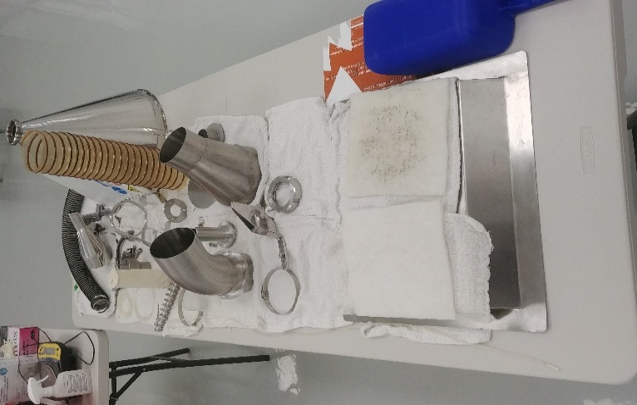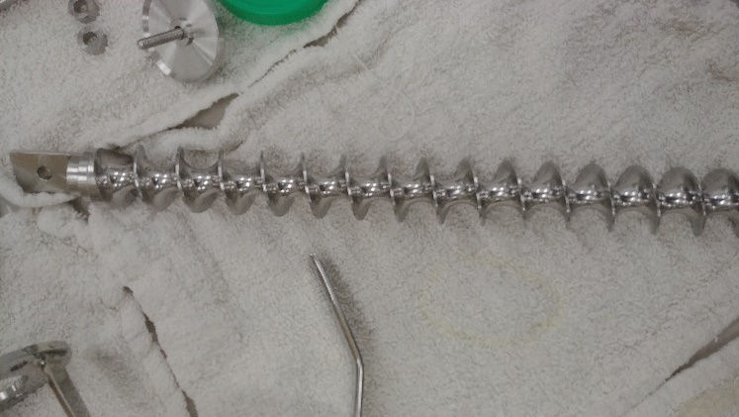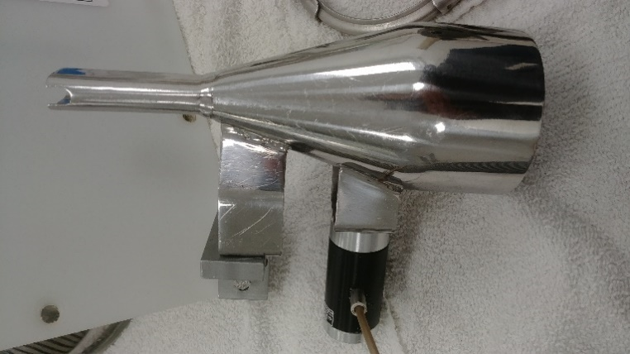

39.1.4 39.1.5 39.1.6
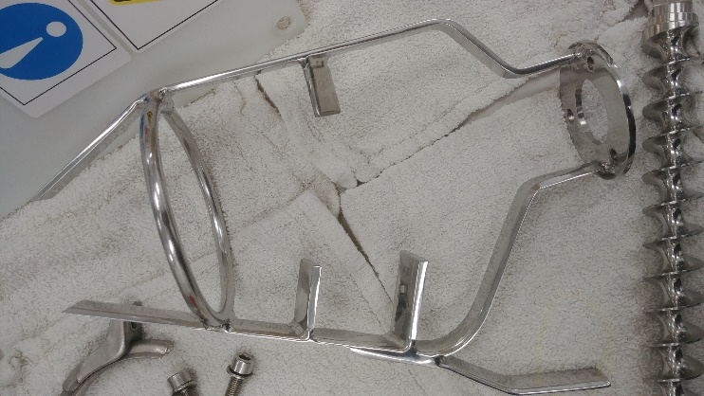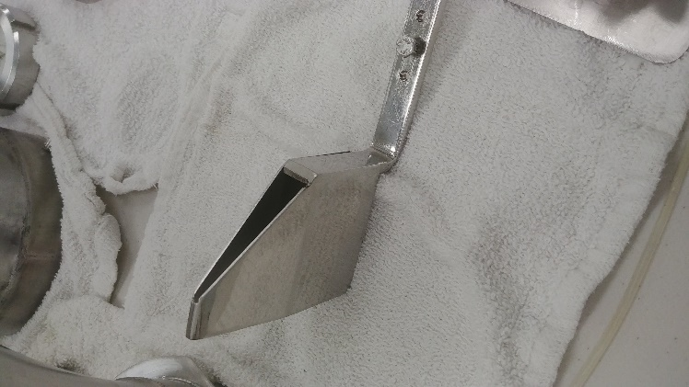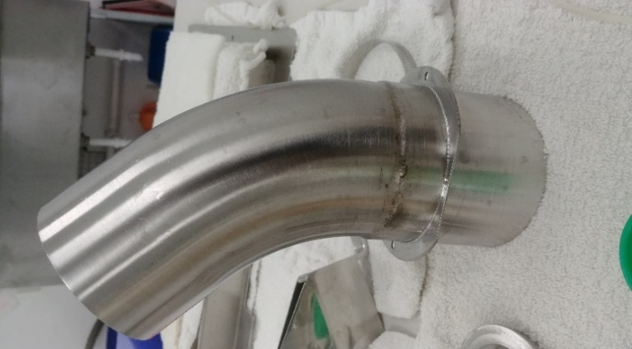
39.1.7 39.1.8 39.1.9
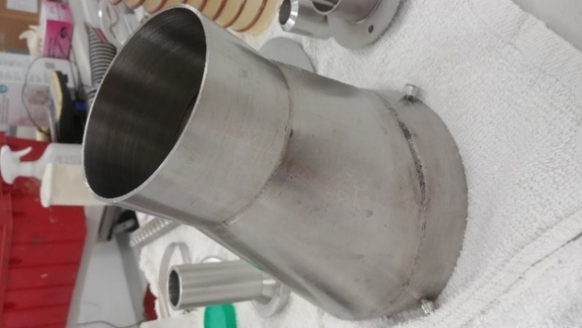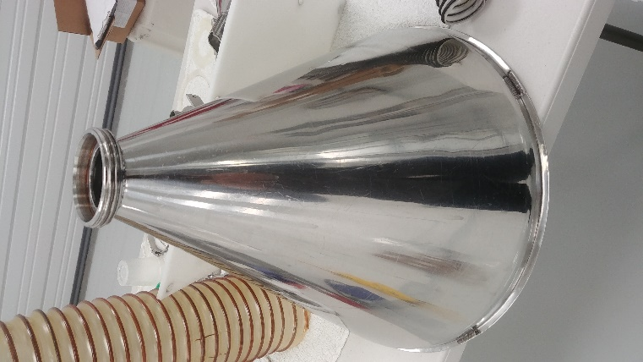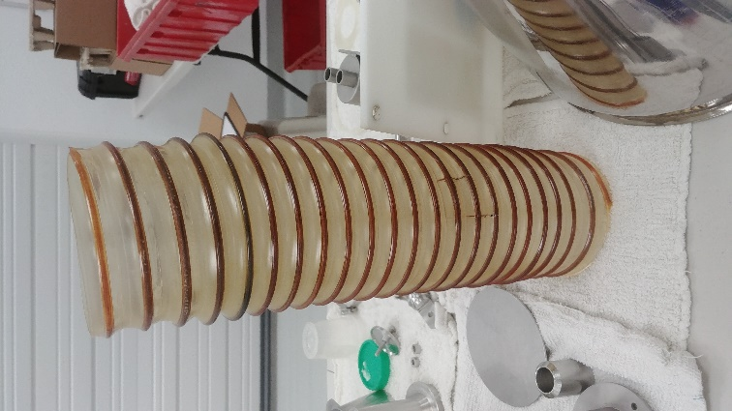

39.1.10 39.1.11
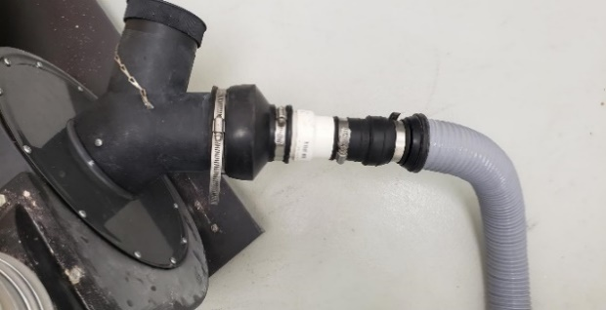

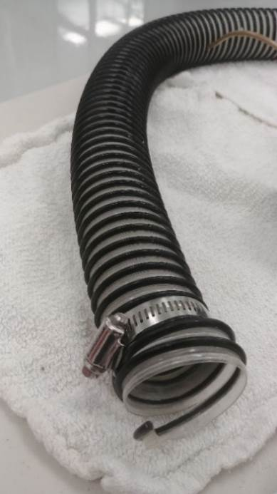

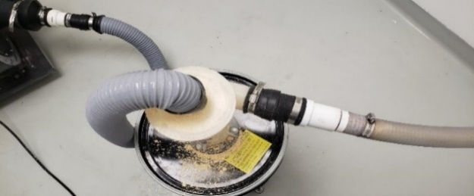
39.1.12

39.1.13 39.1.14 39.1.15
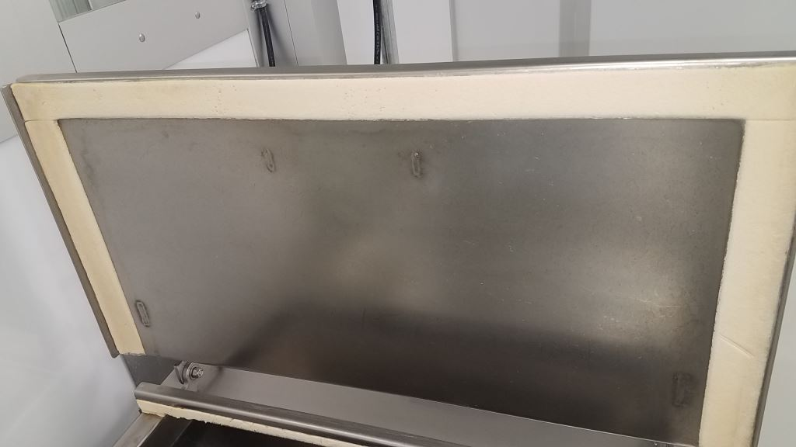
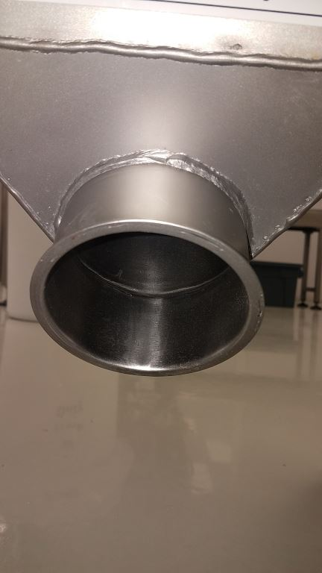
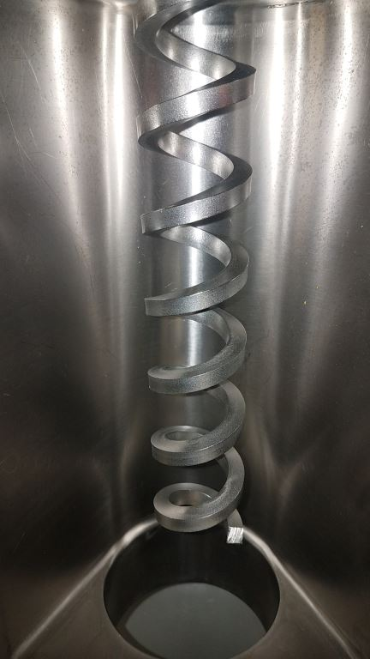

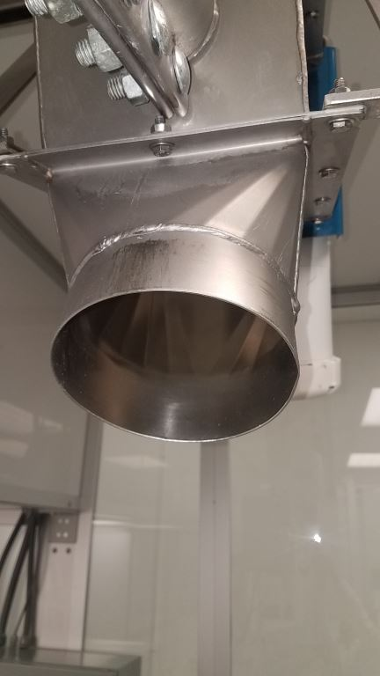
39.1.16 39.1.17 39.1.18
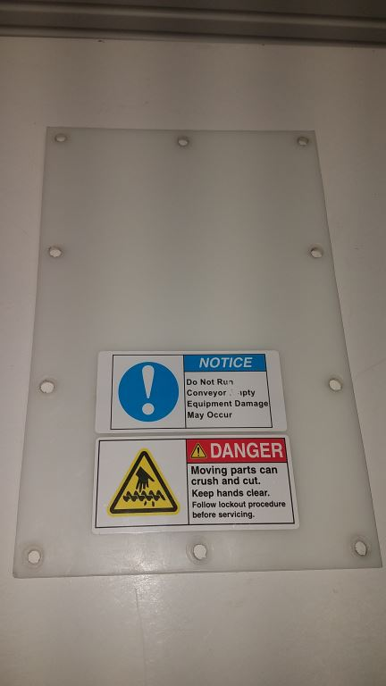
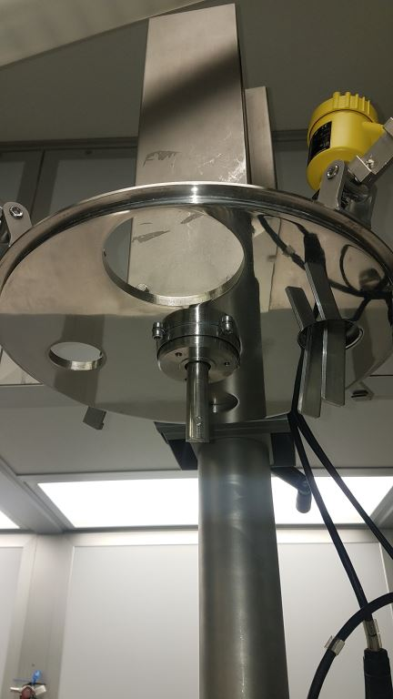

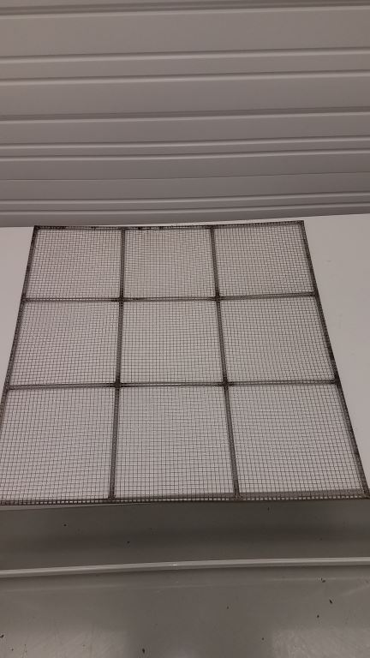
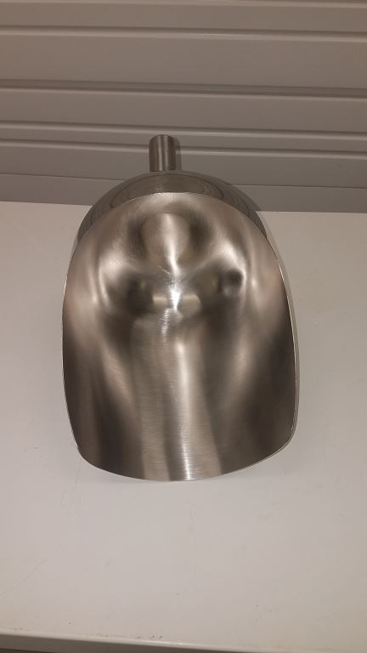
39.1.19 39.1.20 39.1.21
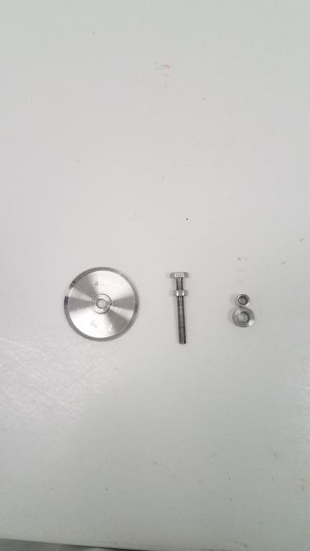

39.1.22 39.1.23 39.1.24
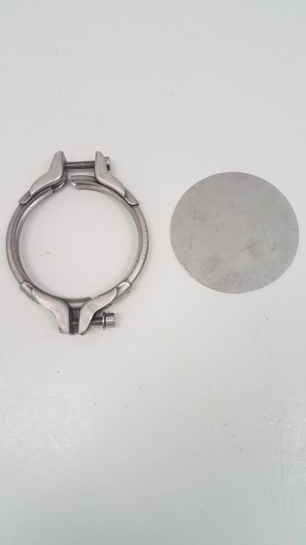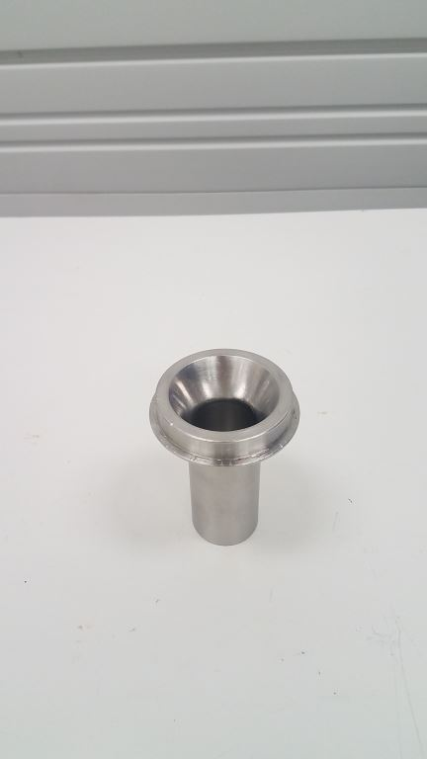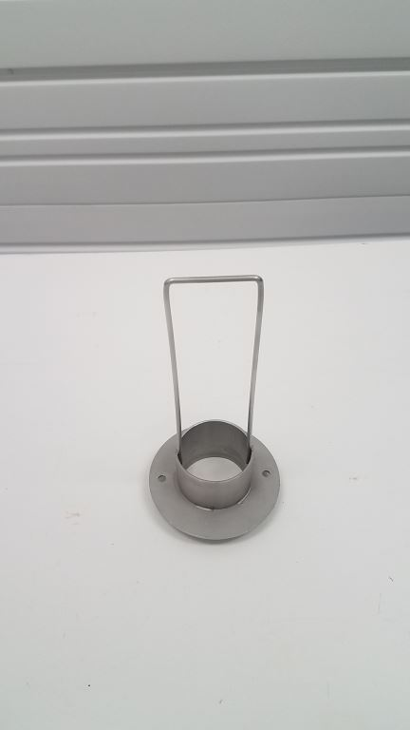

39.1.25 39.1.26
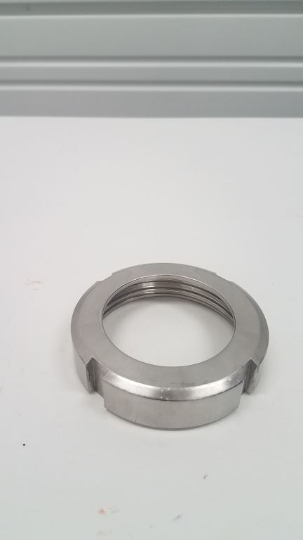
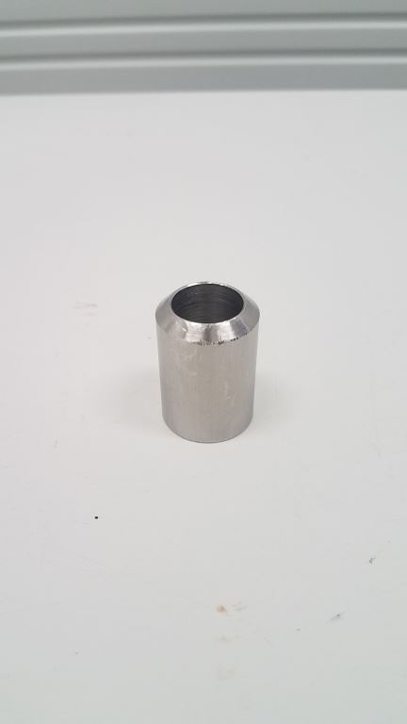

- References
  - PMI-US-SOP-003 - Microbiological Sampling Procedure for the Equipment Sterilization Audit
  - PMI-USA-SOP-004 – CAPA Program
  - PMI-US-SR-001 - Equipment Sanitization Audit for the Effytec Powder Filling Machine and the Flexicon Auger
  - PMI-USA-SR-008- Wet-Cleaning Inspection Record

50.0 History of Changes
Revision | Date Approved | Authorized Representative | Changes
1.0 | 20-Aug-2019 | L. Thurlow | New document
1.1 | 05-Jun-2020 | L. Thurlow | Updated format
1.2 | 21-Aug-2020 | P. Ardila | Updated cleaning procedures to include new chemicals to use- Perasan A and Perafoam solution, Alpha Bac Sanitizer and Neutral Scrub Cleaner.
1.3 | 16-March-2021 | P. Ardila | - Updated section 3.1 to add as part of the required PPE the N-95 Respirator
1.4 | 09-Jul-2021 | P. Ardila | -Updated section 15.0 to clarify that Solution should be prepared fresh during the day the wet clean has been scheduled.  - Updated section 18.0 to include cleaning and sanitation of the fan.  - Updated section 30.0 to clarify that is sprayed with water.  - Updated section 31.0 to clarify that is sprayed with water.  - Updated section 37.0 to clarify that is sprayed with water.
1.5 | 06-Oct-2021 | P. Ardila | -Updated section 15.1 to include that if the concentration limits are not met, Quality should be notified immediately. Also added the reference for PMI-USA-SR-008, to record the results  - Updated Section 18.0 to include that if the concentration limits are not met, Quality should be notified immediately. Also added the reference for PMI-USA-SR-008, to record the results.  - Updated section 17.0 to include that QA must perform the swabbing procedures at this stage instead of after the quat sanitizer is applied.  - Added Pictures from 39.1.13 to 39.1.26  - Updated section 27.3 to include that QA must perform the swabbing procedures at this stage instead of after the quat sanitizer is applied.
1.6 | 14-Sep-2022 | P. Ardila | - Updated section 1 and section 2 to include the auxiliary equipment as part of the wet cleaning procedures.  - Updated section 27.7 to clarify that the scoops will be included in procedure  - Added section 33.0 to include the bins and scale as part of the wet cleaning routine.
1.7 | 19-Oct-2022 | P. Ardila | - Updated the wording in sec 19.0

