RECALL PROGRAM

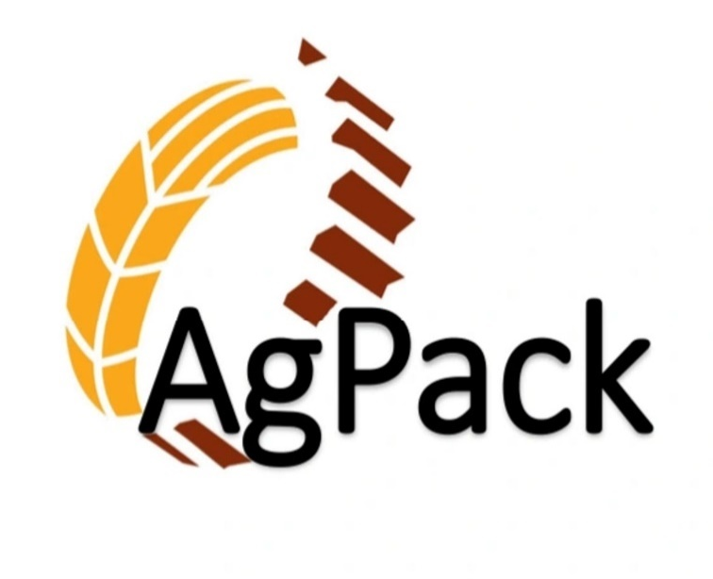

R1
1

Recall Contact List

Owner
Gerhard Van Rensburg
(Cell) 504-514-9080

Business Manager
Blake Diamond
(Cell) 256-298-2150

Quality & Nutrition Director
Malik Hashim
(Cell) 979-587-8906

Disputanta Plant
Colin Pickford
(Cell) 804-944-5128

Sanford Plant
Angela McClary
(Direct) 919‐723-7956
(Cell) 540-827-7336

Westville Plant Manager
Harold Ballou
(Direct) 539‐664‐9640 (Cell) 479-387-0760
Secondary‐Assistant Plant Manager‐Scott Hale
(Direct) 539‐664‐9640
(Cell) 918‐696‐1608
(Home) 918‐723‐3446

**Other important contact numbers can be found in the onsite Crisis Communication Plan**

2

RECALL PLAN FLOW
Notification of Problem

NO
Potential
Hazard?

Handle as regular complaint

YES

Crisis Leader Notified.
Crisis Leader assembles Crisis Communication Team. Team collects information and evaluates potential risks.

Recall?
NO

YES

Release product Keep records

Crisis Communication Team to develop Recall Strategy

Notify Regulatory Agency
Define Recall Class

Class I Recall at consumer level Prepare Press Release
Designate a Spokesperson Perform Effectiveness Checks
Class II
Recall at retail level
Class III or Market Withdrawal
Recall at wholesale level

Remove Quarantine Dispose
Remove Dispose or Correct
Remove Dispose or Correct

Recall Termination
YES
NO
Continue to perform effectiveness checks
3

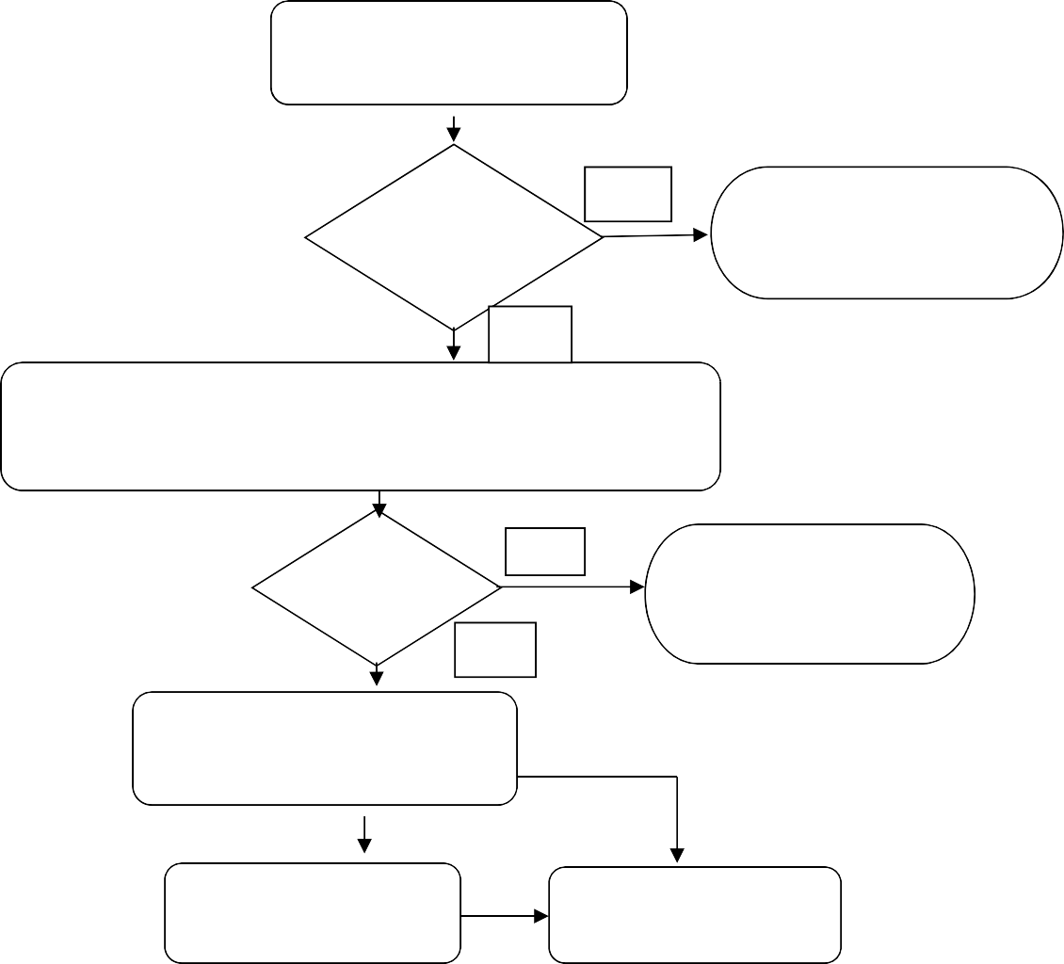
Publish final report Notify regulatory Agency

Crisis

Phone call to Crisis Leader,
( natural disaster Catastrophic e end Product
safety)

Facility manager assembles information

Crisis Communication Team

documents needed Incident report of all ingredients/products

Crisis Leader assembles team

Internal Communications Manager

Gathers information from support team acts as backup to Crisis Leader (CEO)

Prepares Public statements for CEO

Collect documents for team including facility detail and media contact sheet

Crisis Leader determines media contact (typically
division President)

Public Relations

Division President

support Team

Crisis Leader determines timing of internal and external communication

CFO - Insurance
EVP Sales & Marketing-Advisor Communications
Legal Counsel
Division President - Backup to Crisis Leader
director of Operations - Facility Information
director of HR - Personnel Information

JAT 10/03/13

STANDARD OPERATING PROCEDURE  Recall Plan | Effective Date  4/20/2021 | Number  AHN-A-102
Animal Health & Nutrition Division | Page  1 of 3 | Revision  #1

- CONCEPT
AgPack LLC. Animal Health & Nutrition division shall maintain a plan to recall product, should a situation deem necessary. The objectives are to:
- stop the distribution and sale of any affected product
- effectively notify management, customers, and regulatory authorities (as needed)
- efficiently remove effected product from the marketplace
- take action to prevent reoccurrence
All responsibilities at each step of the recall process are outlined in the Recall Program under “Recall Plant Duties”. This SOP is to define the planned steps to take when performing a recall.

- PRIOR KNOWLEDGE
The employee must read and understand the procedures on this SOP.

- SAFETY CONCERNS
No known safety concerns.

- QUALITY CONCERNS
A product recall is completed to protect animal/human health and safety.

- PROCEDURES

Problem Indication
    - All potential problems reported to AgPack LLC. shall be reviewed and investigated to determine the severity of the issue.
    - Should a problem involving a potential feed/food safety risk or company reputation issue, the Plant Manager shall contact the Crisis Leader.
    - The Crisis Leader will assemble the Crisis Communication Team.
    - Plant Manager to determine “Book Ends” via receiving records, batching records, empty bin logs, shipping records, etc.
    - Appendix A, part A to be completed by Plant Manager and distributed to Crisis Communication Team.
    - Crisis Communication Team to decide best course of action to take to verify threat, continue or cease production and who needs to be informed of the situation at this point.
    - Crisis Communication Team to decide whether a recall is warranted.
    - If no recall is needed, release the product, and keep all records.

STANDARD OPERATING PROCEDURE  Recall Plan  Animal Health & Nutrition Division | Effective Date  4/20/2021 | Number  AHN-A-102
 | Page  2 of 3 | Revision  #1

    - If recall is needed proceed to the next steps in this recall plan.

Threat Confirmation
    - Crisis Communication Team shall develop a recall strategy specific to the product being recalled and the hazards involved. (Guidelines in Appendix B).
    - Crisis Communication Team shall designate FDA contact person and AgPack Public contact person.
    - FDA contact person to notify FDA by phone and Reportable Food Registry website.
    - AgPack Public contact person to develop a media statement.
    - QA Manager will contact IT to establish a technical email group to minimize communication error. QA manager will also make a Box folder to keep track of all relevant information.

Recall Implemented
    - Crisis Communication Team to handle all public relations
    - Plant Manager to gather all needed recall information (Appendix A, part B) and distribute to Crisis Communication Team.
    - Sales Manager to inform customers and or suppliers of the nature of the problem by phone.
    - AgPack designated Public Contact person to generate a letter to customers with details of the recall. Product, Individual Bill of Lading numbers, date loads were delivered and weights.
    - Crisis Communication Team to devise a failsafe method to track and account for all recalled material.
    - Local Manager to arrange schedule to remove the recalled product from all customer facilities and route to predetermined site.
    - Local Manager to quarantine, dispose, or correct the recalled material following FDA guidelines and Crisis Communication Team strategy.
- Accounting to devise coding and communicate to all involved personnel of the system to track expenses involved.
- Operations to reallocate finished feed production to unaffected plants as needed
- Purchasing department to reroute inbound raw materials destinations to unaffected plants as needed
- Credits issued for material picked up at customer sites
- Crisis Communication Team to fully account for expenses involved.

STANDARD OPERATING PROCEDURE  Recall Plan  Animal Health & Nutrition Division | Effective Date  4/20/21 | Number  AHN-A-102
 | Page  3 of 3 | Revision  #1

- Crisis Communication Team to fully account for all recalled material
- East Operations Manager and QA Manager to perform Root Cause Analysis study and implement measures to prevent future occurrence.

Termination of Recall
A recall will be terminated when FDA and the recalling firm agree that the product subject to the recall has been properly removed and correctly handled.

Mock Recall
A mock recall shall be performed at least annually per procedures defined in the Mock Recall SOP. All documents shall be kept according to corporate guidelines.

Record Retention Policy
All records regarding a recall or a mock recall shall be kept according to corporate guidelines.
- TRAINING DOCUMENTATION

Employee Name Date of Training/Certification Signature verifying trainee
has read and understands SOP

- REVISION HISTORY

REVISION NUMBER | DATE | ORIGINATOR | REASON
R1 | 4/20/2021 | Harold Ballou | Develop a written procedure

APPENDIX A PRODUCT RECALL FORM
Date:

Plant Location:

INFORMATION FOR RECALL DESCISION

  - What is the product?

  - What is the source of the complaint? Name:

Company:

Address:

Telephone:

Fax:

  - When was the complaint received?

  - What is the reason for the complaint?

  - What tests have been carried out that support the complaint?

  - Detailed Information about product involved. Product:

Invoice Number:

Bill of Lading:

Date of Manufacture: Date of Delivery:
1

Quantity:

Disposition of product:

  - Information on raw material. Suppliers:

Quantity in finished product:

Quantity still on hand:

Disposition of product on hand:

RECALL INFORMATION

  - Number of loads and tonnage affected

  - Customers affected and how much product exists on hand

  - Name and contact information for the person contacted to stop selling the product.

  - Destination for recalled product

  - Recalling duration
    - Start Time-
    - Finish Time-

  - Depth of the recall
Class I
Class II
Class III Comments-
  - Were all Customers notified?

  - Was all recalled product accounted for?

2

APPENDIX B
21CFR Section 7.42 Recall Strategy

GENERAL
  - A recall strategy that considers the following factors will be developed by the agency for a Food and Drug Administration- requested recall and by the recalling firm for a firm- initiated recall to suit the individual circumstances of the recall:
    - Results of health hazard evaluation.
    - Ease in identifying the product.
    - Degree to which the product’s deficiency is obvious to the consumer or user.
    - Degree to which the product remains unused in the market-place.
    - Continued availability of essential products.
  - The Food and Drug Administration will review the adequacy of a proposed recall strategy developed by a recalling firm and recommend changes as appropriate. A recalling firm should conduct the recall in accordance with an approved recall strategy but need not delay initiation of a recall pending review of its recall strategy.

ELEMENTS OF A RECALL STRATEGY
A recall strategy will address the following elements regarding the conduct of the recall:
  - Depth of recall- Depending on the product's degree of hazard and extent of distribution, the recall strategy will specify the level in the distribution chain to which the recall is to extend, as follows:
- Consumer or user level, which may vary with product, including any intermediate wholesale or retail level; or
- Retail level, including any intermediate wholesale level; or
- Wholesale level.
  - Public warning- The purpose of a public warning is to alert the public that a product being recalled presents a serious hazard to health. It is reserved for urgent situations where other means for preventing use of the recalled product appear inadequate. The Food and Drug Administration in consultation with the recalling firm will ordinarily issue such publicity. The recalling firm that decides to issue its own public warning is requested to submit its proposed public warning and plan for distribution of the warning for review and comment by the Food and Drug Administration. The recall strategy will specify whether a public warning is needed and whether it will issue as:
- General public warning through the general news media, either national or local as appropriate, or

1

- Public warning through specialized news media, e.g., professional or trade press, or to specific segments of the population such as physicians, hospitals, etc.
  - Effectiveness check- The purpose of effectiveness checks is to verify that all consignees at the recall depth specified by the strategy have received notification about the recall and have taken appropriate action. The method for contacting consignees may be accomplished by personal visits, telephone calls, letters, or a combination thereof. The recalling firm will ordinarily be responsible for conducting effectiveness checks, but the Food and Drug Administration will assist in this task where necessary and appropriate. The recall strategy will specify the method(s) to be used for and the level of effectiveness checks that will be conducted, as follows:
- Level A--100 percent of the total number of consignees to be contacted;
- Level B--Some percentage of the total number of consignees to be contacted, which percentage is to be determined on a case-by-case basis, but is greater that 10 percent and less than 100 percent of the total number of consignees;
- Level C--10 percent of the total number of consignees to be contacted;
- Level D--2 percent of the total number of consignees to be contacted; or
- Level E--No effectiveness checks.

RECALL CLASS DEFINITIONS

Recalls are actions taken by a firm to remove a product from the market. Recalls may be conducted on a firm's own initiative, by FDA request, or by FDA order under statutory authority.

  - Class I recall: a situation in which there is a reasonable probability that the use of or exposure to a violative product will cause serious adverse health consequences or death.

  - Class II recall: a situation in which use of or exposure to a violative product may cause temporary or medically reversible adverse health consequences or where the probability of serious adverse health consequences is remote.

  - Class III recall: a situation in which use of or exposure to a violative product is not likely to cause adverse health consequences.

  - Market withdrawal: occurs when a product has a minor violation that would not be subject to FDA legal action. The firm removes the product from the market or corrects the violation. For example, a product removed from the market due to tampering, without evidence of manufacturing or distribution problems, would be a market withdrawal.

2

STANDARD OPERATING PROCEDURE  Mock Recall | Effective Date  4/20/2021 | Number  AHN-A-103
Animal Health & Nutrition Division | Page  1 of 2 | Revision  #1

- CONCEPT
AgPack LLC. Animal Health & Nutrition division shall perform a mock recall at least annually per procedures defined in this SOP.

- PRIOR KNOWLEDGE
The employee must read and understand the procedures on this SOP.

- SAFETY CONCERNS
No known safety concerns.

- QUALITY CONCERNS
A mock recall is completed to determine the effectiveness of the recall plan.

- PROCEDURES
  - A Mock Recall will be performed at least annually in the Animal Health & Nutrition Division.
  - The Quality Assurance Manager will determine the plant and scenario that is to be used to test the effectiveness of the recall plan.
  - All correspondence during the Mock Recall must be labeled “MOCK RECALL”
  - A full report of the Mock Recall is to be written and distributed.
  - The report must outline the following categories: Exercise, Results, Challenges, Weaknesses, and Corrective Actions.
  - Any major problems identified during the Mock Recall shall be corrected and repeated within a reasonable time frame.
  - All records are to be kept of mock recalls as per corporate guidelines.

- TRAINING DOCUMENTATION

Employee Name Date of Training/Certification Signature verifying trainee
has read and understands SOP

STANDARD OPERATING PROCEDURE  Mock Recall  Animal Health & Nutrition Division | Effective Date  4/20/2021 | Number  AHN-A-103
 | Page  2 of 2 | Revision  #1

- REVISION HISTORY

REVISION NUMBER | DATE | ORIGINATOR | REASON
R1 | 4/20/2021 | Harold Ballou | Develop a written procedure

