- Purpose: The purpose of the Sanitation SOP’s is to provide Miller sanitation personnel the procedures to safely and effectively clean the facility and equipment.

- Scope: Repak RE20 Horizontal Form Fill and Seal Machines (HFFS)

- Definitions
  - Top film: Film located centrally on the machine that is used to seal packages
  - Forming Film: Film located at the lower infeed of the machine that is formed into a pocket.
  - Sealing Box: Section in middle of machine where vacuum is pulled on the package and the top film is sealed to the forming film

- Responsibilities
  - Sanitarian: Clean, rinse, and sanitize the equipment
  - Pre-op Personnel: Visually inspect, swab, reclean if necessary
  - VP of Administration: Assure adherence to sanitation SOP’s and related documentation. Review and update as necessary.

- Procedure
  - Put on the appropriate PPE for the sanitation chemicals in use
  - Turn off machine power. Turn off air to machine. No external vacuum pump.
  - Remove package trim from vacuum cannister at discharge of machine and dispose.
  - Put bag over top and forming film rolls, HMI and vacuum cannister.
    - 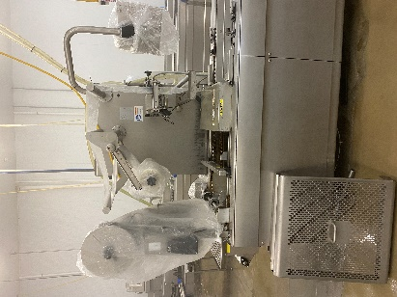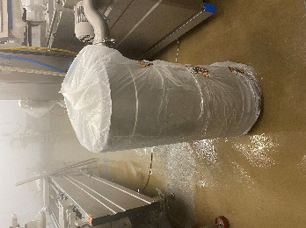

  - Remove forming dies and store on cart outside packaging room
  - Remove guarding and place on table for rinsing, foaming, wiping and rinsing.
    - 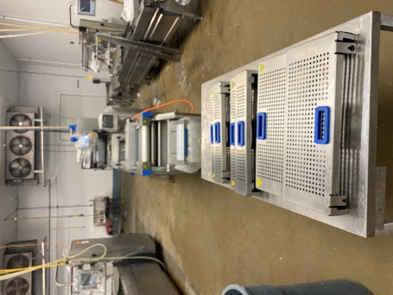
  - Put a plastic bag over sealing box. No forming box to cover.
    - 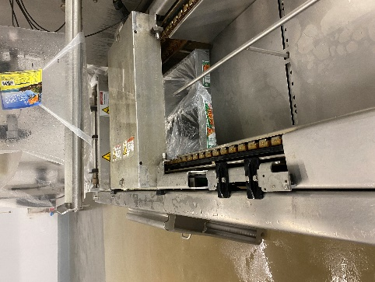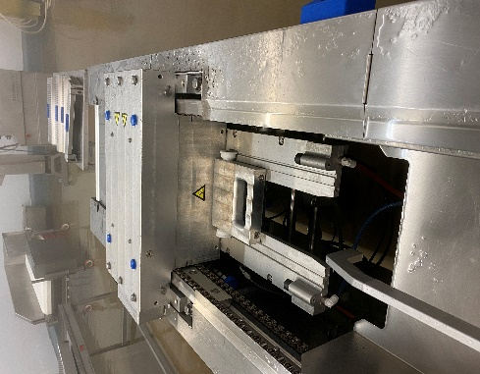

  - Scrape major debris from frame and rails.

  - Rinse frame, rails, and guards with hot, low pressure water from the top to the bottom.

  - Foam frame, rails, and guards with Enrich 299 at the recommended concentration.
    - 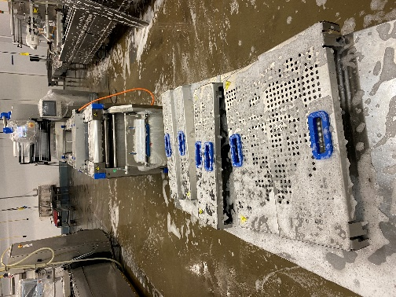
  - Handwipe frame, rails, and guards with a single use scratch pad or white bristled brush.
  - Rinse frame, rails, and guards with low pressure, hot water.
  - Visual inspection using flashlight to ensure the cleanliness of equipment’s and parts before sanitizing. (If found food residues, reclean as needed)
  - Sanitize frame, rails, and guards with Multi-Quat at the recommended concentration.
  - Remove bags from film rolls, HMI, vacuum cannister and sealing box. Put dry bags over film rolls.
  - Handwipe sealing box with Multi-Quat.
  - Pre-op personnel reassemble guards, visually inspect, swab, and reclean if necessary.
- Weekly Perasan A Mixing Procedure & measurements.
    - To mix please use the following based on 25 gallons of water:
    - Perafoam- Mix 6 ounces every 6 gallons of water. (20 ounces total)
    - Perasan A- Mix 1 ounces for every 6 gallons of water (4 ounces total)
    - Titrate using the Perasan A testing procedure, target is 91-195ppm of Perasan A.
.(+/- 13ppm)
  - Sanitize frame, rails, and guards with Perasan A.
  - Remove bags from film rolls, HMI, vacuum cannister and sealing box. Put dry bags over film rolls.
  - Handwipe sealing box with Perasan A.
  - Pre-op personnel reassemble guards, visually inspect, swab, and reclean if necessary.

- Records
  - Pre-op checklist to include Charm unit swab record.
  - Master Sanitation Plan

- Document History
REVIEWED: | PROPOSED CHANGE:
Roland Pilar Dated:12/7/2021 | Removed Indosan 485 changed to Multi-Quat.  Added Visual inspection using flashlight to ensure the cleanliness of equipment’s and parts before sanitizing. (If found food residues, reclean as needed)
Roland Pilar 6/27/2022. | 6.0-Weekly Perasan A Mixing Procedure & measurements.  6.1.1-To mix please use the following based on 25 gallons of water:  6.1.2-Perafoam- Mix 6 ounces every 6 gallons of water. (20 ounces total)  6.1.3-Perasan A- Mix 1 ounces for every 6 gallons of water (4 ounces total)  6.1.4-Titrate using the Perasan A testing procedure, target is 91-195ppm of Perasan A.  6.1.5-Sanitize frame, rails, and guards with Perasan A.  6.1.6-Remove bags from film rolls, HMI, vacuum cannister and sealing box. Put dry bags over film rolls.  6.1.7-Handwipe sealing box with Perasan A.  6.1.8-Pre-op personnel reassemble guards, visually inspect, swab, and reclean if necessary.
Roland Pilar 9/28/2022 | Added Perasan A mixing procedure & measurement.
Roland Pilar / Alfredo Robles 03/15/2023 | Added SSOP number

