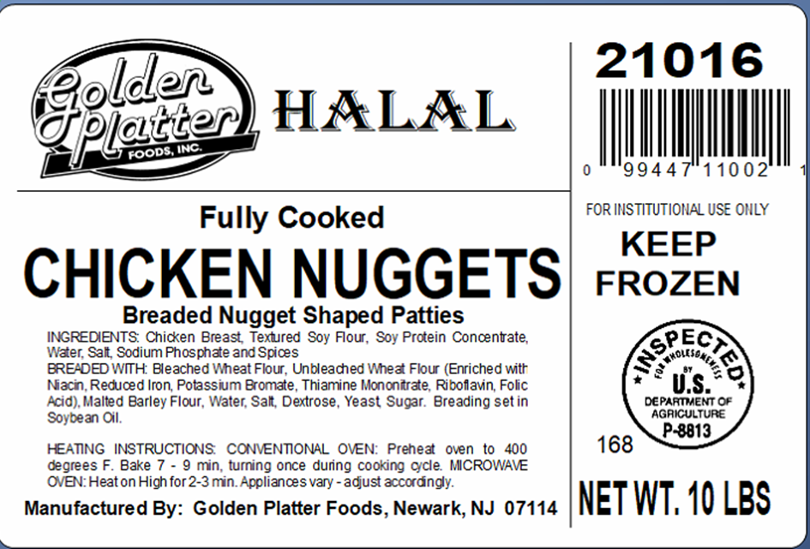

Product Details
ITEM Fully Cooked Halal Chicken Breaded Nuggets

CODE# 21016

DESCRIPTION Fully Cooked Halal Breaded Nuggets.

INGREDIENTS Chicken Breast, Texture Soy Flour, Soy Protein Concentrate, Water, Salt, Sodium, Phosphate and Spices. BREADING & BATTER INGRIDIENTS: Bleach Wheat Four, Unbleached Wheat Flour (Enriched with Niacin, Reduced Iron, Potassium Bromate, Thiamine Mononitrate, Riboflavin, Folic Acid), Malted Barley Flour, Water, Salt, Dextrose, Yeast, Sugar. Breading set in Soybean Oil.

Product Specification_____________________________________________________
Case Weight 10 lbs.
Bag/Case 1

Shelf Life
Total Shelf Life 1 year from production
Minimum Shelf Life 10 months
To Warehouse

Storage
STORAGE Frozen
SHIPPING REQUIREMENTS Keep Frozen

Claims/Certifications
CLAIMS Fully Cooked
No Preservatives
0g Trans Fat/Serving
No Hormones Added
KOSHER/HALAL Halal

REGULATORY USDA Inspected
Good Manufacturing Practices

Physical Properties
 | Min Temp | Target | Reject/Fail Criteria
Color | Ongoing Visual | Light Golden Brown  A or B on Color Chart | Out of spec
Aroma/Flavor | QA Sampling | No off odor/flavor | An off odor/flavor
Foreign Material | Ongoing | Avoided | Out of spec
Metal Detection | Ongoing | Ferrous Standard: 2.5 mm  Non-Ferrous Standard: 2.5 mm  Stainless Steel Standard: 4.0 mm | Out of spec
Net Weight | Constant Monitoring | USDA Requirements | Less than USDA standards
Nugget Shape | QA Test | Plate determines shape | Wrong plate utilized
Nugget Size | QA Test | 0.6 oz. | Wrong plate utilized
Batter/Breading | QA Test | 20-22% | + / - 2%

Microbiological Properties
Test | Limits
Aerobic plate count | <100
Listeria Spp. | Negative
Salmonella | Negative
E.Coli | Negative

Allergens
ALLERGENS Product contains egg, gluten and soy

Labeling
LABELING Case label contains the flowing:
- Inspection Legend: P-8813
- Item description:
- Net Weight of Case: 10 Lbs.
- Keep Frozen
- Ingredients
- Manufactured By: Golden Platter Foods, Newark, NJ 07114
- Production Date

LOT/DATE CODE Product must have clearly printed, proper Lot/Date Code on label.

CONSUMER INFORMATION Product contains Heating Instructions

UPC UPC Printed on Package

Nutritional Information
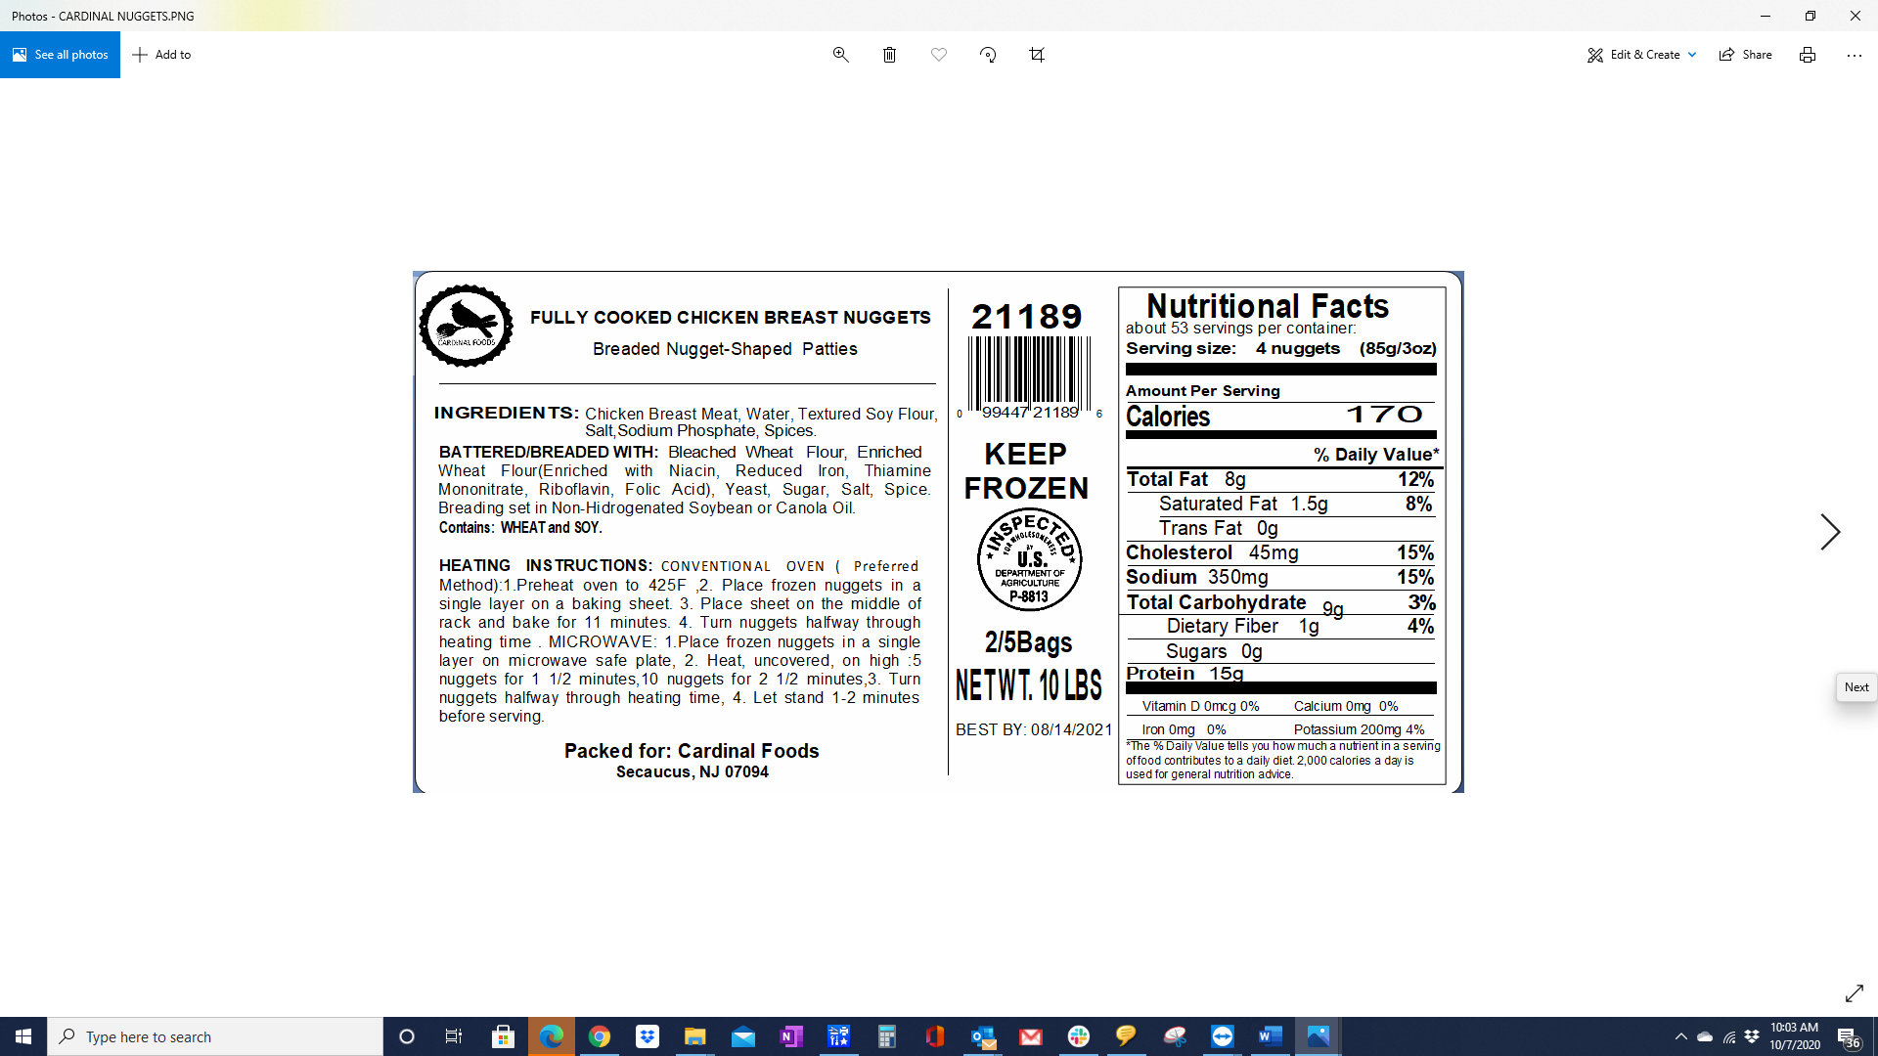

Formulation

INTERNAL FORMULATION # FC- 003WG

FORMULATION Proprietary

