Product Details
ITEM Fully Cooked Halal Chicken Breaded Nuggets

CODE# 21016

DESCRIPTION Fully Cooked Halal Breaded Nuggets.

INGREDIENTS Chicken Breast, Texture Soy Flour, Soy Protein Concentrate, Water, Salt, Sodium Phosphate, Onion Powder, Garlic Powder, and Spices. BREADING & BATTER INGRIDIENTS: Bleached Wheat Flour, yeast, sugar, salt, Enriched wheat flour (enriched with niacin, reduced iron, thiamine mononitrate, riboflavin, folic acid), salt spice. Breading set in Soybean Oil.

Product Specification_____________________________________________________
Case Weight 10 lbs.
Bag/Case 1

Shelf Life
Total Shelf Life 1 year from production
Minimum Shelf Life 10 months
To Warehouse

Storage
STORAGE Frozen
SHIPPING REQUIREMENTS Keep Frozen

Claims/Certifications
CLAIMS Fully Cooked
No Preservatives
0g Trans Fat/Serving
No Hormones Added
KOSHER/HALAL Halal

REGULATORY USDA Inspected
Good Manufacturing Practices

Physical Properties
 | Min Temp | Target | Reject/Fail Criteria
Color | Ongoing Visual | Light Golden Brown  A or B on Color Chart | Out of spec
Aroma/Flavor | QA Sampling | No off odor/flavor | An off odor/flavor
Foreign Material | Ongoing | Avoided | Out of spec
Metal Detection | Ongoing | Ferrous Standard: 2.5 mm  Non-Ferrous Standard: 2.5 mm  Stainless Steel Standard: 4.0 mm | Out of spec
Net Weight | Constant Monitoring | USDA Requirements | Less than USDA standards
Nugget Shape | QA Test | Plate determines shape | Wrong plate utilized
Nugget Size | QA Test | 0.6 oz. | Wrong plate utilized
Batter/Breading | QA Test | 20-22% | + / - 2%

Microbiological Properties
Test | Limits
Aerobic plate count | <100
Listeria Spp. | Negative
Salmonella | Negative
E.Coli | Negative

Allergens
ALLERGENS Product contains wheat and soy

Labeling
LABELING Case label contains the flowing:
- Inspection Legend: P-8813
- Item description:
- Net Weight of Case: 10 Lbs.
- Keep Frozen
- Ingredients
- Manufactured By: Golden Platter Foods, Newark, NJ 07114
- Production Date

LOT/DATE CODE Product must have clearly printed, proper Lot/Date Code on label.

CONSUMER INFORMATION Product contains Heating Instructions

UPC UPC Printed on Package

Nutritional Information
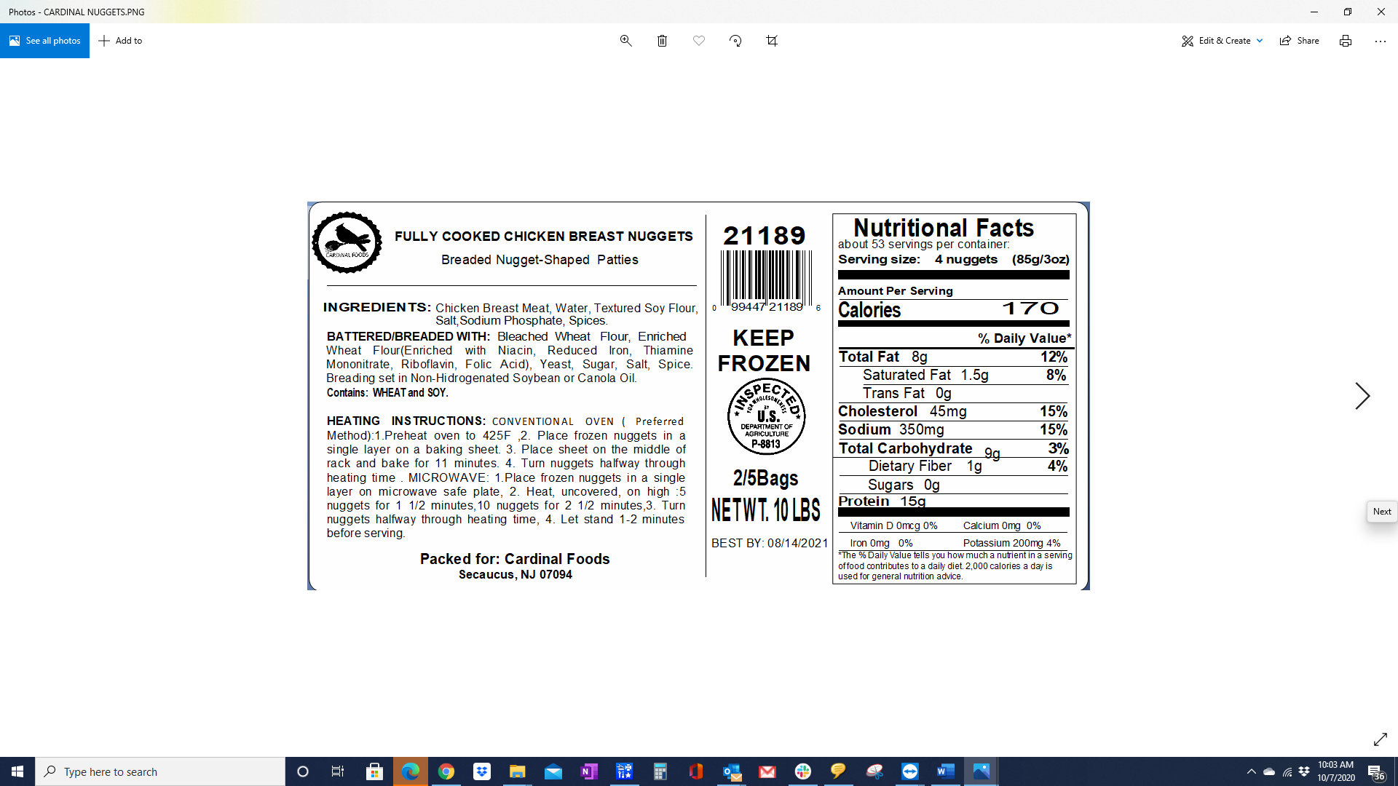

Formulation

INTERNAL FORMULATION # FC- 003WG

FORMULATION Proprietary

