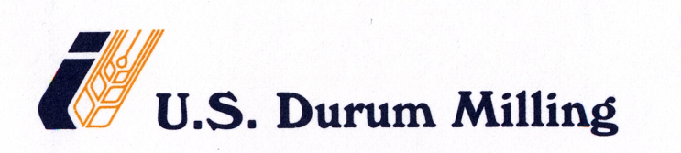

HAIR CONTROL POLICY

A risk assessment has been conducted for the possibility of hair entering into the ﬂour during various stages of the process like manufacturing, storage, transporting etc. Products are manufactured at our mill mostly in closed processing conditions. It is a totally automated mill and during the manufacturing process the raw material ﬂour that is being manufactured gets very little or no contact by the mill employees. Automated processing conditions of the mill help to minimize or totally eliminate the potential chances of hair entering into the product that is being shipped.

Evaluating from the past performance perspective, there was not a single incidence or any sort of
customer complaint nor a shipment rejected due to hair being found in our shipments.

Strict implementation of the GMPs along with effective sanitation program in place is the basis
for establishing this hair control policy.

