Prepared by: Vic F.  Date: 3-15-16 |  |  | Approved by:  Date:
Rev | Section | Brief Description of Change |  | Effective Date
01 | All | Initial release, include facility map to specify trap /service location.

- Purpose:
This procedure defines the procedures and processes CCMI shall employ to prevent damage, deterioration, contamination or other adverse effects on product quality due to pest control.
- Scope:
This procedure applies to all CCMI storage areas, stock rooms, and manufacturing areas used in the manufacture of CCMI products.
- Responsibility:
CCMI employees will regularly inspect their work areas for mice, insect or other pests. Sanitation will be notified of any infestation. CCMI employees will regularly inspect their work areas for cleanliness. Corrections will be made as needed. The approved pest control supplier will maintain all interior and exterior pest control measures. Sanitation is responsible for routine cleaning of all work areas and for the management of pest control services.
- Pest Control
  - Rodent Control
    - CCMI pest control service provider shall place traps in areas specified on the Pest Control Placement Map. Trap # / location and service will be listed as service contract.
    - The quantity and location of the traps will be clearly stated and accounted for.
    - Each trap is clearly marked with the date and time it is placed into service.
    - The Sanitation department shall inspect traps on a weekly basis. Traps needing replacement or the need for additional traps shall be reported to the pest control supplier.
    - The approved pest control supplier shall inspect the traps at least quarterly. Traps that are in good condition will be reused. The supplier shall replace all damaged traps. See ( 17 ) trap map.
    - Pest control service provider shall provide a report of all service performed. Pest control co. will be requested to provide an annual audit of entire facility to assess areas of pest concern.
  - Dead Rodent Removal
    - With latex gloved hands, any dead rodent or other small animal found either in a trap or outside the building shall be immediately picked up, placed into a plastic bag, and placed in the trash dumpster. Used gloves will be disposed afterwards followed by thorough hand washing with cleaner.
  - Miscellaneous Insects and Other Pests
    - Pest control service shall be provided for the exterior on at least a quarterly basis and for the interior as needed. Interior spraying will not occur on or around product. Insect control / tools that attracts insect as a means to congregate / control insect will be allowed inside the facility.
    - The pest control supplier shall spray for insects using approved insecticides. Information of insecticides will be kept on file.
    - CCMI employees shall notify CCMI Sanitation if any infestation of insects or other pests are noted.
      - Sanitation personnel will alert management to immediately schedule pest control service provider
      - The pest control supplier should complete their service within 24 hours following a service request.
    - The pest control supplier shall document all visits.
- Housekeeping
  - All storage facilities that warehouse components shall be routinely cleaned and maintained to prevent contamination of material.
  - All buildings must be kept clear of pests including birds, rodents and insects.
    - Windows are to be kept closed so as to restrict entry by birds and insects.
    - Pest deterrence hardware shall be maintained in each building as necessary so as to inhibit pest entry.
    - Doors shall be kept closed while building is idle to prevent pest entry.
    - A regular pest control service shall be maintained so as to prevent rodent nesting and insect infestation.
  - All building floors shall be swept at least weekly.
    - Brooms, dust mops, and floor sweep material shall be used to maintain cleanliness of each building.
    - No loose material (dust, dirt, debris) shall be allowed to build up on floor surfaces.
    - The tops of material containers shall be kept free of dust and debris.
    - The building shall be kept free of cobwebs.
  - CCMI employees shall inspect their work area on a regular basis. Any findings shall be corrected or reported to Sanitation.
  - Only equipment and materials required for the performance of a process or processes are to be present in the processing area before and during a process.
  - All unused materials and equipment shall be removed from the process area upon completion of the process and shall be placed in appropriate storage areas.
  - Trash and organic waste in and from each building and immediate premises shall be held and disposed of in a safe, timely and sanitary manner.
- Record Retention
  - QA shall maintain all pest control service / report records for a period of 3 years

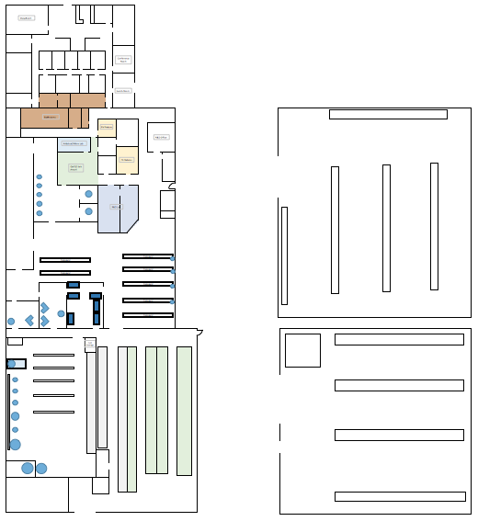
1
13
BLDG 3
14
4
5
17
16
7
QC
RM
BLDG 2
15
12
10
11
9
8
6
3
2

