- Purpose: The purpose of the Sanitation SOP’s is to provide Miller sanitation personnel the procedures to safely and effectively clean the facility and equipment.
- Scope: TREES RACK

- Definitions: None

- Responsibilities
  - Sanitarian: Clean, rinse, and sanitize the equipment
  - Pre-op Personnel: Visually inspect, swab, reclean if necessary.
  - VP of Administration: Assure adherence to sanitation SOP’s and related documentation. Review and update as necessary.

- Procedure
  - Move all trees rack and rods to the wash room.
  - Put on the appropriate PPE for the sanitation chemicals in use.
  - Rinse Trees rack and rods with warm water from top to bottom this includes the trees wheels.
  - For Rods, soak with Enrich 299 at the recommended concentration in the gondolas for approx. 10-15 minutes.
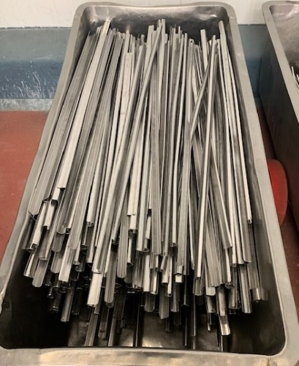
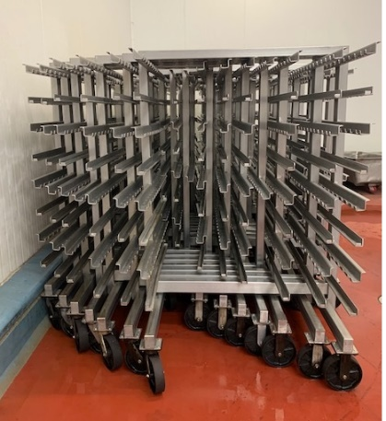
  - For Rods, take out rods from gondola’s and move to other gondolas for rinsing to remove chemical residues and apply sanitizer Multi-Quat at the recommended concentration and let it air dry.
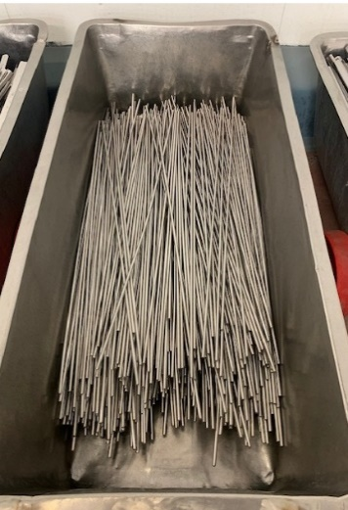
  - Foam the Trees rack with Enrich 299 at the recommended concentration.
  - For Trees Only “Use scratch pad or white bristled brush to remove build up food residues, if necessary.
  - Rinse the Trees rack with warm pressure water and or sanitation water hose to wash down to remove chemical residues.
  - Visual inspection using flashlight to ensure the cleanliness of Trees rack
(If found food residues, reclean as needed)
  - Sanitize The Trees rack with Multi-Quat at the recommended concentration.
  - Move Trees rack to cleaned area and let it air dry.
  - All rods stay in the gondolas.

- Records
  - Pre-op checklist to include Charm unit swab record.
  - Master Sanitation Plan

- Document History

REVIEWED: | PROPOSED CHANGE:
Roland Pilar / Alfredo Robles 03/15/2023 | Added SSOP number

