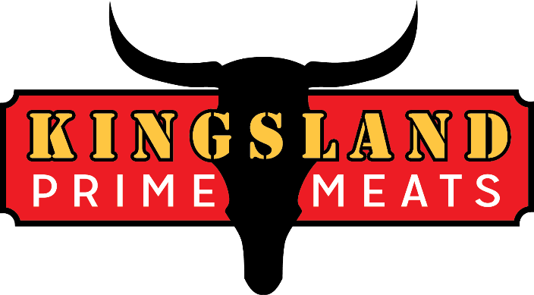
10 Squirrelwood Road
Woodland Park NJ, 07424
Tel: 862 239-9401
Fax: 862 239-9403
Kingslandprimemeats@gmail.com
Plant Number: 5067

7/17/24

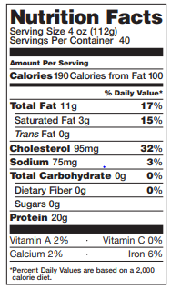
Halal Ground Turkey – 10 Lb. Chub

- All natural, gluten free
- Lean – 90%
- Traditional Grind
- No added hormones or steroids
- Halal Turkey from Certified Farms

Product Code – HGT1
Product shipped frozen
Packing – 2 x 10-pound chubs, 20 pound box
Palletization – 100 boxes per 40 x 48 pallet
Frozen Shelf Life – 300 days, Store at 0 degrees or colder

Product Description: Raw Ground Turkey Consisting of Halal White Meat and Dark Turkey

Ingredients: Halal Turkey

