SAFE FEED SAFE FOOD



Disputanta, VA
SECTION:
- GENERAL POLICY
- HAZARDS
- AUDIT
- TESTING
- RECORDS
- INSPECTIONS
- FDA FACILITY REGISTRATION
- PEST CONTROL PROGRAM
- QIF PROGRAM
- FINISHED PRODUCTS
- RECALL PROGRAM
- JOB DESCRIPTIONS
- RAW INGREDIENTS
- QUARTERLY QUALITY REPORTING

SECTION 1
GENERAL POLICY
SECTION 1:
- Mission Statement
- QA & HAACP Team
- Feed Safety Plan
- AH&N Reporting structure
- Current Good Manufacturing Practice
- Feed Defense Protocol
♦♦♦ Quality Assurance Assay list
- Ingredient Acceptance flow
- Finished Product Release flow
- SF/SF Review
- Product Development
- Formulation Request
- Contract Services
- Approved Carriers
- Definitions


FEED SAFETY MISSION STATEMENT
AgPack LLC, Inc. is a name synonymous with dependability and excellence. Customers expect value, quality and responsiveness from AgPack.
It is our mission at AgPack’s Animal Health & Nutrition Division to not only provide a quality product, but a safe product as well. We strive to do this by implementing many quality assurance programs such as; AFIA’s Safe Feed/Safe Food guidelines, Statistical Process Control, Enhanced Operator training with Standard Operating Procedures, a vigorous Quality Assurance Testing Program, and a monitored Sanitation Housekeeping Program.
We are committed to providing a safe, quality product to our customers where each process step is scrutinized for quality and safety.

Gerhard van Rensburg - Animal Health & Nutrition

QA & HACCP TEAM
DIRECTOR OF OPERATIONS- GERHARD VAN RENSBURG
EAST OPERATIONS MGR.- BLAKE DIAMOND
DIRECTOR OF NUTRITION, SCIENCE & TECHNOLOGY- MALIK HASHIM QUALITY ASSURANCE MGR.- HAROLD BALLOU
DISPUTANTA PLANT MANAGER- GERHARD VAN RENSBURG
DISPUTANTA ASSISTANT PLANT MANAGER- COLIN PICKFORD
FEED SAFETY PLAN


This Feed Safety Plan is to serve as an outline of the steps taken to ensure the safety of our finished product. The steps described within are applicable to Animal Health & Nutrition Division of AgPack.
Hazard Analysis
Each facility will conduct a hazard analysis of each processing step in their facility. Each hazard analysis will contain a flow diagram of the process. Each processing step will be analyzed for hazards that are reasonably likely to occur and are relevant to that particular step. These defined hazards are introduced, controlled, or enhanced at the processing step. Within the hazard analysis, each hazard that is defined will'have a stated control measure for that hazard. Additional controls needed will also be defined for each hazard. The hazard analysis will be reviewed and approved by the QA Manager.
Risk Based Preventative Controls
For each hazard that is identified by the facility, risk based preventative controls will be put into place. These controls are to eliminate or reduce the hazard to an acceptable level.
Recall Plan
An Animal Health & Nutrition Division Recall Plan will be documented and implemented and is applicable to all facilities. This plan will outline the responsibilities and methods used to withdraw or recall product. This plan identifies those that are responsible for initiating, managing, and investigating a product withdrawal or recall. An annual test of this system will be performed to test the strength of the plan. If any severe deficiencies are noted during the test corrective actions must be taken and the test is to be redone.
Monitoring
All hazards will be monitored as per written SOPs and Quality Assay schedule. The person responsible for the monitoring shall be documented within these procedures. Procedures are to be reviewed and trained upon at least annually or when changes to the system warrant changes to the procedures. They will be made available to applicable employees and posted on Box.
Corrective Actions
Any deviations from the norm are to be documented by the QIF system. This system contains pertinent information regarding each incident including incident type, required routing of individuals, description of the incident, and corrective actions. Corrective actions should be sought for all incidents with the intent of fixing the root cause in order to prevent future occurrences.

Verification
All monitoring procedures are to be verified. Personnel responsible for this verification are outlined in the applicable SOPs. This verification can take the form of initials or entry into the Oracle system that creates a log of employee entering information. Records of verification are to be maintained. -
Records
Records involving the safety and quality of our products are to be kept, as per procedure, for at least two years unless corporate policies dictate a longer frequency.
AgPack LLC
Animal Health and Nutrition
 |  |  |  |  | Directors
 |  |  |  |  | Gerhard van Rensburg
 |  |  |  |  | Blake Diamond
 |  | Mgr., Logistics |  |  | Director of Nutrition |  |  | Mgr., Quality Ass
 |  | Angela McClary |  |  | Malik Hashim |  |  | Harold Ballou
 |  | Plant Manager |  |  | Assist. Plant Manager |  |  | Assist. Plant Manager
 |  | Harold Ballou |  |  | George Bates |  |  | Colin Pickford
 |  | Westville |  |  | Sanford |  |  | Disputanta

CGMP | SUPPORTING PROCEDURES/VERIFICATION | VALIDATION
21 CFR 507.14- Personnel | Animal Food Safety Program, Job Descriptions, Personal Hygiene SOP AHN-B-204, Visitor Safety Rules, and Hand wash signs. | Review training records, look for trends or common question issues, review 21 CFR requirements for CGMPs, and review all internal audits.
21 CFR 507.17- Plant And Grounds | Plant specific Grounds Risk Assessment XXX-C-300, Waste Management SOP AHN-J-1001, and Pest Control Program AHN-C-301. | Review of Grounds Risk Assessment should a change occur. Annual review with Pest Control Company. Review of waste management.
21 CFR 507.19- Sanitation | Plant specific Housekeeping SOP, Waste Management SOP AHN-J-1001, and Chemical cabinets. | Review sanitation records. Observe sanitation procedures. Observe waste management practices. Review chemical cabinet usage.
21 CFR 507.20- Water Supply And Plumbing | Water & Air Supply SOP AHN-I-904 and Personal Hygiene SOP AHN-B-204. | Review city water report and air testing reports. Observe solid and liquid waste removal.
21 CFR 507.22- Equipment And Utensils | Equipment and Utensil SOP AHN-J-1003, Preventive Maintenance Practices, and Food Grade Grease. | Visual inspection of tools.  Observed maintenance performing maintenance repair during PM. Verify use of Food Grade Grease.
21 CFR 507.25- Plant Operations | Training SOPs, Site specific Training Matrix, Laboratory Testing, Magnets, Screeners, and Incoming trailer inspections. | Review records to ensure compliance. Check samples to ensure accuracy of testing equipment. Magnet and screen checks.
21 CFR 507.27- Holding And Distribution | Hold and Release SOP AHN-I-901, Ingredient and Finished Feed Acceptance Flows AHN-I-900, New Products Procedures AHN-I-902. Trailer inspections. | Record review of incoming and outgoing trailer inspections. Review raw material testing results and new product documentation for completeness. Review mock recalls.
21 CFR 507.28- Holding And Distribution Of Human Food By-Products For Use As Animal Food | N/A | N/A
- The PCQI shall validate the effectiveness of CGMPs and animal food safety limits at least yearly or if significant changes occur in the system.
- This review should ensure that CGMPs achieve the desired results, animal food safety limits achieve the designated level of control of the identified hazard, and changes to processes or procedures do not affect the controls.
- Validation methods could include, but are not limited to: scientific literature, peer reviewed published research, in house studies, and in house historical data.
- Records of all validation activities shall be maintained for a minimum of 2 years or as otherwise defined by corporate policy.

Current Good Manufacturing Practices

AHN-I-913 R4
Below are the CGMP components followed by Agpack LLC to help to assure compliance to 21 CFR 507 Subpart B: Current Good Manufacturing Practices.

FEED DEFENSE PROTOCOL
The purpose of this document is to outline the methods, responsibilities, and criteria implemented at AgPack’s Disputanta, VA location to prevent feed adulteration caused by deliberate acts of sabotage.
Employee Identification: Hourly employees must clock in with the designated time card. Hourly employees, upon hire, are assigned appropriate uniforms with shirts containing their names. Visitor, Contractor, Tour Access: All visitors and contractors must check in at the front office and sign the visitor's log that contains Date, Name, Purpose of Visit, Time In, and Time Out. Visitors and Contractors must abide by all define rules within the Visitor Safety Rules pamphlet.
Facility Physical Security: AgPack Disputanta, VA contains the following physical security measures: Secured doors, secured windows, pit covers, and ladder Locks.
Secured Chemical Storage: Any chemicals used on site must be stored in the designated chemical storage cabinet.
Restricted areas: Only authorized AgPack personnel are allowed in restricted areas of processing. Restricted areas will be mark accordingly with signage.
Secured Storage: Outside of normal operating hours all ingredients, packaging, equipment, and finished product are stored and secured within the manufacturing building so as not to pose a feed safety risk.
Review: Plant management is responsible for the implementation of this feed defense protocol. This plan must be reviewed annually and/or when evidence shows a need for increased feed defense measures.

QUALITY ASSURANCE
Waybill # for finished product or an Invoice # for incoming ingredients. These numbers are unique to each load and are preprinted on the paper work that is used at shipping and receiving. Samples are to be mailed by most inexpensive way possible. The sampling schedules are defined below in regards to finished feed and ingredients. With each sampling schedule all ingredients and products are to be rotated so that all customers and suppliers are sampled equally.
FINISHED PRODUCTS
Each batch of finished product will be sampled and will be tested for Crude Protein NIR Analyzer. A composite sample will be shipped to SGS for each order/shipment to obtain a Health Certificate and COA.
TESTING SCHEDULE.SGS North America
All samples submitted to SGS must be ground prior to shipping. The sample bag and submission paperwork must state that the material is pre-ground before being sent to SGS.

SGS North America
1405 32nd Ave
Brookings, SD 57006
(605)692-7611
analytical.brookings@sgs.com

Finished Product Release Flow

INBOUND INGREDIENTS

All bulk incoming Ingredients will be sampled and tested for Crude Protein by the NIR Analyzer.
NIR-Protein
One sample per truck will be pulled for following ingredients:
- CGM
- SBM
- FISH

Samples are to be ground and analyzer by NIR.All samples will be retainer for one year.
Finished
Product
Test
Results

Pass
1
Fail

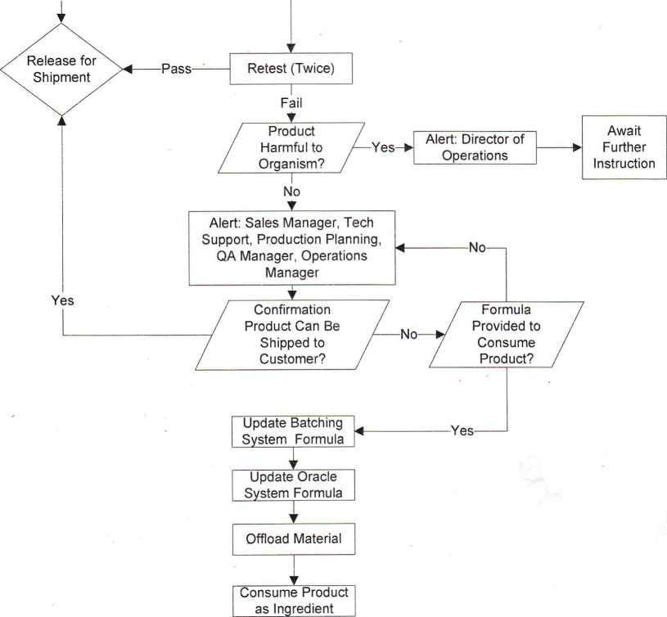

- DOMINION ELECTRIC
- UPS
CONTRACT SERVICES
- EASY AUTOMATION

APPROVED CARRIERS

CMC Transportation
Brown & Sons Trucking
Marula Farms

Saunders Transportation
Perdue Agribussiness
Stallins Transportation

DEFINITIONS

CALIBRATION AND INSPECTION OF EQUIPMENT
The plant shall establish and maintain documented procedures to control, calibrate and inspect measuring equipment. Inspection, measuring and testing of equipment shall be used to ensure that the equipment is consistent with the requirement of the equipment.

CERTIFICATE OF ANALYSIS
Specific analysis requested of suppliers in regard to ingredients, packages and finished product to ensure the items identified on the purchase order are key elements in regard to feed safety.

CONTROL OF NON-CONFROMING PRODUCT
The plant shall establish and maintain procedures to ensure that product that does not meet expected specific requirements is prevented from shipment. The controls should include identification, documentation, evaluation and retention procedures. Nonconforming product may be:
Reprocessed under specific conditions if it can meet all specific requirements (under direction of a qualified person).
Rejected or destroyed in a safe manner.

CORRECTIVE ACTION
The procedure for corrective action shall include investigation of the cause of the nonconforming product. The investigation shall include product process, records associated with the product, employee interviews to help determine the possible cause of the issue and determination of the corrective action required to prevent future similar issues.

CRITICAL CONTROL POINTS
A specific point, procedure, or step in feed manufacturing at which the control can be exercised to reduce, eliminate, or prevent the possibility of a feed safety hazard. These controls can be applied and are essential to prevent or eliminate a feed safety hazard or reduce it to an acceptable level.

DOCUMENT CONTROL
The plant shall establish and maintain document procedures to control all documents and data that relate to the products, process and ingredients used in the process of manufacturing product. The records shall be maintained to meet all federal and state regulations. Any changes to the record program shall be reviewed by the Feed Safety team to ensure they meet all requirements.

FEED SAFETY TEAM
The feed safety team shall consist of management and at least one operator involved in the process of manufacturing feed. The team shall evaluate all processes that could have an effect on feed safety. The team shall meet at least annually to review the process and whenever any new processes, ingredients or equipment is changed.

GOOD MANUFACTURING PRACTICES (GMPs)
The Good Manufacturing Practices shall be followed as outlined in the Code of Federal Regulation 21, Part 225.

INTERNAL GMP AUDITS
In planning for the bi-annual self-audit, the plant should establish procedures for planning and implementing internal audits to verify activities and related processes to determine the effectiveness of all processes and procedures in regard to feed safety. The results of the audit should be reviewed by the Feed Safety Team to determine any necessary changes to improve feed safety and any follow-up action necessary.

PREVENTATIVE ACTIONS
A change implemented to address a weakness in the operations that is not yet responsible for causing non-conforming product. This action may have been determined by the feed safety team or when developing critical control points.

PROCESS CONTROLS
Process control is the method by which the input flow is controlled and regulated by various measurements. Process control can also describe the method of keeping processes within specified boundaries and minimizing variation within a process. Activities involved in ensuring a process is dependable, consistent and operating effectively, ensuring all products meet feed safety requirements.

PROCESS CHANGE
The plant shall plan any process changes to evaluate the possible direct effect on feed safety, and the Feed Safety Team shall develop any new procedures, process controls and training required to ensure all products meet feed safety requirements.

PRODUCT SAFETY
The plant shall develop a feed safety policy, documents, and maintain feed safety guidelines to ensure that all ingredients, finished product packages and finished products conform to specific requirements. All employees shall be trained in all areas of feed safety in regard to their work duties. All procedures and policies should be review and updated annually.

STATISTICAL TECHNIQUES
The plant should evaluate statistical techniques in establishing procedures, process controls and verifying process capabilities of the equipment.

TRAINING
The plant shall establish and maintain records to identify training requirements and provide training to all personnel performing work that may have an effect on feed safety. All employees shall be qualified on the assigned tasks on the basis of training and experience.
SECTION 2
HAZARDS

SECTION 2:
AFIA SF/SF Hazard guidelines
CCP Decision tree
Hazard Evaluation of New Equipment
Disputanta Hazard Assessment
List of common Chemicals
AFIA SAFE FEED/SAFE FOOD HAZARD GUIDELINES
Class | Potential Hazards | Potential Sources
Chemical | Dioxin/PCBs¹  Medicated feed additives²  Feed additives³  Heavy metals⁴  Mycotoxins’  Pesticides⁶  Industrial contaminants⁷ | Cross contamination in feed mill, batching error, weighing error during batching, ingredient, intentional or unintentional contamination.
Biological | BSE⁸  Pathogenic enteric microbes⁹ | Contaminated feed ingredients, animal feces or urine, contamination during transport, contamination on- farm

’Dioxin/PCB tolerance levels have not been established for feed. Generally, any levels 2 parts per trillion of dioxin (including PCBs) or higher in finished feed should result in consideration of sampling for the source of the dioxin. The government is attempting to establish baselines of dioxin in various ingredients.
² ³Feed additives and medicated feed additives are defined as hazardous if used in an unapproved manner and exceed the mineral feed tolerances established by the National Research Council’s Mineral Tolerance of Domestic Animals (NRC, 1980) or unapproved animal drug levels as defined by 21 CFR, Part 558 et. seq., as applicable.
⁴Heavy metals are deemed hazardous if the levels in feed exceed the feed tolerances established by the National Research Council’s Mineral Tolerance of Domestic Animals (NRC, 1980).
⁵ Mycotoxin action levels have been established by FDA for aflatoxins, vomitoxin (DON) and fumonisin in several ingredients and finished feed. Feed and feed ingredients above these levels can be considered hazardous. Other mycotoxins may be considered contaminants at levels reasonably likely to cause harm to animals or humans based on scientific research.
⁶Pesticide tolerances for feed ingredients are established in 40 CFR, Part 180. If no tolerance is established, then the tolerance is zero and any feed ingredient, except a raw agricultural commodity (RAC), can be considered contaminated and hazardous if it contains a pesticide tolerance not established by regulation.
industrial contaminants are hazardous if they are reasonably likely to cause harm to animals or humans based on scientific research.
⁸Compliance with the FDA “BSE Feed Rule” (21 CFR § 589.2000) indicates adherence to these guidelines.
⁹Pathogenic enteric microbes are any microbes that are reasonably likely to cause harm to animals or humans based on scientific research. Elimination or reduction of these risks indicates adherence to these guidelines.

Process/Step | Hazard | *  Qi a. Do preventive measures exist for the identified hazard(s)?  If no—go to Qlb.  If yes-go to Q2. | Qlb. Is control at this step necessary for safety?  If no-not a CCP.  If yes—modify step, process or product and return to Q1 a. | Q2. Does this step eliminate or reduce the likely occurrence of a hazard(s) to an acceptable level?  If no-go to Q3. If yes—CCP | Q3. Could contamination with identified hazard(s) occur in excess of acceptable levels or could these increase to unacceptable levels?  If no-not a CCP. If yes—go to Q4. | Q4. Will a subsequent step eliminate hazard(s) or reduce the likely occurrence to an acceptable level?  If no-CCP. If yes-not a CCP. | CCP No.
Incoming  Ingredients  Termin-8  Application | - BSE  - EBAC | YES  YES |  | YES  YES |  |  | CCP 1  CCP 2
KSU & AMSA HACCP 1995-Revised, 1998

Reviewed By:
Date:

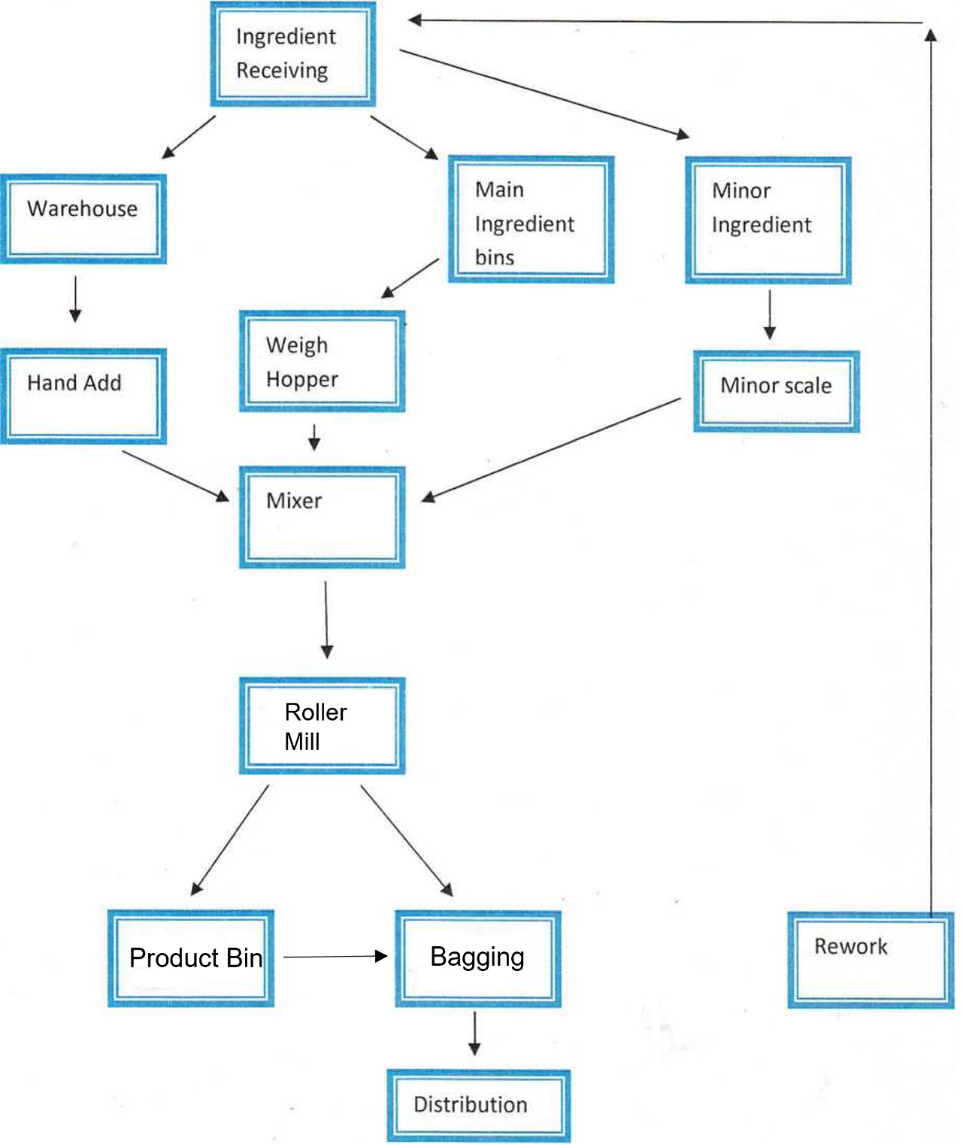

Process/Step | Potential Hazards  Introduced, controlled, or enhanced at this step | Control Measure applied to prevent significant hazard | Additional Preventive Controls needed? Justify your decision.
Ingredient  Receiving | Animal DNA | Only use vegetable products from approved vendors | No
 | Chemical: Pesticides, Fertilizers,  Rancidity | Preferred Vendor Program, Pesticide  Testing Program, and Trailer  Inspections. | No
 | Physical: Off spec, Metal, Off Color, Off Odor, Poor trailer conditions | Visual Trailer Inspections, Receiving Grates, Ingredient testing | Yes, Magnets placed further in the processing step to catch metal.
Warehouse  Storage | Biological: Pests | Pest control program | Pest control program maintained by Eco-Lab monthly with activity report filed.
 | Chemical: Cross contamination, | Preventative maintenance, Cleaning program. Inventory lot control. | SOP training
 | Physical: Glass, Broken bag | Glass policy, Broken Bag policy | SOP training

Process/Step | Potential Hazards  Introduced, controlled, or enhanced at this step | Control Measure applied to prevent significant hazard | Additional Preventive Controls needed? Justify your decision.
Main Ingredient  Bins | Biological: Pests, Mold  Chemical: Cross contamination, | Pest Control program, FIFO product flow. Bin Inspections,Quarterly Facility inspections. Empty bin log.  Receiving SOP, Food grade Lubricants. | Pest control program maintained monthly with activity report filed.  Any bin found to have cracks or leaks should be inspected and documented. Bin should be put out of service if mold is found.
 | Physical: Wet product, Metal, Plastic | Quarterly facility inspections, Bin  Inspections, magnet on receiving leg, whirly feed cleaner | SOP training
Minor Ingredient  Bins | BiologicakNo foreseeable hazard | Dedicated trucks and bins; separated receiving pipes.
 | Chemical: No foreseeable hazard | Dedicated trucks and bins; separated receiving pipes.
• | Physical: Metal shavings, Plastic from auguring system. | Preventative maintenance program, Whirly Cleaner and Magnets. | SOP’s and cleaning log for Whirly cleaner and Magnet

Process/Step | Potential Hazards  Introduced, controlled, or enhanced at this step | Control Measure applied to prevent significant hazard | Additional Preventive Controls needed? Justify your decision.
Weigh Hopper | Biological: No foreseeable hazard introduced in the weigh hopper. | Weigh Hopper is sealed from outside contaminants.
 | Chemical: No foreseeable hazard introduced in the weigh hopper. | Weigh Hopper is sealed from outside contaminants.
 | Physical: Weight discrepancy | Quarterly scale calibration
Hand Add | Biological: Pests | Pest control Program | Pest control program maintained monthly with activity report filed.
 | Chemical: Cross contamination, misweighed product | Strict formulation, Inventory control, | SOP training, daily inventory
 | Physical: glass,paper or string from bags | Cleaning policy, Roller mill, Protective covers on lights, Glass Policy | SOP training

Process/Step | Potential Hazards  Introduced, controlled, or enhanced at this step | Control Measure applied to prevent significant hazard | Additional Preventive Controls needed? Justify your decision.
Minor Scale | Biological: No foreseeable hazard introduced in the weigh hopper. | Weigh Hopper is sealed from outside contaminants.
 | Chemical: No foreseeable hazard introduced in the weigh hopper. | Weigh Hopper is sealed from outside contaminants.
 | Physical: Weight discrepancy | Quarterly scale calibration
Mixer | Biological: Pests, Mold, Entro for Microbial | Closed System, . | Anitox testing program.  Fumigation Program
 | Chemical: Cross Contamination | Maintenance program, feed grade lubricants. | SOP training
 | Physical: Off spec chips, Metal, Off Color, Off Odor, | Controlled at unloading and further in the system by the whirly cleaner. | SOP’s and cleaning log for Whirly cleaner and Magnet

Process/Step | Potential Hazards  Introduced, controlled, or enhanced at this step | Control Measure applied to prevent significant hazard | Additional Preventive Controls needed? Justify your decision.
Bagging | Biological: Pest | Pest control program, fumigation program, Truck inspection sheets. | Pest control program maintained monthly with activity report filed.
 | Chemical: Cross Contamination | Specific Formulation, Automated batch records. | Dedicated bin space per formula Product rotated FIFO
 | Physical: oversized product, foreign material, Metal, | Roller mill and Magnets | SOP’s and cleaning log for Roller Mill and Magnet
Distribution | Biological: No foreseeable hazard
 | Chemical: No foreseeable hazard
 | Physical: Wet material | Product are bagged and stored securely | Sipping containers are inspected before loading

Process/Step | Potential Hazards  Introduced, controlled, or enhanced at this step | Control Measure applied to prevent significant hazard | Additional Preventive Controls needed? Justify your decision.
Rework | Biological: pests | Pest control Program. | Pest control program maintained by Eco-Lab monthly with activity report filed.
 | Chemical: Cross Contamination | Rework is treated as an ingredient in rework formulas and is subject to ingredient receiving controls.
 | Physical: Off Spec, product | Rework is treated as an ingredient in rework formulas and is subject to ingredient receiving controls. | Product testing and SPC variance
 |  |  | -

COMMON NAME

CLEANER
Clorox Bleach
Formula 409
Pine-sol
Pledge
Windex
Glade Aerosol
Lysol Bathroom Cleaner Lysol Disinfectant spray Lysol Disinfectant wipes
LIST OF CHEMICALS

DISPUTANTA, VA

CHEMICAL NAME
Sodium Hypochlorite
1/3/2022

SUPPLIER
Clorox
Clorox
Clorox
SC Johnson
SC Johnson
SC Johnson
Reckitt Benckiser
Reckitt Benckiser Reckitt Benckiser
FEED SUPPLEMENT
Biolys | L-Lysine Sulphate | Evonik/ Degussa
DL-Methionine | Methionine | Evonik/ Degussa
MonoProp | Propionic acid | Anitox Corp.
Myco Curb | Ammonium buffered propionic acid | Kemin

MAINTENANCE
Acetylene |  | Airgas
Carbon Dioxide |  | Airgas
Oxygen |  | Airgas
WD-40 | organic mixture | WD-40

MISC
ABC fire exstinguisher
Toner
HP laser jet cartridge
Assail-a-cell
Falcon Signal Horn
Dry Ammonium Phosphate
Zeoglobule PT462
isobutane/ propane Tetrafluoroethane
Badger Fire Protection
Brother
HP
Greek corporation
Falcon

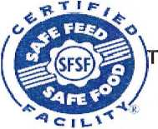

SECTION 4:
Pesticide Testing
Mixer Profile

SECTION 5
RECORDS
SECTION 5:
SF/SF Guidelines for Record-keeping H.J. Baker Record Retention Program Westville Record Keeping SOP

POLICY: RECORD RETENTION PROGRAM
ISSUED BY: Corporate Legal

OBJECTIVE
The purposes of a record retention program are to insure that all necessary records are preserved and to provide for the orderly and consistent destruction of all other records. Good faith and consistent adherence to a practical and efficient Record Retention Program promotes efficiency and preserves resources. The Company expects every employee who has created, or has custody of, Company records to comply fully and consistently with this program.
This Record Retention Program covers ALL written and graphic material regardless of whether it is in physical or electronic form that is produced in the course of the Company’s business. Such records include all correspondence, notes, memos, records, files, agreements, books, spreadsheets, databases, power point and other presentations, test results, procedures, policies, emails, voicemails, photographs, charts, data and other information produced in the course of the Company’s business regardless of whether such information is stored permanently or temporarily on company hardware or systems, virtual networks, or anywhere else including locally on employee desktops, cell phones and other digital devices. Notes that are taken and retained for a short period of time, e.g. less than a two weeks, without being placed in the file system may be disposed of by the end of such two-week period.
Every record created, whether created as casually as a voice mail message or email or the result of extensive work and revision, becomes subject to this Record Retention Program. Therefore, it is important that records not be created or distributed unnecessarily and that all records created be accurate, factual, limited to what needs to be said in “recorded” form and always created with the recognition that it may become subject to adverse public scrutiny.
Supervisors must ensure that their subordinates comply with all applicable aspects of this Program, including proper record storage for easy access and retrieval, retention for required periods and prompt destruction when such period expires. Individual departments, supervisors and employees should only be in possession of or have access to business records pertaining directly
to their respective functions and duties.
RETENTION STANDARDS
- All records shall be retained for the period required by applicable state, federal and industryspecific laws and regulations, which retention periods are built into this Record Retention Program for records located in the U.S.
- Adequate records shall be developed and maintained to document the Company’s compliance with all relevant laws and regulations.
- All records necessary for business purposes shall be retained for a'period of time that will reasonably assure the availability of those records when needed but not for longer periods than those prescribed in this policy except for particular records that are subject to a legal hold.
- Records vital to the ongoing operations of the Company shall be identified and appropriately safeguarded.
- All records not necessary for legal or business reasons and not required to be retained by law or regulation shall be destroyed in accordance with this Record Retention Program in order to reduce the high cost of storing, indexing and handling the vast amount of information that would otherwise accumulate.
- Destruction of records shall take place only in compliance with the Record Retention Program in order to avoid any inference that any document was destroyed in anticipation of a specific problem.
- Documents that are not otherwise subject to retention for business reasons may need to be retained because of unusual circumstances, such as litigation or a government or internal investigation. If for any reason it is felt that an unusual circumstance exists or arises, the General Counsel should be notified immediately. When litigation or an investigation occurs, the General Counsel will notify appropriate management and direct that the relevant categories of documents be labeled for retention until further notice.
- The privacy and security of records shall be appropriately assured.
- Records such as notes, memoranda, letters, reports, laboratory notebooks, computer disks, tapes, etc. maintained in individual offices, at home, or any other offsite location are subject to this policy and shall be handled accordingly.
AUDIT
Routinely and at least annually, each employee should systematically review his or her files (as well as any computer disks and other electronic storage media) and destroy all memoranda, correspondence, personal notes, superseded drafts, electronic and/or desk calendars, voicemails, old checklists and task lists, emails on which the employee is merely copied or that no longer
require any action or reply by the employee and similar general communications and records that are no longer useful or are more than one year old. In addition each employee should destroy all emails that are more than 2 years old except those few emails that create or interpret a legally binding agreement that is still in effect or pertain to an ongoing project or issue. All chronology folders that are more than 2 years old should also be destroyed.
Correspondence and memoranda should be retained beyond two years only if they grant or confirm a legal right or release from potential liability, or if they supplement, amend or explain a contractual right or obligation. In those cases, one copy of such communication should be retained in the file with the principal document to which it relates.
Each Manager shall be responsible for auditing compliance with document retention and disposal standards in his or her Department and shall report compliance or lack thereof in a written report to the General Counsel on an annual basis. Reports shall be due on February 28th of each year.
ADDITIONS AND EXCEPTIONS
If a manager believes this record retention policy does not include an important category of records that should be retained for more than a minimal period of time, e.g., more than one year, please discuss retention of those records with H. J. Baker’s General Counsel, or his designee. Also, if there is any unlisted record that is necessary for tax filing or review, then the manager should discuss retention of those records with H. J. Baker’s Chief Financial Officer, or his designee, to ensure that any such records are retained for the "Tax Period." The term "Tax Period" denotes the period for which H. J. Baker and its subsidiaries are currently open for IRS audit purposes. Any records dated before the current “Tax Period” began that have the retention designation "Tax Period" should be destroyed unless they are specifically needed for open state tax matters, in which case they should be separately filed in connection with such state tax review records and destroyed only when the state tax review is conclusively finished.
Requests for exceptions to the general requirements of this Record Retention Program must be submitted to the General Counsel.
RECORD DISPOSITION
Sensitive physical records, including without limitation those containing trade secrets and personal or confidential information of employees and others with whom the Company does business shall be disposed of using a cross-cut shredder. Senior management shall determine the best way to dispose of any digital records.
In the event that it is necessary to manually dispose of an electronic record, the IT Department shall use the “permanent delete” function to permanently dispose of electronic records stored in that software. In the event that records must be disposed of which are stored outside of H. J. Baker, the IT Department must be contacted to permanently dispose of electronic records.
SUSPENSION OF RECORD DISPOSITION
If a lawsuit involving H. J. Baker or any of its subsidiaries, affiliates, officers, directors, employees or agents is filed or appears imminent, or if a legal demand such as a subpoena has been served on HJB, then there shall not be any destruction of any records pertaining to such matter or that might lead to information pertaining to such matter without the prior, specific written consent of the General Counsel. Any records that would otherwise be scheduled for destruction under this program that are in any way related to any threatened or pending litigation or claims, must be retained until such matters are finally resolved and the General Counsel has issued a written release permitting destruction of such records. Any doubt whatsoever as to retention of any records that are in any way related to any threatened or pending litigation or claim shall be resolved in favor of retention.
INTERPRETATION AND ASSISTANCE
Management shall be responsible in the first instance for interpreting the provisions of this program as they may apply to specific situations. The General Counsel will assist management regarding such issues on request.
RETENTION PERIOD FOR SPECIFIC RECORDS
CORPORATE/ORGANIZATION RECORDS | RETENTION PERIOD
Acquisition, disposition, merger, dissolution records pertaining to companies that are or have been part of FIJB | Permanent
Acquisitions, calculations, reports, studies, etc. | 5 years (3 years if no deal)
Board records, including agendas, resolutions and minutes | Permanent
Bond records | Permanent
General correspondence, including emails | 3 years
Agreements, including correspondence and emails that form a contract | 7 years after termination
Business licenses and sellers permits (state, county, city) | 3 years after expiration
Corporate minute books | Permanent
Corporate seals | 20 years (after corporation merged, dissolved or sold)
Deeds (original if available, otherwise one copy) | Permanent
Easements (original if available, otherwise one copy) | Permanent
Escheat and abandoned property records | 60 years
Incorporation records, including articles of incorporation and bylaws and charter and all amendments | Permanent
Corporate Policies | 10 years
Tax-exemption records, including application for tax exemption and IRS determination letter | Permanent.

r —  ACCOUNTING RECORDS | RETENTION PERIOD
Accounts Payable | 7 years
Accounts Receivable | 7 years
A/P paid invoices | 7 years
A/R invoices | 7 years
Amortization and depreciation records | Tax period
Annual audit records | 10 years
Annual financial statements | Permanent
Audit reports (Independent) | Permanent

—  ACCOUNTING RECORDS (cont’d) | RETENTION PERIOD
Audit reports (Internal reports and working papers) | Tax Period
Bank statements and reconciliations | 7 years
Business expense reports, | 7 years
Cancelled Checks | 7 years
Capitalization charts, stock and bond certificates | Permanent
Cash receipt and disbursement records | 3 years
Chart of accounts | Permanent
Credit card receipts | 3 years
Data for acquired/divested entities | Permanent
Data for non-acquired/non-divested entities | 5 years
Expense records | 7 years
General ledger | 20 years
Inventory records | 7 years
Journal entries | 7 years
Loan records | 7 years after final payment
Monthly financial statements | 3 years
Purchase and sale orders | 7 years after completion
Stop payment orders | 3 years
Treasurer’s reports, periodic | 3 years

TAX RECORDS | RETENTION PERIOD
1099 Forms | 7 years
City, state excise tax reports and supporting documentation | 7 years
Federal tax returns (not payroll) | Permanent
Foreign income tax returns and receipts | Permanent
Form 990 and supporting documentation | Permanent
Form 990-T and supporting documentation | Permanent
Payroll taxes (Form 941, state withholding forms, state unemployment returns) | 7 years

TAX RECORDS (cont’d) | RETENTION PERIOD
Payroll taxes (W-2, W-3 forms) | Permanent
Real Estate taxes | 7 years
State and local tax returns | Permanent
Supporting worksheets and records for tax returns | 4 years
Payroll tax returns, payments and reports to government, including federal, state, municipal and foreign authorities covering payments and reports related to income tax withholdings, contributions to FICA, state unemployment, worker’s compensation, reports on employees’ earnings and related records. | Tax period
NOTE: A taxpayer is required to retain all machine-sensible files generated by its automatic data processing system unless a retention agreement is reached with the I.R.S. limiting the retention to certain specified records. In cases where an agreement does not exist, the records must be retained until written notice is received that they are no longer required. Retain machine sensible records not currently covered by a retention agreement in accordance with this Policy’s retention period for the particular type of record, e.g., general ledgers - 20 years, and retain for the same period the documentation necessary to access this data.

INSURANCE RECORDS | RETENTION PERIOD
Claim forms, including supporting documentation and evidence | 7 years after resolution of claim
Insurance policies and coverage certificates | Permanent

INTELLECTUAL PROPERTY RECORDS | RETENTION PERIOD
Copyright registrations, applications, renewals, amendments, and related filings (including issued copyright registrations, copyright assignments, records of proceedings in the copyright office and licenses) | Permanent
Outside inventors, agreements with and submissions | Permanent
Patents, patent applications, and related filings (including the issued patent, patent assignments, records of proceedings in the patent office and original invention records search records) | Permanent
Trademark registrations, applications, renewals, and related filings (including issued trademark registrations, assignments, records of proceedings in the trademark office and search reports) | Permanent

LEGAL RECORDS | RETENTION PERIOD
Attorney opinion letters | 4 years after expiration
Confidentiality Agreements | 7 years after termination
Contracts | 7 years after termination
Environmental Studies | Permanent
Leases | 7 years after termination
Litigation records (claims, court records, transcripts, discovery materials) | 7 years following close of case
Personal injury records | 20 years following completion of employment
Real estate contracts and records | Permanent
Trade secret documentation | Life of trade secret

•  MARKETING RECORDS | RETENTION PERIOD
Advertisements | 7 years after no longer used
Marketing Plans | 3 years
Press releases | Permanent
Public filings | Permanent

■ - -  PERSONNEL RECORDS | RETENTION PERIOD
Accident reports | 30 years following completion of employment
Attendance records | 30 years following completion of employment
Background investigation results - persons hired | 3 years following completion of employment
Background investigation results - persons not hired | 1 year
Beneficiary information | 30 years following completion of employment
Benefit plan documents and booklets (one copy) | Permanent
COBRA Letters | Tax Period

Record Retention Policy | Page 9

PERSONNEL RECORDS (cont’d) | RETENTION PERIOD
Disciplinary warnings, demotions, lay-offs, and discharges | 30 years following completion of employment
Education assistance | While employed
Employee applications, including resumes and employment history - persons hired | 30 years following completion of employment
Employment applications, including resumes - persons not hired | 1 year after receipt
Employment and termination agreements | 30 years following later of completion of employment or fulfillment of all obligations under such agreement
ERISA reports or certificates | Permanent
Evaluations | 30 years following completion of employment
Fair Labor Standards Act records for each individual | 30 years following completion of employment
1-9 Immigration Forms | 3 years following completion of employment
Incentive plans | 7 years (after expiration)
Individual earnings records and summaries (including withholdings) of employees eligible for retirement pension plans | Permanent
Individual earnings records and summaries (including withholdings) of employees not eligible for retirement pension plans following termination of employment | 30 years following completion of employment
Job announcements and advertisements | 1 year
Letters of recommendation - persons hired | 3 years following completion of employment
Letters of recommendation - persons not hired | 1 year after receipt
Medical and safety records | 30 years after completion of employment
Medical examinations - persons hired | 3 years following completion of employment
OSHA Records | 7 years

Record Retention Policy
Page 10
PERSONNEL RECORDS (cont’d) | RETENTION PERIOD
Payroll deductions | 30 years following completion of employment
Pension Plans | 30 years (after expiration)
Promotions, raises, reclassifications, and job descriptions | 30 years following completion of employment
Retirement plans | 7 years (after expiration)
Salary or current rate of pay | 30 years following completion of employment
Savings Plan, e.g. 40IK | Permanent
Sick leave benefits | While employed
Time cards (NOTE: Information needed to determine pension eligibility should be permanently retained if not located in a permanent pension file.) | 30 years following completion of employment
Wage or salary history | 30 years following completion of employment
Wage rate tables | 30 years
Workers’ compensation reports | 7 years
NOTE: Refer to Appendix B for a list of widely-applicable federal rules relating to Employee Health and Safety Documents, as well as Appendix C for a list of specific statute required retention periods.

MANUFACTURING, PRODUCT ENGINEERING | RETENTION PERIOD
Authority to scrap or sell | Tax period
Bids and cost estimates | 4 years
Bills of material (original or master) | Permanent
Contract documents for purchase of goods and services, including quotations, offers, purchase orders, sales orders, acknowledgements, modifications and cancellations and related notes and correspondence | Longer of tax period or 7 years (after termination)
Cost deviation reports | 2 years
Cost factor cards and data sheets | 10 years
Design and drafting orders | Permanent
Design records (pertaining to safety features of manufactured product) | Permanent

MANUFACTURING, PRODUCT ENGINEERING (cont’d) | RETENTION PERIOD
Drawings, specifications and tracings (one copy) | Permanent
Inventory control | Tax period
Manufacturing cost changes | 10 years
Operating reports | 2 years
Planning summaries | 2 years
Plant inventory and machine location records | Tax period (after obsolete)
Plant layout charts | Current
Production orders, reports and registers | 3 years
Quality control records, including inspection records, bills of materials, supplements to customer's orders and change orders | 7 years
Receiving reports | 2 years
Service engineer’s call reports | 7 years
Specifications sheets | 7 years
Stock status report | 2 years
Work or shop orders | 3 years

REAL PROPERTY AND IMPROVEMENTS | RETENTION PERIOD
Appraisals | Permanent
Certificates of Occupancy | Permanent
Construction contracts and related notes and correspondence | 7 years (after final acceptance of the work)
Deeds (original if available, otherwise one copy) | Permanent
Drawings, specifications and boring logs (original signed and sealed copy) | Permanent
Easements (original if available, otherwise one copy) | Permanent
Guaranties and warranties | 7 years after termination
Equipment | Tax period
Furniture | Tax period
Leases (original if available, otherwise one copy) | Permanent

REAL PROPERTY AND IMPROVEMENTS (cont’d) | RETENTION PERIOD
Local, state and federal approvals | 10 years after termination
Permits and licenses pertaining to building and land use | Permanent
Elevator and similar permits | 10 years after termination
Repair contracts | 7 years
Service and maintenance contracts | 7 years after termination
Surveys | Permanent
Title insurance policies, including maps | Permanent
Utilities agreements | 7years after termination
Zoning matters | Permanent

- . . . . - .... - - ■ =  RESEARCH, DEVELOPMENT AND DESIGN ENGINEERING | RETENTION PERIOD
Basic scientific and engineering records, standards and notes (one copy) | 10 years
Design records - machinery and product | Permanent
Design records - production tool | Current year
Drawings, blueprints, tracing and transparencies | Current year
Engineering specifications (one copy) | Permanent
Invention agreements, submissions and historical records | Permanent
Notebooks, engineering and research | Permanent
Operating manuals, instructions and warnings (one copy) | Permanent
Purchased machines and equipment | 7 years after disposal (give copy to purchaser)
Specifications | Permanent
Test procedures and records | Permanent

TRAFFIC - ^HIPPING AND RECEIVING | RETENTION PERIOD
Bills of Lading | Tax Period
Claims | Longer of tax period or 3 years (after settlement)
Customs records | Tax Period
Delivery records, e.g., delivery receipts and drivers’ physical reports | Tax Period
Export applications, declarations licenses and supporting documentation | Longet of tax period or 7 years (after last use)
Freight bills and statements | Tax Period
Receipts for certified and registered mail and express packages | 1 year
Shipping reports and instructions, delivery reports and receiving reports | Tax period
Waybills, manifests - NOTE: Refer to Appendix A -  Environmental Documents for hazard waste manifests. Also state laws applicable to special wastes, e.g., industrial wastes, may require a longer retention period | Tax period

APPENDIX A
Environmental Documents
General Principle - The Company must keep permanently all documents relating to its effect on the environment as will enable it to demonstrate compliance with any applicable regulations. The following is a current list of widely applicable federal rules.
HAZARDOUS WASTE GENERATORS | RETENTION PERIOD
A copy of each manifest signed in accordance with 40 C.F.R.-262.23(a) . | Shorter of 3 years or until receipt of a signed manifest from facility receiving the hazardous waste
A copy of the manifest signed by the facility receiving the waste | 3 years from date the initial transporter accepted the hazardous waste
A copy of each biennial report (40 C.F.R.-262.41) and exception report (40 C.F.R.-262.42) | 3 years from the due date of the report
Records of any test results, waste analyses, or other determinations made in accordance with 40 C.F.R. - 262.11 | 3 years from the date the waste was last sent to on-site or off-site treatment, storage or disposal

NPDES PERMITTEES | RETENTION PERIOD
Records of all monitoring information, including all calibration and maintenance records and all original strip charter recordings for continuous monitoring instrumentation, copies of all reports required by the NPDES permit, and records of all data used to complete the application for the NPDES permit | 3 years from date of sample measurement, report or application

EPA PRETREATMENT STANDARDS FOR DISCHARGES TO PUBLIC OW NED TREATMENT WORKS (40 C.F.R. - 403) | RETENTION PERIOD
Records of monitoring activities and results | 3 years

Record Retention Policy | Page 15

APPENDIX A (conf d)
Environmental Documents
OIL POLLUTION PREVENTION REGULATIONS (40 C.F.R.-112) | RETENTION PERIOD
Oil spill prevention control and countermeasures inspection reports (40 C.F.R. - 112.7(e)(8)) | 3 years

APPENDIX B
Employee Health and Safety Documents
General Principle - Keep all documents relating to employee health and safety for such periods as will enable HJB to demonstrate compliance with any applicable regulation or standard. These standards and regulations are in a state of continual expansion and change. Following is a current list of widely-applicable federal rules.
OCCUPATIONAL SAFETY & HEALTH (29 C.F.R. 1910.1020) | RETENTION PERIOD
Records relating to each occupational injury or illness, including the annual summary and other OSHA forms | 6 years
OSHA Administration Regulations requires employers to keep medical records of employees who are exposed to toxic substances and harmful agents. | Duration of employment + 30 years
Employee Exposure Records | 30 years

ASBESTOS STANDARDS (29 C.F.R.* - 1920.1001) | RETENTION PERIOD
Personal or environmental monitoring | Duration of employment + 30 years
Employee medical examinations | Duration of employment + 30 years
*29 C.F.R. refers to Title 29 of the Code of Federal Regulations which is available at many public libraries or from Superintendent of Documents, United State Government Printing Office, Washington, D.C. 20402 (Subscription Desk 202-275-3054).

MECHANICAL POWER PRESS STANDARDS | - - .  RETENTION PERIOD
Records of periodic regular inspection | Permanent

  INDUSTRIAL SLINGS STANDARD (29 C.F.R. - | RETENTION PERIOD
1910.184) | |
Inspection records | Permanent
Repair records | 1 Permanent

APPENDIX B (cont’d)
Employee Health and Safety Documents
FIRE PROTECTION STANDARD (29 C.F.R. - 1910.38,1910.156-157,1910.159-160) | RETENTION PERIOD
Emergency action plans, fire prevention plans, statement of fire brigade policy, central records of location, number and design of sprinklers | Until superseded
Evidence of hydrostatic testing of portable fire extinguishers and semiannual checks of fixed extinguishing systems | Until re-testing or removal from service

a
HAZARD COMMUNICATON STANDARD (29 C.F.R. -1910.20 AND 1910.1200) | RETENTION PERIOD
Analysis using exposure or medical records | Period of employment plus 30 years
Exposure records | Period of employment plus 30 years
Certain background data relating to exposure records | 1 year**
Medical records | The duration of employment plus 30 years***
* Material safety data sheets and any other record which reveals where and when used the identity of a toxic substance or harmful physical agent, which concern the identity of a substance or agent need not be retained for any specified period as long as some record of the identity (chemical name is known) of the substance or agent, where it was used, and when it was used is retained for at least thirty (30) years.
** Background data relevant to environmental (workplace) monitoring or measuring, such as laboratory reports and worksheets need only be retained for one (1) year as long as the sampling results, the collection methodology (sampling plan), a description of the analytical and mathematical methods used, and a summary of other background data relevant to interpretation of the results obtained, are retained for at least thirty (30) years.
*** The following type of medical records need to be retained for any specified period: Health insurance claims records maintained separately from the employer’s medical program and its records.

APPENDIX C
Employment Records
FAIR LABOR STANDARDS ACT (29 C.F.R. §§ 516.2516.6 and 516.11-29) | RETENTION PERIOD
Establishes recordkeeping regarding employment information, payroll, certificates, basic employment and earning records, wage rate tables, work time schedules, job evaluations, merit seniority systems, and other documents that explain wage differences to employees in the same establishment. | 30 years from the completion of employment, but subject to legal hold until final disposition of any discrimination case that might arise during this period

CIVIL RIGHTS ACT AND EQUAL PAY ACT (29 C.F.R. § 1602.14) | RETENTION PERIOD
Employment and personnel records of hiring promotion, demotion, termination, transfer, layoff, pay raises, et al. | 30 years from the completion of employment, but subject to legal hold until final disposition of any discrimination case that might arise during this period

INTERNAL REVENUE SERVICE (IRS) | RETENTION PERIOD
Employment tax records (Social Security documents) | 4 years after the due date of the tax. If a claimant files a claim, it should be retained for 30 years after the date of the filing.

WELFARE AND PENSION PLANS DISCLOSURE ACT (29 U.S.C. § 30S) | RETENTION PERIOD
Reports as required by Act | 30 years

STANDARD OPERATING PROCEDURE  Record Retention  Disputanta, VA | Effective Date 01/03/2022 | Number  RR-1
 | Page  1 Of 1 | Revision  #1

- CONCEPT
The following information is for al! employees involved with the maintaining of facility records.
- SAFETY CONCERNS
No physical safety concerns.
- PRIOR KNOWLEDGE:
The employee should basic organizational skills and be familiar with the filing process.
IV PROCEDURE
- All load paperwork will be completed in its entirety.
- It will be stapled to all relevant paper work, (wash out tickets, etc)
- It will be filled in accordance to Filing SOP.
- All records will be maintained as outline in the corporate record retention program,
for a minimum of 2 years.
Training Documentation
Signature verifying trainee has read and understands SOP
Employee Name Date of Training/Certification

SECTION 6
INSPECTIONS
SECTION 6: Most recent copy of

Self Inspection Checklist
Feed Division

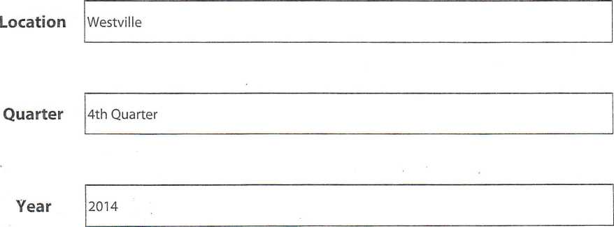

Submit by Email
Print Form

EMPLOYER POSTING:
1 | Is the required OSHA workplace poster displayed in a prominent location where all employees are likely to see it? | [Xj Yes | □ ^{No} | □ N/A
2 | Are emergency telephone numbers posted where they can be readily found in case of an emergency? | [x] Yes | Q No | □ N/A
3 | Are signs concerning exits, biohazards, microwave use, or exposure to other harmful substances posted where appropriate? | 0 Yes | □ No | □ N/A
4 | Is the Summary of Work-Related Illnesses and Injuries (OSHA 300A) posted where your employees can see it from February 1 st thru April 30th? | [x] Yes | □ No | □ N/A
RECORDKEEPING: ,
5 | Are all occupational injuries or illnesses, except minor injuries requiring only first aid, being recorded as required on the OSHA 300 Log? . | 0 ^{Yes} | □ No | □ N/A
6 | Are employee medical records and records of employee exposure to hazardous substances or harmful physical agents up-to-date and in compliance with current OSHA standards? | 0 Yes | □ No | O N/A
7 | Are employee training records kept accessible for review by employees, when required by OSHA standards? | [xj Yes | □ No | □ N/A
8 | Have arrangements been made to keep required records for the legal period of time for each specified record? | Yes | □ No | □ N/A
9 | Are operating permits and records up-to-date for such items as elevators, air pressure tanks, LPG tanks, etc.? | [3 Yes | □ No | □ N/A
SAFETY AND HEALTH PROGRAM:
10 | Do you have an active safety and health program in operation that deals with general health and safety program elements as well as the management of hazards specific to your worksite? | [x] Yes | □ No | □ N/A
11 | Are monthly safety meetings being held per the safety and health program, and are records of these meetings being properly maintained? | [x| Yes | □ No | Q N/A
12 | Do you have a working procedure for handling in-house employee complaints regarding safety and health that ensures no repercussions to the reporting employee? | [xj Yes | □ No | □ N/A
13 | Do you have an open line of communication with the members of the Safety Committee, and are their services available to you as stated in the Corporate Plant Safety and Health Program? | [x] Yes | □ No | □ N/A
14 | Are your employees advised that the Safety Committee is continuously working to keep their workplace as safe as possible, and is always respective to Safety related comments and suggestions from them? | [3 Yes | □ No | □ N/A
MEDICAL SERVICES AND FIRST AID:
15 | Are medical emergency phone numbers posted by all phones accessible to plant employees? | [xj Yes | □ No | □ N/A
16 | Are first aid kits easily accessible, with the necessary supplies available, periodically inspected and replenished as needed? | [x] Yes | □ No | □ N/A
17 | Have first-aid kit supplies been approved by a physician, indicating that they are adequate for your plant's usage? | 0 Yes | □ No | □ N/A

18 | Are means provided for quick drenching or flushing of the eye and body in areas where corrosive liquids or materials are handled? | 0 Yes | □ No | □ N/A
19 | Are AED defibrillators located in an area where employees can easily locate and is easily accessible to responders? | [x| Yes | □ No | □ N/A
20 | Is the AED Responder List and monthly inspection form posted near the defibri 1 lator(s) location and legible? | [Xj Yes | □ No | □ N/A
FIRE PROTECTION:
21 | Is your local fire department well acquainted with your facility(s), location(s), and specific hazards? | |x] Yes | □ No | □ N/A
22 | Are portable fire extinguishers provided in adequate number and type per recommendations of the local fire department? , | |x| Yes | Q No | □ N/A
23 | Are fire extinguishers inspected monthly and serviced annually, and does each extinguisher have a tag logging this inspection / service? | [x] Yes | □ No | □ N/A
24 | Are employees trained in the use of portable fire extinguishers at least annually and is a record of training maintained on file? | [Xj Yes | □ No | □ N/A
PERSONAL PROTECTIVE EQUIPMENT:
25 | Is there an active Personal Protective Equipment Program per OSHA Standard 1910.132 and 1910.133? | Jx] Yes | □ No | □ N/A
26 | Are protective goggles or face shields provided and worn where there is any danger of flying particles or corrosive materials? | [x] Yes | □ No | □ N/A
27 | Are approved safety glasses required to be worn at all times in areas where there is a risk of eye injury such as punctures, abrasions, contusions, or burns? | [x] Yes | □ No | □ N/A
28 | Are protective gloves, aprons, shields, or other means of protection provided, and their use required in areas where employees could be cut, or where there is a reasonably anticipated exposure to corrosive materials, or other hazardous products? | [x] Yes | □ No | □ N/A
29 | Are hard hats provided and their use required in areas where there is a danger of falling objects from overhead? | lx] Yes | □ No | □ N/A
30 | Are employees trained in the proper don/doff techniques of personal protective equipment? | [x] Yes | []J No | □ N/A
EXITING OR EGRESS:
31 | Are all exits marked with an exit sign and illuminated by a reliable light source? | [X] Yes | □ No | □ N/A
32 | Are doors, passageways, or stairways, that are neither exits or accesses to exits (and which could be mistaken for exits), appropriately marked "NOT AN EXIT', "TO BASEMENT", ETC.? | [X] Yes | □ No | □ N/A
33 | Are exit signs provided with the word "EXIT" in lettering at least 5 inches high and the width of the lettering at least 1/2 inch wide? | [X] Yes | □ No | □ N/A
34 | Are exit doors side-hinged? | [XJ Yes | □ No | □ N/A
35 | Are all exits kept FREE of obstructions? | [Xj Yes | □ No | □ N/A
36 | Are at least two means of egress provided from elevated platforms, pits, or rooms where the absence of a second exit would increase the riskof injury from hot, poisonous, corrosive, suffocating, flammable, or explosive substances? | [3 Yes | □ No | □ N/A
37 | Are there sufficient exits to permit prompt escape in case of an emergency? | Ixj Yes | □ No | □ N/A

EX3T DOORS:
39 | Are doors which are required to serve as exits designed and constructed so that the way of exit travel is obvious and direct? | jxj Yes | Q No | □ N/A
40 | Can all exit doors be opened from the direction of exit travel without the use of a key or any special effort when the building is occupied? | [Xj Yes | □ No | □ N/A
41 | Are doors that swing in both directions, and are located between rooms where there is frequent traffic, provided with viewing panels? | □ Yes | □ No | [xj N/A
PORTABLE LADDERS: ,
42 | Are employees trained in the safe use and proper storage techniques of portable ladders? | [x] Yes | □ No | □ N/A
43 | Are all ladders maintained in good condition (joints between steps and side railings tight, all hardware and fittings securely attached, and moveable parts operating freely without binding or undue play)? | 0 Yes | □ No | tl N/A
44 | Are non-slip safety feet provided on each ladder? | [X] Yes | □ No | □ N/A
45 | Are ladder rungs and steps free of grease and oil? | [xj Yes | □ No | □ N/A
46 | Is it prohibited to place a ladder in front of doors opening toward the ladder except when the door is blocked open, iocked, or guarded? | [X] Yes | □ No | □ N/A
47 | Is it prohibited to place ladders on boxes, barrels, or other unstable bases to obtain additional height? | jx] Yes | □ No | □ N/A
48 | Are employees instructed to face the ladder when ascending or descending the ladder? | [X, Yes | □ No | □ N/A
49 | When portable run ladders are used to gain access to elevated platforms, roofs, etc., does the ladder always extend at least 3 feet above the elevated surface? | [Xj Yes | □ No | □ N/A
50 | Are employees prohibited from using ladders that are broken, missing steps, rungs or cleats, have broken side rails orfaulty equipment? | |x] Yes | □ No | □ N/A
51 | Are employees instructed not to use the top step of ordinary stepladders as a step? | 0 Yes | □ No | □ N/A
52 | Are portable metal ladders legibly marked "CAUTION -Do Not Use Around Electrical Equipment" or equivalent wording? | jxj Yes | □ No | □ N/A
53 | Are employees prohibited from using ladders as guys, braces, skids, gin poles or for any purpose other than their intended purpose? | [Xj Yes | □ No | □ N/A
54 | Are the rungs of the ladders uniformly spaced at 12 inches, center to center? | [xj Yes | □ No | □ N/A
HAND TOOLS AND EQUIPMENT:  55 Are all company-owned and employee-owned tools used by employees in good condition? |  | [xj Yes | □ No | □ N/A
56 | Are hand tools such as chisels, punches, drifts, etc. which develop mushroomed heads when used, reconditioned or replaced periodically? | [xj Yes | □ No | □ N/A
57 | Are broken or fractured handles on hammers, axes, siedge hammers, etc. checked regularly for deterioration or damage and then promptly replaced when required? | 0 Yes | □ No | Q N/A
38
is emergency lighting provided and maintained for egress paths?
0 Yes □ No □ N/A

59 | Are hand tools and other equipment returned to their proper storage location immediately following use and not left sitting around where they can become a hazard? | [x] Yes | □ No | □ N/A
ABRASIVE WHEEL EQUIPMENT-GRINDERS:
60 | Is the work rest used and always kept to an adjustment of 1/8" maximum from the wheel? | 0 Yes | □ No | □ N/A
61 | Is the adjustable tongue on the top side of the grinder used and kept adjusted to 1/4" maximum from the wheel? | [X] Yes | □ No | □ N/A
62 | Do side guards cover the spindle, nut, and flange, and 75% of the wheel diameter? | [3 ^{Yes} | □ No | □ N/A
63 | Are bench and pedestal grinders permanently mounted to a solid surface or to a portable structure? | [X] ^{Y}es | □ No | □ N/A
64 | Are goggles or a face shield worn (over Safety Glasses if required) when using the grinder? | [x] Yes | □ No | □ N/A
65 | Is the maximum RPM rating of each abrasive wheel compatible with (or higher than) the RPM rating of the grinder motor? | [xj Yes | □ No | □ N/A
66 | Are fixed or permanently mounted grinders connected to their electrical supply system with metallic conduit or other permanent wiring method? | [X] Yes | □ No | □ N/A
67 | Does each grinder have an individual on/off switch? | [x] Yes | □ No | □ N/A
68 | Is each electrically-operated grinder effectively grounded? | [X] Yes | □ No | □ N/A
69 | Before new abrasive wheels are mounted, are they visually inspected and ring-tested? | [xj Yes | □ No | □ N/A
70 | Is cleanliness maintained around grinders? | [x] Yes | □ No | □ N/A
PORTABLE (POWER OPERATED) TOOLS AND EQUIPMENT:
71 | Are grinders, saws, and similar equipment provided with the proper safety guards? | [3 ^{Yes} | □ No | □ N/A
72 | Are guard's always left in place when the equipment is used? | jxj Yes | □ No | □ N/A
73 | Are power tools always used with the correct shields, guards, or attachments in place? | [3 Yes | □ No | □ N/A
74 | Are portable circular saws equipped with guards above and below the base shoe? | [3 Yes | □ No | □ N/A
75 | Are all cord - connected, electrically - operated tools and equipment effectively grounded or of the approved double-insulated type? | 0 ^{Yes} | □ No | □ N/A
76 | Are effective guards in place over belts, pulleys, chains, or sprockets, on equipment such as mixers, air compressors, etc..? | [X] Yes | □ No | □ N/A
77 | Do portable fans have full guards or sturdy screens with openings of 1 /2 inch or less? | [x] Yes | □ No | □ N/A
78 | Is hoisting equipment available and used for lifting heavy objects, and are hoist ratings and characteristics appropriate for the task? | [X] Yes | □ No | □ N/A
79 | Are pneumatic and hydraulic hoses on power-operated tools checked regularly for deterioration and damage? If found faulty are they immediately replaced or at least marked out of service? | [xj Yes | □ No | □ N/A
58
Are worn or bent wrenches replaced on a regular basis?
[x] Yes □ No □ N/A

MACHINE GUARDING:
80 | Is there a training program to instruct employees on safe methods of machine operation? | 3 Yes | □ No | □ N/A
81 | Are an adequate number of observations made to ensure employees are following safe machine operating procedures? | 3 Yes | □ ^{No} | □ N/A
82 | Is there a regular program for safety inspections of machinery and equipment? | 3 Yes | □ No | □ N/A
83 | Is all machinery kept clean and properly maintained? | 3 Yes | □ No | □ N/A
84 | is sufficient clearance provided around and between machines to allow for safe operations, setup, and servicing? | 0 ^{Yes} | □ No | □ N/A
85 | Is equipment and machinery securely placed and anchored when necessary to prevent tipping or other movement that could result in personal injury? | 3 Yes | □ No | □ N/A
86 | Can electrical power to each machine be independently locked out during maintenance, repair, or cleaning, etc? | 3 Yes | □ No | □ N/A
87 | Are manually-operated valves and switches controlling the operation of equipment or machines clearly identified and easily accessible? | [3 ^{Yes} | □ No | □ N/A
88 | Are all emergency stop buttons colored red? | 3 Yes | □ No | □ N/A
89 | Are all pulleys and belts that are within 7 feet of the floor or working level, properly guarded including a back side guard? | [3 Yes | □ No | □ N/A
90 | Are all moving chains, sprockets, and gears properly guarded including back side guards? | 3 Yes | □ No | □ N/A
91 | Are machinery guards secure and so arranged that they do not create a hazard in their use? | 3 Yes | □ No | □ N/A
92 | Are provisions made to prevent machines from automatically starting when power is restored after a power failure? | 3 Yes | □ No | □ N/A
93 | If machinery is cleaned with compressed air, is the air pressure controlled to within the OSHA pressure standard, and is personal protective equipment or other safeguards utilized to protect operators and other workers from eye and / or other bodily injury? | 0 Yes | □ No | □ N/A
LOCKOUT TAGOUT PROCEDURES:
92 | Do employees receive training on lockout/tagout policy and procedures at least annually, and is the training documented? | 3 Yes | □ No | □ N/A
93 | Is all machinery or equipment required to be locked out (and blocked out if applicable) prior to and during cleaning, servicing, adjusting, or any other hands on work that creates a hazard to those performing the work? | 3 Yes | □ No | □ N/A
94 | Is the lockout/tagout procedure enforced, and are observations made to assure the procedure is done correctly? | 3 Yes | □ No | □ N/A
95 | Where there is more than one source of energy supplying the same user, are both sources properly disabled prior to working on the user? | 3 Yes | □ No | □ N/A
96 | Are stored sources of energy removed and disabled prior to working on the user (i.e.: air pressure, hydraulic pressure, flywheel, suspended weight, etc.)? | 3 Yes | 3 No | □ N/A
97 | Are equipment control valve handles provided with a means for locking out? | 3 Yes | □ No | □ N/A
98 | Are all employees provided with individually keyed personal safety locks and hasps? | 3 Yes | □ No | □ N/A

99 | Are employees required to keep control of their personal key(s) while they have safety locks in use? | 0 Yes | □ No | □ N/A
100 | Is it required that only the employee placing the lock for lockout purposes be allowed to remove the lock? | 3 Yes | □ No | □ N/A
101 | Is it required that employees check the safety of the lockout by attempting to start up after making sure no one is exposed, and prior to starting up any work on the machine that is locked out? | 3 Yes | □ No | □ N/A
102 | Are employees instructed to always push the control circuit stop button prior to re-energizing the main power switch? | 3 Yes | □ No | □ N/A
103 | Is there means to identify all employees who are working on locked-out equipment by their locks or by accompanying tags? | 3 Yes | □ No | □ N/A
104 | Does training include a live lockout/tagout demonstration performed by a qualified employee? | 3 Yes | □ No | □ N/A
WELDING, CUTTING AND BRAZING:  105 Are only authorized and trained personnel permitted to use welding, cutting, or brazing  equipment? |  | [3 ^{Yes} | □ No | tl N/A
106 | Are compressed-gas cylinders regularly checked for obvious signs of defects, deep rusting, or leakage? | 3 ^{Yes} | □ No | □ N/A
107 | Is care used to store cylinders, safety valves, relief valves, etc., to prevent damage? | 3 Yes | □ No | □ N/A
108 | Are precautions taken to prevent the mixture of air or oxygen with flammable gasses, except at a burner or in a standard torch? | 3 ^{Yes} | □ No | □ N/A
109 | Are only approved apparatus (torches, regulators, pressure reducing valves, acetylene generators, manifolds) used? | 3 ^{Yes} | □ No | □ N/A
110 | Are cylinders kept away from sources of heat, and kept away from elevators, stairs, gangways etc.? | 3 ^{Yes} | □ No | □ N/A
111 | Are empty cylinders appropriately marked and their valves kept closed? | 3 ^{Yes} | □ No | □ N/A
112 | Are safety signs reading: "DANGER - NO SMOKING, MATCHES, OR OPEN LIGHTS", or equivalent, posted in cylinder storage area(s)? | 3 ^{Yes} | □ No | □ N/A
113 | Are cylinders, cylinder valves, couplings, regulators, hoses, and apparatus kept free of oily or greasy substances? | 3 ^{Yes} | □ No | □ N/A
114 | Unless secured on specially-designed trucks, are regulator valves removed and valve protection caps installed before moving cylinders? | 3 ^{Yes} | □ No | □ N/A
115 | Are all cylinders, especially acetylene, kept in an upright position? | 3 ^{Yes} | □ No | Q N/A
116 | Are liquefied gasses stored and shipped valve-end up with the valve covers in place? | 3 ^{Yes} | □ No | Q N/A
117 | Before a regulator is removed, is the valve dosed and gas pressure released from the regulator? | 3 ^{Yes} | □ No | 3 N/A
118 | Is red used to identify the acetylene (and other fuel gas) hose, green for oxygen hose and black for inert gasses and/or air hose? | 3 ^{Yes} | □ No | 3 n/a
119 | Are pressure reducing regulators used only for the gas and pressure for which they are intended? | 3 ^{Yes} | □ No | 3 N/A

120 | Is open-circuit (No Load) voltage of the arc welding machine as low as possible and on in excess of the recommended limits? | 0 Yes | □ No | 3 N/A
121 | Is grounding of the machine frame and safety ground connections of portable machines checked periodically? | 3 Yes | □ No | □ N/A
122 | Are electrodes removed from the holders when not in use, and kept dry at all times? | [3 Yes | □ No | □ N/A
123 | Are woke and electrode lead cables frequently inspected for wear and damage, and replaced (not taped) when needed? | [3 Yes | □ No | Q N/A
124 | Do means for connecting cable lengths (splices) have adequate insulation? | 3 Yes | □ No | □ N/A
125 | Is it required that electric powerto the welder be shut off when no one is in attendance? | 3 Yes | □ No | 3 N/A
126 | Is suitable fire extinguishing equipment available for immediate use? | 3 Yes | □ No | 3 N/A
127 | Is the welder forbidden to loop or coil welding electrode cable around their body? | 3 Yes | 3 No | □ N/A
128 | Are fire watches assigned when welding or cutting in an area where a fire may develop? | 13 ^{Yes} | □ No | 3 N/A
129 | Are combustible floors (i.e.:. plywood) and vicinity kept wet, covered with damp sand, or protected with fire-resistant shields prior to cutting or welding? | 3 ^{Yes} | □ No | 3 N/A
130 | Is it required that eye protection helmets, hand shields, and goggles meet appropriate standards? | 3 ^{Ye}s | □ No | 3 N/A
131 | Are employees exposed to the hazards created by welding, cutting, or brazing operations protected with personal protective clothing and equipment? | 3 Yes | □ No | 3 N/A
132 | Is a check made for adequate ventilation in the area where welding or cutting is to be performed? | 3 Yes | □ No | 3 N/A
COMPRESSORS AND COMPRESSED AIR:
133 | Are compressors equipped with pressure relief valves, and pressure gauges? | 3 Yes | 3 No | 3 N/A
134 | Are compressor air intakes installed and equipped so as to ensure that only clean uncontaminated air enters the compressor? | 3 Yes | □ No | 3 n/a
135 | Are air filters installed on the air intake? | 3 Yes | □ No | 3 N/A
136 | Are compressors operated and maintained in accordance with the manufacturer's recommendations? | 3 Yes | □ No | 3 N/A
137 | Before any work is done on the pressure system of the compressor, is the pressure bled off and the system locked out? | 3 Yes | □ No | 3 N/A
138 | Are signs posted to warn of the automatic starting feature of the compressor? | 3 Yes | □ No | □ N/A
139 | Is it strictly prohibited to direct compressed air toward a person? | 3 Yes | □ No | 3 N/A
140 | Are employees prohibited from using high pressure air for cleaning purposes? | 3 Yes | □ No | 3 N/A

141 | If compressed air is used to clean off clothing being worn, is pressure reduced to below 10-PSI? | 3 ^{Yes} | 3 No | □ N/A
142 | When using compressed air for cleaning equipment, is air pressure reduced to less than 30-PSI, and are employees required to wear protective chip guarding and personal protective equipment? | [3 Yes | □ No | □ N/A
143 | Are safety pins or other locking devices used at couplings of high pressure hose lines where a connection failure would create a hazard? | 3 Yes | □ No | Q N/A
144 | Before compressed air is used to empty containers of liquid, is the safe working pressure of the container checked? | □ Yes | □ No | 3 N/A
145 | When compressed air is used with abrasive blast cleaning equipment, is the operating valve a type that must be held open manually? , | [3 Yes | 3 No | 3 N/A
146 | Is it prohibited to use compressed air to clean up or move combustible dust if such action could cause the dust to become suspended in the air and possibly cause a fire or explosion? | 3 Yes | □ No' | □ N/A
COMPRESSED AIR RECEIVERS: |  |  |  | a
147 | Is every receiver equipped with a pressure gauge and with one or more automatic, spring-loaded safety valves? | [3 Yes | □ No | □ N/A
148 | Is the total relieving capacity of the safety valve capable of preventing pressure in the receiver from exceeding the maximum allowable working pressure of the receiver by more than  10 percent? | 3 Yes | □ No | 3 N/A
149 | Is every air receiver provided with a drain pipe and valve at the lowest point for the removal of accumulated water and oil? | 3 Yes | 3 No | 3 N/A
150 | Are compressed air receivers periodically drained of moisture and air? | 3 Yes | □ No | □ N/A
151 | Are all safety valves tested frequently and at regular intervals to determine whether they are in good operational condition? | 3 Yes | 3 No | □ N/A
152 | Is each safety valve inspection and test documented along with the results of the inspection and test? | 3 Yes | □ No | 3 N/A
153 | Is there a current operating permit, if required by the State Division of Occupational Health (or other applicable agency)? | □ Yes | □ No | 3 N/A
COMPRESSED GAS CYLINDERS:
154 | Are all cylinders with a water weight capacity over 30 pounds equipped with means for connecting a valve protector device, or with a collar or recess to protect the valve? | 0 Yes | □ No | 3 N/A
155 | Are cylinders legibly marked to clearly identify the gas contained? | [3 Yes | □ No | 3 N/A
156 | Are compressed gas cylinders stored in areas which are protected from external heat sources such as flame impingement, intense radiant heat, electric arcs, or high temperature lines? | 3 Yes | □ No | 3 N/A
157 | Are cylinders located or stored in areas where they will not be damaged by passing or falling objects or subjected to tampering by unauthorized persons? | [3 Yes | □ No | 3 N/A
158 | Are cylinders stored and/or transported in a manner to prevent them from creating a hazard by tipping, falling, or rolling? | [3 Yes | □ No | 3 N/A
159 | Are all cylinders, especially acetylene, stored in the upright position? | 0 Yes | □ No | 3 N/A

160 | Are cylinders containing liquefied fuel gasses stored or transported in a position so the safety relief device is always in direct contact with the vapor space in the cylinder? | 3 Yes | □ No | □ N/A
161 | Are valve protectors always placed on cylinders when the cylinders are not in use or connected for use? | 0 Yes | □ No | □ N/A
162 | Are all valves closed off before a cylinder is moved, when the cylinder is empty, and at the completion of each job? | [3 ^{Yes} | □ No | □ N/A
163 | Are low-pressure fuel-gas cylinders checked for corrosion, general distortion, cracks, or any other defect that might indicate a weakness or render them unfit for service? | [X] Yes | □ No | □ N/A
164 | Does the periodic check of low pressure fuel-gas cylinders include a close inspection of the cylinder's bottom? | [3 Yes | □ No | □ N/A
INDUSTRIAL TRUCKS - FORKLIFTS:
165 | Are only trained and authorized personnel allowed to operate industrial trucks? | 3 Yes | □ No | □ N/A
166 | Is substantial overhead protective equipment provided on high lift equipment? | 3 Yes | □ No | I N/A
167 | Are the required lift truck operating rules posted and enforced? | 3 Yes | □ No | n n/a
168 | Does each industrial truck have a warning horn, whistle, gong, or other device which can be clearly heard above the normal noise in the areas where operated? | 3 Yes | □ No | □ N/A
169 | Are the brakes on the industrial truck capable of bringing the vehicle to a complete and safe stop when fully loaded? | 3 Yes | □ No | □ N/A
170 | Will the industrial truck's parking brake effectively prevent the vehicle from moving when unattended? | 3 Yes | □ No | □ N/A
CONFINED SPACES:
171 | Have all confined spaces been located? | Yes | □ No | □ N/A
172 | Has the proper analysis been completed to determine if the confined space is a permit-required confined space? | 3 ^{Yes} | □ No | □ N/A
173 | Have all permit-required confined spaces been sealed or properly marked at each entrance to prevent personnel from entering? | 3 Yes | □ No | □ N/A
174 | Have all employees been instructed not to enter the confined spaces under any circumstances? | 3 Yes | □ No | □ N/A
175 | Have all the forms for identifying and analyzing confined spaces been completed and filed per the Confined Space Program? | 3 Yes | □ No | 3 N/A
ENVIRONMENTAL CONTROLS:
176 | Are all work areas properly illuminated? | 3 Yes | □ No | □ N/A
177 | Are employees instructed in proper first-aid and other emergency procedures? | 3 Yes | □ No | □ N/A
178 | Are employees aware of the hazards involved with the various chemicals that may be exposed to their environment such as ammonia, chlorine, epoxies, caustics, etc.? | 3 Yes | □ No | □ N/A
179 | Is the work area's ventilation system appropriate for the work being performed? | 3 Yes | □ No | □ N/A

180 | Is employee exposure to welding fumes controlled be ventilation, use of respirators, exposure time, or other means? | 0 Yes | □ No | □ N/A
181 | Are welders and other workers nearby provided with flash shields during welding operations? | 0 ^{Yes} | □ No | □ N/A
182 | If forklifts and other vehicles are used in buildings or other enclosed areas, are the carbon monoxide levels kept below the maximum acceptable concentration? | jxj Yes | □ No | □ N/A
183 | Has there been a determination that noise levels in the facilities are within acceptable levels? | Ixj Yes | □ No | □ N/A
184 | Are steps being taken to use engineering controls to reduce excessive noise levels? | □ Yes | □ No | [X] N/A
185 | Are engineering controls examined and maintained or replaced on a scheduled basis? | □ Yes | □ No | □ N/A
HAZARDOUS CHEMICAL EXPOSURE:

186 | Are employees trained in the safe handling practices of hazardous chemicals such as acids, caustics, etc.? | □ Yes | □ No | '□ N/A
187 | Are employees aware of the potential hazards involving various chemicals stored or used in the workplace such as acids, bases, caustics, epoxies, phenols, etc.? | □ Yes | □ No | □ N/A
188 | Is employee exposure to chemicals kept within acceptable levels? | ^{Yes} | □ No | □ N/A
189 | Are eye wash fountains and safety showers provided in areas where corrosive chemicals are handled? | [xj Yes | □ No | □ N/A
190 | Are all containers, such as vats, storage tanks, etc., labeled as to their contents, e.g., "CAUSTICS"? | [3 Yes | □ No | □ N/A
191 | Are all employees required to use personal protective clothing and equipment when handling chemicals (gloves, eye protection, respirators, etc.)? | □ Yes | □ No | □ N/A
192 | Are flammable or toxic chemicals kept in approved closed containers when not in use? | □ Yes | □ No | □ N/A
193 | Are chemical piping systems clearly marked as to their content? | □ Yes | □ No | □ N/A
194 | Have standard operating procedures been established and are they being followed when cleaning up chemical spills? | □ Yes | □ No | Q N/A
195 | Where needed for emergency use, are respirators stored in a convenient, clean, sanitary location? | □ Yes | □ No | Q N/A
196 | Are respirators intended for emergency use adequate for the various uses for which they may be needed? | □ Yes | □ No | □ N/A
197 | Are employees prohibited from eating in areas where hazardous chemicals are present? | [x] Yes | □ No | □ N/A
198 | Is personal protective equipment provided, used and maintained whenever necessary? | □ Yes | □ No | □ N/A
199 | Are there written standard operating procedures for the selection and use of respirators where needed? | □ Yes | □ No | □ N/A
200 | Are your employees instructed on the correct usage and limitations of respirators? | |x] Yes | □ No | □ N/A

201 | Are the respirators NIOSH/MESA approved for their particular application? | S Yes | □ ^{N}° | □ N/A
202 | Are the respirators regularly cleaned, sanitized, checked, and maintained? | 0 Yes | lJ No | □ N/A
203 | Are you familiar with the Threshold Limit Values, time weighted averages, or Permissible Exposure Limits of airborne contaminants and physical agents used in your workplace? | [x] Yes | [J No | □ N/A
204 | Have control procedures been instituted for hazardous materials where appropriate, such as respirators, ventilation systems, handling practices, etc.? | [x] Yes | □ No | □ N/A
205 | Do employees complain about dizziness, headaches, nausea, irritation or other factors of discomfort when they use solvents or other chemicals? | □ Yes | [Xj No | n n/a
206 | Is there a dermatitis problem? Do employees complain about dryness, irritation, or sensitization of the skin? | □ Yes | [X] No | □ N/A
207 | Is vacuuming used, rather than blowing or sweeping dusts-, whenever possible for cleanup? | [X] Yes | □ No | □ N/A
208 | Are materials which give off toxic asphyxiant, suffocating or anesthetic fumes stored in remote or isolated locations when not in use? | jXj Yes | □ No | N/A
HAZARDOUS SUBSTANCE COMMUNICATION:
209 | Is there a list of hazardous substances used in your workplace ? | Ixj Yes | □ No | □ N/A
210 | Is there a written hazard communication program dealing with Safety Data Sheets, labeling, and employee training in accordance with HazCom 2012? | Yes | □ No | □ N/A
211 | Is each container used for a hazardous substance (i.e„ vats, bottles, storage tanks, etc.) labeled with product identity and a hazard warning (communication of the specific health hazards and physical hazards)? | Yes | □ No | □ n/a
212 | Is there a Safety Data Sheet or MSDS readily available for each hazardous substance used? | [x] Yes | □ No | □ N/A
ELECTRICAL:
213 | Do you specify compliance with OSHA standards for all contract electrical work? | jx] Yes | □ No | □ n/a
214 | Are all employees required to report as soon as practical any obvious hazard to life or property observed in connection with electrical equipment or lines? | [X] Yes | □ No | □ N/A
215 | When electrical equipment or lines are to be serviced, maintained or adjusted, are necessary switches opened, locked-out and tagged whenever possible? | Yes | □ No | □ N/A
216 | Are portable electrical tools and equipment grounded or of the double-insulated type? | [X] Yes | □ No | □ N/A
217 | Are electrical appliances such as vacuum cleaners, polishers, vending machines, etc., grounded? | 0 Yes | Q No | □ N/A
218 | Do extension cords used in the plant have a grounding conductor? | [X] Yes | □ No | □ N/A
219 | Are multiple-plug adapters prohibited? | [x] Yes | □ No | □ N/A
220 | Is exposed wiring (or cords) with frayed or deteriorated insulation repaired or replaced promptly? | 0 Yes | □ No | □ N/A
221 | Are flexible cords and cables free of splices or taps? | [X| Yes | □ No | □ n/a

222 | Are clamps or other securing means provided on flexible cords or cables at plugs, receptacles, tools, equipment, etc., and is the cord jacket securely held in place? | □ Yes | □ No | □ N/A
223 | Are all cord, cable, and raceway connections intact and secure? | □ Yes | □ No | □ N/A
224 | In wet or damp locations, are electrical tools and equipment appropriate for the use or location, or are they some other way protected? | □ Yes | □ No | □ N/A
225 | Are metal measuring tapes, ropes, hand lines, or similar devices with metallic thread woven into the fabric prohibited where they could come in contact with energized parts of equipment or circuit conductors? | (Xj Yes | □ No | □ N/A
226 | Are all electrical connector or junction boxes completely closed and free from any holes or openings? | 0 Yes | □ No | □ N/A
IDENTIFICATION OF PIPING SYSTEMS:
227 | When hazardous substances are transported through above-ground piping, is each pipeline identified at points where confusion could introduce hazards to employees? | □ Yes | □ No | □ N/A
228 | When pipelines are identified by color painting, are all visible parts of the line so identified? | □ Yes | □ No | N/A
229 | When pipelines are identified by color painted bands or tapes, are the bands or tapes located at reasonable intervals and at each outlet, valve or connection? | □ Yes | □ No | □ N/A
230 | Where the contents of pipelines are identified by name or name abbreviations, is the information readily visible on the pipe near each valve or outlet? | [3 Yes | □ No | □ N/A
231 | When pipelines carrying hazardous substances are identified by tags, are the tags constructed of durable materials, the message carried clearly and permanently distinguishable and are tags installed at each valve or outlet? | 0 Yes | □ No | □ N/A
232 | When pipelines are heated by electricity, steam, hot oil, or other external source, are suitable warning signs or tags placed at unions, valves, or other serviceable parts of the system? | □ Yes | □ No | □ N/A
SANITIZING EQUIPMENT AND CLOTHING:
233 | Is personal protective clothing or equipment that employees are required to wear or use of a type capable of being cleaned easily and disinfected? | □ Yes | □ No | □ N/A
234 | Are employees prohibited from interchanging personal protective clothing or equipment unless it has been properly cleaned? | □ Yes | □ No | □ N/A
235 | Are employees prohibited from smoking or eating in any area where contaminates, that could be injurious, if ingested are present? | Yes | □ No | □ N/A
236 | When employees are required to change from street clothing into protective clothing, is a clean change room with separate storage facility for street and protective clothing provided? | □ Yes | □ No | □ N/A
FLOOR AND WALL OPENINGS:
237 | Are floor openings guarded by a cover, a guardrail, or equivalent on all sides (except at entrance to stairways or ladders)? | [xl Yes | □ No | □ N/A
238 | Are toeboards installed around the edges of permanent floor openings (where persons may pass below the opening)? | [3 Yes | □ No | □ N/A
239 | Are signs posted, when appropriate, showing an elevated surface? | [3 Yes | □ No | | | N/A

MATERIAL HANDLING:
240 | Is there safe clearance for equipment through aisles and doorways? | 0 ^{Yes} | □ No | □ N/A
241 | Are motorized vehicles and mechanized equipment inspected daily or before every use? | [3 Yes | □ No | □ N/A
242 | Are vehicles shut off and brakes set priorto ioading? | [Xj Yes | □ No | □ N/A
243 | Are dock boards (bridge plates) used when loading or unloading operations are taking place between vehicles and docks? | [Xj Yes | □ No | □ N/A
244 | Are hand trucks maintained in a safe operating condition? | [3 Yes | □ No | □ N/A
245 | Are pallets usually inspected before being loaded or moved? | [x] Yes | □ No | □ N/A
RIGGING INSPECTION:
246 | Do tow ropes, cables or slings have excessively broken or cut fibers? | □ Yes | [X] No | □ N/A
247 | Do tow ropes, cables or slings have excessive gouges, abrasions, deformed, or seriously worn fibers? | □ Yes | [X] No | □ N/A
248 | Is there any visible damage that causes doubt as to the strength of the ropes, cables or slings? | □ Yes | 0 No | Q N/A
249 | Do chains, links, or hooks have deformation, cracks, or excessive damage or streching? | □ Yes | |X] No | □ N/A

Action List:

Signature:

Harold Ballou

Date:

12/30/14

SISTEMA DE GEST1ON
INTEGRAL

Telephone number:
INFORMATION ABOUT THE SUPPLIER:
Person who answered the audit:
Position:
Additional Contacts:
Position:
Telephone number:
>allou@b;
SUPPLIER DETAILS:
Does the supplier actives is? Tipo de proveedor:
Date of last Audit made:
Last Audit Score:
a) Active
a) Producer
10/18/2012
97.78%
Plant Manager
539-664-9640
203-682-9230
Type of raw material that supplies us:
Please Specify:
a) Raw Material for animal feed Proplus 8i Propak
Date of Next Audit:
SECTION 7
FDA FACILITY

ness Associat | - | 90% -100%
Appr | - | 80% - 89%
Approved in Development | - | 70% - 79%
Conditioned | - | <70%
REGISTRATION

SECTION 8
PEST CONTROL PROGRAM
SECTION 9
QIF PROGRAM
Quality Incident/lnformation
Request Process Flow
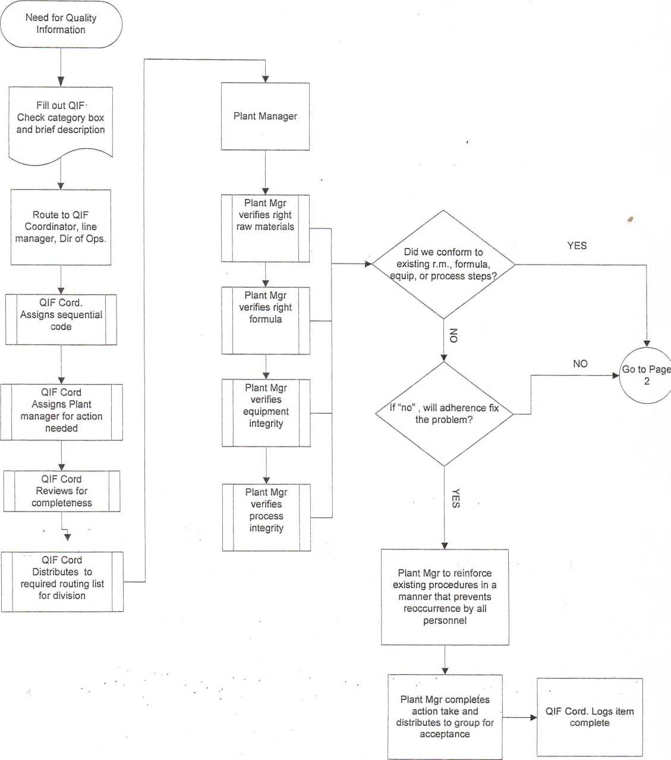

Quality Incident/lnformation
Request Process Flow
Page 2
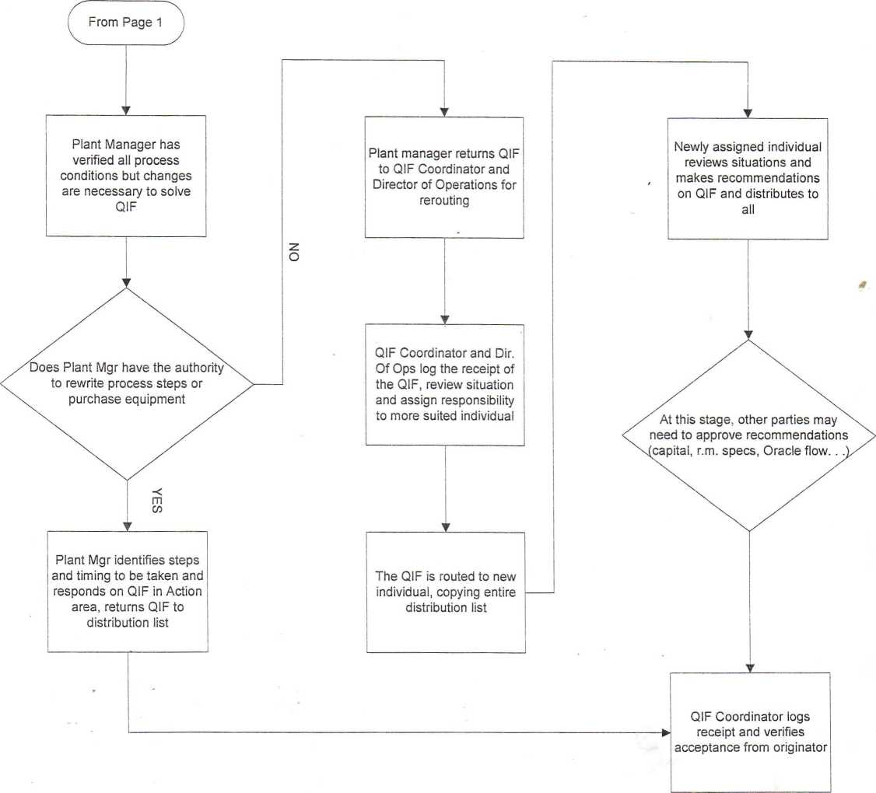

SECTION 10
FINISHED PRODUCTS


FINISHED PRODUCTS
a
Bagged
- AgPro60

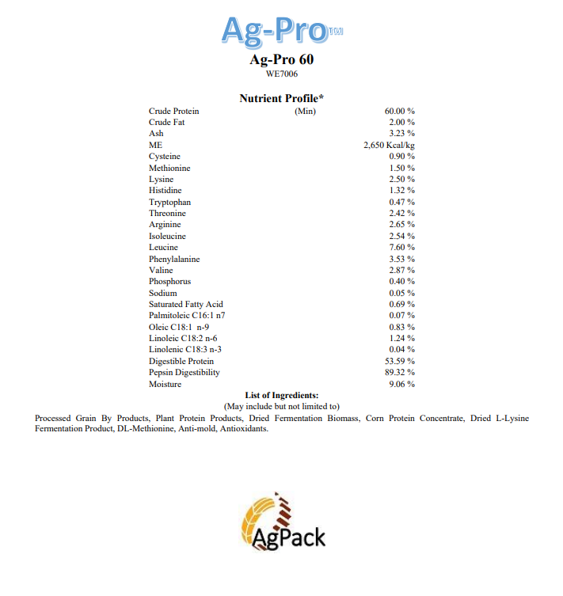

QUALITY ASSURANCE SPECIFICATION
“SUEUBTi | ORACLE ITEM NO. | “PAGE'MO
Finished Material Specification | AG60 | 1 of 2
 | DATE | SUPERSEDES
AgPro60 | January 3, 2022 | ' N/A

- DESCRIPTION
® ®
Vegetable Protein
II. ANALYSIS  Nutritional Standards  Characteristics  Protein  Moisture  Density(lbs/ft³) | Standard  65.0%  5.0%  36.9 | Expected Ranqe 65.0%-67.0%  1.0%-10.0%  31.1-43.1 | Test Method  N Cube Combustion Moisture Analyzer Bulk Density Test
b) Physical Standards
1. Color | Light tan to dark brown
2. Odor | Citrusy blend
3. Visual | Small granular of different color

- PACKAGING
Typical packaging is bulk. Bulk material can be delivered via truck or railcar. Augur systems are utilized to transfer material as needed within the production system. Precautions must be taken to minimize exposure to moisture or other contaminants. Product is to be stored so that moisture exposure is kept to a minimum

QUALITY ASSURANCE SPECIFICATION
SUBJECT | ORACLE TTEOW. |  | Page No.
Finished Material Specification |  | AG60 | 2 of 2
AgPro60 | DATE | January 3, 2022 | SUPERSEDES  N/A

- DEFECTIVES
Excessive moisture/clumping
Foreign material
Visual oversized product or particles in product Positive “Animal DNA ” test
- APPROVED SUPPLIERS
N/A
Approved By: Date:

SECTION 11
RECALL PROGRAM
RECALL PROGRAM

RECALL PLAN FLOW
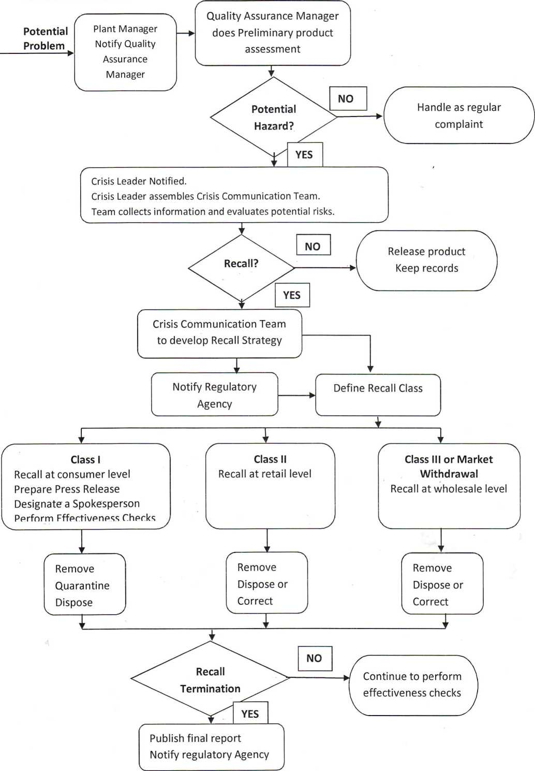
Crisis Communication Tree
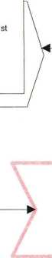





Phone call to Crisis Leader ( C. Smith), 1 alternate, Division President
Crisis
(Natural Disaster, Catastrophic event, Product Safety)
Crisis Leader assembles team
>
Facility manager assembles information
Internal
Communications
Manager
Documents Needed:
Incident report, SDS of all ingredients/products
Crisis Communication Team
Public Relations (Aberdeen
203-618-1709)
Division President
Crisis Leader determines
media contact (typically
Division President)




Crisis Leader determines
timing of internal and
external communication
Collect documents for
team, including facility
detail and media contact
sheet
Prepares Public
statements for CEO
Gathers information from
support team, acts as
backup to Crisis Leader
(CEO)
Support Team
CFO - Insurance
EVP Sales & Marketing-Advisor Communications Legal Counsel (Dorsey & Whitney LLP 212-415-9200)
Division President - Backup to Crisis Leader Director of Operations - Facility Information
Director of HR - Personnel Information

JAT 10/03/13



STANDARD OPERATING PROCEDURE  Recall Plan | Effective Date 11/18/2014 | Number  Recall-1
Animal Health & Nutrition Division | Page  1 Of 3 | Revision  #1

- CONCEPT
H.J. Baker & Bro., Inc. Animal Health & Nutrition division shall maintain a plan to recall product, should a situation deem necessary. The objectives are to:
•stop the distribution and sale of any affected product
•effectively notify management, customers, and regulatory authorities (as needed)
•efficiently remove effected product from the marketplace •take action to prevent reoccurrence
All responsibilities at each step of the recall process are outlined in the Recall Program under “Recall Plant Duties”. This SOP is to define the planned steps to take when performing a recall.
- PRIOR KNOWLEDGE
The employee must read and understand the procedures on this SOP.
- QUALITY CONCERNS
A product recall is completed to protect animal/human health and safety.
- PROCEDURES
1. Problem Indication
- All potential problems reported to H.J. Baker & Bro., Inc. shall be reviewed and investigated to determine the severity of the issue.
- Should a potential problem involving a potential feed/food safety risk or company reputation issue, the Plant Manager shall contact the Quality Assurance Manager for further investigation.
- When a complaint is received the Quality Assurance Manager shall perform a preliminary product assessment and determine if there is a potential hazard present.
- When a potential hazard exists the Quality Assurance Manager must notify the Director of Operations who will in turn notify the Crisis Leader. QA manager will contact IT to establish a technical email group to minimize communication error. QA Manager to make a Box folder to keep track of all relevant information.
- The Crisis Leader will assemble the Crisis Communication Team.
- Appendix A, part A to be completed by Quality Assurance Manager
& East Operations Manager and distributed to Crisis
Communication Team.
- Director of Operations to advise Division Management of risk or lack of risk of staying in production
STANDARD OPERATING PROCEDURE  Recall Plan | Effective Date 11/18/2014 | Number  Recall-1
, Animal Health & Nutrition Division | Page  2 of 3 | Revision  #1

- Director of Operations to inform of technical services’ advice on production interruption, verification method and all options available. Crisis Communication Team to decide best course of action to take to verify threat, continue or cease production and who needs to be informed of the situation at this point.
- Crisis Communication Team to decide whether a recall is warranted.
- If no recall is needed, release the product and keep ail records.
- If recall is needed proceed to the next steps in this recall plan.
- Threat Confirmation
- Crisis Communication Team shall develop a recall strategy specific to the product being recalled and the hazards involved. (Guidelines in Appendix B).
- Crisis Communication Team shall designate FDA contact person and HUB Public contact person.
- Division General Manager to notify FDA by phone and Reportable Food Registry website.
- Recall Implemented
- Crisis Communication Team to handle all public relations
- Quality Assurance Manager to gather all needed recall information (Appendix A, part B) and distribute to Crisis Communication Team.
- Internal Communications Manager advised of public message.
- Sales Manager to inform customers and or suppliers of the nature of the problem by phone.
- Marketing to generate a letter to customers with details of the recall. Product, Individual Bill of Lading numbers, date loads were delivered and weights.
- Crisis Communication Team to devise a failsafe method to track and account for all recalled material.
- Local Manager to arrange schedule to remove the recalled product from all customer facilities and route to predetermined site.
- Local Manager to quarantine, dispose, or correct the recalled material following FDA guidelines.
- Accounting to devise coding and communicate to all involved personnel of the system to track expenses involved.
- Production Coordinator reallocate finished feed production to unaffected plants as needed
STANDARD OPERATING PROCEDURE  Recall Plan | Effective Date  11/18/2014 | Number  Recall-1
Animal Health & Nutrition Division | Page  3 of 3 | Revision  #1

- Production Coordinator to reroute inbound raw materials destinations to unaffected plants as needed
- Credits issued for material picked up at customer sites
- Crisis Communication Team to fully account for expenses involved.
- Crisis Communication Team to fully account for all recalled material
- East Operations Manager to perform Root Cause Analysis study and implement measures to prevent future occurrence.
- Termination of Recall
A recall will be terminated when FDA and the recalling firm are in agreement that the product subject to the recall has been properly removed and correctly handled.
- Mock Recall
A mock recall shall be performed at least annually (1 plant per year in the Animal Health & Nutrition Division) per procedures defined in the Mock Recall SOP. All documents shall be kept according to corporate guidelines.
- Record Retention Policy
All records in regards to a recall or a mock recall shall be kept according to corporate guidelines.
Training Documentation
Employee Name Date of Training/Certification
Signature verifying trainee has read and understands SOP
Recall Plan Duties
- PROBLEM INDICATION
- Plant Manager
- Notify QA manager of potential problem
- Gather all information requested regarding problem
- Determine "Book Ends" via batching records, empty bin logs, etc.
- Trucking logistics if needed at this step
- Quality Assurance Manager
- Preliminary product assessment to determine if potential hazard exists
- Notify Director of Operations of potential hazard '
- Contact IT to establish technical email group
- Fill out Recall Program Appendix A part A
- Director Of Operations
- Notify Crisis Leader of potential hazard
- Advise Division Management of risk of staying in production
- Keep Crisis Team informed of all information from Operations.
- Crisis Leader
- Assemble Crisis Communication Team
- Oversee all activities of Crisis Communication Team
- Crisis Communication Team
- Gather all information from Director of Operations
- Determine best course of action to verify threat
- Decide whether to continue or cease production
- Determine who needs to be informed of the situation at this point
- Determine if recall is warranted
- THREAT CONFIRMATION
- Crisis Communication Team
- Develop recall strategy using guidelines in Appendix B
- Designate FDA contact person
- Designate AgPack Public Contact person
- Designated FDA Contact
- Notify FDA by phone
- Notify FDA by Reportable Food Registry Website
- RECALL IMPLEMENTED
- Crisis Communication Team
- Devise fail safe method to track and account for all recalled material
- Fully account for expenses involved
- Fully account for recalled material
- Quality Assurance Manager
- Gather all needed information for Recall Program Appendix A, Part B
- Fill out Appendix A, Part B and place in Box
- Internal Communication Manager
- Handle all public relations
- Advises of public message
- Sales Manager
- Inform Customers of the nature of the problem
- Marketing Manager
- Generate letter to customers with details of the recall, product, BOL number, date of delivery, and weights
- Plant Manager
- Arrange schedule to remove recalled product from all customer facilities
- Route recalled product to predetermined site
- Quarantine, dispose, or correct recalled material following FDA guidelines
- Production Coordinator
- Reallocate finished feed production to unaffected plants
- Reroute inbound raw materials to unaffected plants
- Accounting
- Devise coding to track expenses
- Issue credits for recalled material
- TERMINATION OF RECALL
- Crisis Communication Team
- Work with FDA on agreement of recall termination
- RECORD RETENTION
- Quality Assurance Manager
- Ensure completion of all documents and save to Box
- Plant Manager
- Keep hard copies of all documents on site
- MOCK RECALL
- Quality Assurance Manager
- Perform Annual Mock Recall
- Complete Recall Plan Appendix C
- Ensure completion of all documents and save to Box
- Plant Manager
- Assist QA Manager in mock recall
Recall Contact List

Albertville Plant Manager
Blake Diamond
(Direct) 256-279-9047 (Cell) 203-293-5750
Secondary-Forest Plant Manager-Mike Walsh

Forest Plant Manager
Mike Walsh
(Direct) 601-469-2812
(Cell) 203-293-3882
Secondary-Bruce Warren
(Cell) 601-668-1276

Ft. Smith Plant Manager
Eugene Rogers
(Direct) 479-222-0315
(Cell) 203-291-9011
Secondary

Sanford Plant Manager
Mike Kelly
(Direct) 919-774-7956
(Cell) 203-451-4426
Secondary-East Operations Manager- Matt
Kimes

Quality Assurance Manager
Lacy Westfall
(Direct) 479-222-0310
(Cell) 203-451-9764
Secondary-East Operations Manager-Matt
Kimes or Director of Operations-Ric Valagene

East Operations Manager
Matt Kimes -
(Direct) 251-202-3820
(Cell) 203-451-5451
Secondary-Director of Operations-Ric Valagene or General Manager-Clark Springfield

Director of Operations
Ric Valagene
(Direct) 417-732-9229
(Cell) 203-451-5264
(Home) 417-732-1916
Secondary-East Operations Manager-Matt
Kimes or General Manager-Clark Springfield

General Manager
Clark Springfield
(Direct) 501-400-0621
(Cell) 203-216-2903
Secondary-Director Business Operation and
Procurement-John Hickey
(Direct) 501-400-0632
(Cell) 203-216-8266

Westville Plant Manager
Harold Ballou
(Direct) 539-664-9640
(Cell) 203-216-0966
(Home) 479-824-5610
Secondary-Assistant Plant Manager-Scott Hale (Direct) 539-664-9640
(Cell) 918-696-1608
(Home) 918-723-3446
WWW
STANDARD OPERATING PROCEDURE  Mock Recall | Effective Date 11/18/2014 | Number  Mock Recall-1
Animal Health & Nutrition Division | Page  1 Of 1 | Revision  #1

- CONCEPT
H.J. Baker & Bro., Inc. Animal Health & Nutrition division shall perform a mock recall at least annually (1 plant per year in the Animal Health & Nutrition Division) per procedures defined in this SOP.
- PRIOR KNOWLEDGE
The employee must read and understand the procedures on this SOP.
- QUALITY CONCERNS
A mock recall is completed to determine the effectiveness of the recall plan.
IV PROCEDURES
- A Mock Recall will be performed at least annually in the Animal Health & Nutrition Division.
- The Quality Assurance Manager will determine the plant and scenario that is to be used to test the effectiveness of the recall plan.
- All correspondence during the Mock Recall must be labeled “MOCK RECALL”
- A full report of the Mock Recall is to be written and distributed.
- Appendix C is to be completed by QA manager and placed into a folder on Box.
- Any problems identified during the Mock Recall shall be corrected and repeated within a reasonable time frame.
- All records are to be kept of mock recalls as per corporate guidelines.
Training Documentation
Employee Name Date of Training/Certification
Signature verifying trainee has read and understands SOP
APPENDIX A
PRODUCT RECALL FORM
Date:
Plant Location:
- INFORMATION FOR RECALL DESCISION
- What is the product?
- What is the source of the complaint?
Name:
Company:
Address:
Telephone:
Fax:
- When was the complaint received?
- What is the reason for the complaint?
- What tests have been carried out that support the complaint?
- Detailed Information about product involved.
Product:
Invoice Number:
Bill of Lading:
Date of Manufacture:
Date of Delivery:
Quantity:
Disposition of product:
- Information on raw material. Suppliers:
Quantity in finished product:
Quantity still on hand:
Disposition of product on hand:
- RECALL INFORMATION
1. Number of loads and tonnage affected
- Customers affected and how much product exists on hand
- Name and contact information for the person contacted to stop selling the product.
- Destination for recalled product
- Recalling duration
- Start Time-
- Finish Time-
- Depth of the recall
- Class I
- Class II
- Class III
Comments-
- Were all Customers notified?
- Was all recalled product accounted for?
APPENDIX B
21CFR Section 7.42 Recall Strategy
1. GENERAL
- A recall strategy that takes into account the following factors will be developed by
the agency for a Food and Drug Administration- requested recall and by the recalling firm for a firm- initiated recall to suit the individual circumstances of the particular recall: '
- Results of health hazard evaluation.
- Ease in identifying the product.
- Degree to which the product's deficiency is obvious to the consumer or user.
- Degree to which the product remains unused in the market-place.
- Continued availability of essential products.
- The Food and Drug Administration will review the adequacy of a proposed recall strategy developed by a recalling firm and recommend changes as appropriate. A recalling firm should conduct the recall in accordance with an approved recall strategy but need not delay initiation of a recall pending review of its recall strategy.
- ELEMENTS OF A RECALL STRATEGY
A recall strategy will address the following elements regarding the conduct of the recall:
- Depth of recall- Depending on the product's degree of hazard and extent of distribution, the recall strategy will specify the level in the distribution chain to which the recall is to extend, as follows:
- Consumer or user level, which may vary with product, including any intermediate wholesale or retail level; or
- Retail level, including any intermediate wholesale level; or
- Wholesale level.
- Public warning- The purpose of a public warning is to alert the public that a product being recalled presents a serious hazard to health. It is reserved for urgent situations where other means for preventing use of the recalled product appear inadequate. The Food and Drug Administration in consultation with the recalling firm will ordinarily issue such publicity. The recalling firm that decides to issue its own public warning is requested to submit its proposed public warning and plan for distribution of the warning for review and comment by the Food and Drug Administration. The recall strategy will specify whether a public warning is needed and whether it will issue as:
1. General public warning through the general news media, either national or local as appropriate, or
- Public warning through specialized news media, e.g., professional or trade press, or to specific segments of the population such as physicians, hospitals, etc.
- Effectiveness check- The purpose of effectiveness checks is to verify that all consignees at the recall depth specified by the strategy have received notification about the recall and have taken appropriate action. The method for contacting consignees may be accomplished by personal visits, telephone calls, letters, or a combination thereof. The recalling firm will ordinarily be responsible for conducting effectiveness checks, but the Food and Drug Administration will assist in this task where necessary and appropriate. The recall strategy will specify the method(s) to be used for and the level of effectiveness checks that will be conducted, as follows:
- Level A-100 percent of the total number of consignees to be contacted;
- Level B-Some percentage of the total number of consignees to be contacted, which percentage is to be determined on a case-by-case basis, but is greater that 10 percent and less than 100 percent of the total number of consignees;
- Level C--10 percent of the total number of consignees to be contacted;
- Level D-2 percent of the total number of consignees to be contacted; or
- Level E-No effectiveness checks.
- RECALL CLASS DEFINITIONS
Recalls are actions taken by a firm to remove a product from the market. Recalls may be conducted on a firm's own initiative, by FDA request, or by FDA order under statutory authority.
- Class I recall: a situation in which there is a reasonable probability that the use of or exposure to a violative product will cause serious adverse health consequences or death.
- Class II recall: a situation in which use of or exposure to a violative product may cause temporary or medically reversible adverse health consequences or where the probability of serious adverse health consequences is remote.
- Class III recall: a situation in which use of or exposure to a violative product is not likely to cause adverse health consequences.
- Market withdrawal: occurs when a product has a minor violation that would not be subject to FDA legal action. The firm removes the product from the market or corrects the violation. For example, a product removed from the market due to tampering, without evidence of manufacturing or distribution problems, would be a market withdrawal.
APPENDIX C
Mock Recall Record
Plant Location
Date & Time lnitiated(AM/PM) | -
Date & Time Completed (AM/PM)
Description of Product or Raw Material U y " ' -
Description Of Scenario

Problems identified | Corrective Action

Completed By: Date:
Reviewed By:



JOB DESCRIPTION

JOB DESCRIPTION
Position Title: | Administrative Assistant
Reports To: | Plant Manger

POSITION SUMMARY
This position is to assist the plant manager by performing vital daily activities to ensure the highest level of customer satisfaction, both internally and externally.

POSITION RESPONSIBILITIES
- Sage 100 data entry: shipping, receiving, batching, quality data, freight rates, as required.
- Maintain all daily reports: daily inventory, color sheet, daily activity log, etc.
- Submit weekly time sheet to payroll.
- Maintain personnel records: Vacation/ Sick days available.
- Facilitate pick-up and delivery of product.
- Assemble weekly delivery schedule from all sales order emails
- Coordinate pick-up numbers with the carriers
- Perform a daily follow up with the carriers
- Notify manager of any delays in the schedule
- Communicate customer problems with sales staff and product coordinator.
- Record retention: organize, file and preserve all shipping, receiving, and batching records.
- Shipping & Receiving:
- Check or weight trucks in.
- Prepare relative load documents: receiving, delivery order, copies of washout, etc.
- Communicate shipments to the production staff.
- Make sure all shipping docs are in order for railcar release. (if applicable)
- Aid in month end and year end inventories.
- Scan and submit monthly bills to accounting
- General office duties:
- Answer the telephone
- Greet vendors and visitors
- Prepare and set up Fed-ex or UPS shipments (samples)
- Order general plant supplies.
- Office housekeeping
- Assist the manager and corporate team whenever needed.
- In addition, all employees are responsible for “Food Quality and Safety”

POSITION SPECIFICATIONS
Good verbal, written and communication skills.
- Ability to accomplish results through cooperative efforts.
- Ability to adapt to process changes.
- Efficient in Word and Excel.
- Previous experience in office management is a plus.

JOB DESCRIPTION
Position Title: | Plant Supervisor
Reports To: | Manager

POSITION SUMMARY
This position is accountable for directing all plant operators and coordinating incoming and outgoing product (shipping and receiving). Plant Supervisor will oversee all ingredient inventories in production tanks to ensure steady and efficient production of formulated finished product.

POSITION RESPONSIBILITIES
- Will continue all duties and responsibilities of the position presently held.
- Monitor production ingredient tank inventory and coordinate incoming loads to correct production tanks.
- Maintain plant efficiencies both in the presence and absence of the Plant Manager.
- Coordinate the actions of fellow production workers to ensure safe, smooth and efficient loading and unloading of product.
- Responsible for Sage 100 real time data entry in a timely and accurate fashion. (Real Time Shipping and Receiving in Sage)
- Coordinate with next shift any information needed that would affect that shift.
- Promote a safe work environment for all employees and freight carriers.
- Will assure that all production employees have the ingredient tank inventory information necessary to have uninterrupted production.
- Plant Supervisor will be efficient in all other positions in production plant through Cross Training provided in case of vacations or absences.
- POSITION SPECIFICATIONS
- Excellent verbal, written and communication skills.
- Some computer skills.
- Ability to accomplish results through cooperative efforts.
- Be able to cross train for other production positions.

JOB DESCRIPTION

Position Title:
Lab Technician

Manager / asst. Manager
Reports To:

POSITION SUMMARY
This position is accountable for daily functions of the lab. Including, but not limited to, various testing on inbound and outbound products, routine lab maintenance, and data entry.

POSITION RESPONSIBILITIES
- Test proteins on inbound ingredients and finished products.
- Test moistures on inbound ingredients and finished products.
- Take routine inventory of lab supplies.
- Order lab supplies as needed.
- Perform routine maintenance on all lab equipment.
- Enter test results into Oracle
- Prepare samples to send to outside labs for various testing.
- Send daily analysis report to appropriate management personnel.
- Be aware of MSDS information for all lab supplies.
- Understand and follow all laboratory SOP’s.

POSITION SPECIFICATIONS
- Previous lab experience preferred
- Excellent verbal, written and communication skills.
- Ability to understand and follow all laboratory procedures.
- Moderate computer literacy. Oracle experience is a plus.
- Ability to accomplish results through cooperative efforts.

In addition, all employees are responsible for “Food Quality and Safety”.

JOB DESCRIPTION
Position Title: | Plant Operator
Reports To: | Manager / asst. Manager
Location: | Disputanta, VA

POSITION SUMMARY
This position is accountable for directing and coordinating incoming and outgoing product (shipping and receiving). Plant Operator will oversee all ingredient inventories in production tanks to ensure steady and efficient production of formulated finished product.

POSITION RESPONSIBILITIES
- Will continue all duties and responsibilities of the position presently held.
- Monitor production ingredient tank inventory and coordinate incoming loads to correct production tanks.
- Maintain plant efficiencies both in the presence and absence of the Plant Manager.
- Coordinate the actions of fellow production workers to ensure safe, smooth and efficient loading and unloading of product.
- Responsible for Oracle real time data entry in a timely and accurate fashion in the Scale room within 30 minutes after truck departure. (Real Time Shipping and Receiving in Oracle)
- Coordinate with next shift any information needed that would affect that shift.
- Promote a safe work environment for all employees and freight carriers.
- Will assure that all production employees have the ingredient tank inventory information necessary to have uninterrupted production.
- Plant Operator will be efficient in all other positions in production plant through Cross Training provided in case of vacations or absences.
In addition, all employees are responsible for “Food Quality and Safety”.

POSITION SPECIFICATIONS
- Excellent verbal, written and communication skills.
- Some computer skills.
- Ability to accomplish results through cooperative efforts.
- Be able to cross train for other production position

DESCRIPCIÓN DE FUNCIONES
Título de la posición: | Empleado de producción
Informa a: | Gerente / Operador
Ubicación: | Disputanta, VA

RESUMEN DE LA POSICIÓN
Esta posición es responsable de todos los deberes relacionados con la producción.

RESPONSABILIDADES DEL PUESTO
- Continuará con todos los deberes y responsabilidades del cargo que actualmente ocupa.
- Embolsado y apilamiento adecuado de los productos.
- Mantener la eficiencia de la planta tanto en presencia como en ausencia del Gerente de Planta.
- Coordinar las acciones de los compañeros trabajadores de producción para garantizar una carga y descarga segura, fluida y eficiente del producto.
- Coordinar con el siguiente turno cualquier información necesaria que afecte a ese turno.
- Promover un ambiente de trabajo seguro para todos los empleados y transportistas de carga.
- .
Además, todos los empleados son responsables de "Calidad y Seguridad Alimentaria".

ESPECIFICACIONES DE POSICIÓN
- Excelentes habilidades verbales, escritas y de comunicación.
- Capacidad para lograr resultados a través de esfuerzos cooperativos.
- Ser capaz de cruzar el tren para otra posición de producción

JOB DESCRIPTION
Position Title: | Production Employee
Reports To: | Manager / Operator
Location: | Disputanta, VA

POSITION SUMMARY
This position is accountable all production related duties.

POSITION RESPONSIBILITIES
- Will continue all duties and responsibilities of the position presently held.
- Proper bagging and stacking of products.
- Maintain plant efficiencies both in the presence and absence of the Plant Manager.
- Coordinate the actions of fellow production workers to ensure safe, smooth and efficient loading and unloading of product.
- Coordinate with next shift any information needed that would affect that shift.
- Promote a safe work environment for all employees and freight carriers.
- .
In addition, all employees are responsible for “Food Quality and Safety”.

POSITION SPECIFICATIONS
- Excellent verbal, written and communication skills.
- Ability to accomplish results through cooperative efforts.
- Be able to cross train for other production position

SECTION 13

RAW INGREDIENTS

INGREDIENTS

BULK
- SBM
- CGM

BAGGED
- DL Methionine
- Pet-Ox
- Empyrel75
- Fish Meal
- Myco-Curb
- BioLys

QUALITY ASSURANCE SPECIFICATION
SUBJECT | ORACLE ITEM NO. | PAGE NO.
Raw Material Specification | MFISH | 1 of 2
 | DATE | SUPERSEDES
Menhaden Fish Meal | June 11, 2014 | ' N/A

I. DESCRIPTION
Menhaden Fish Meal
II. ANALYSIS
a) Nutritional Standards |  | Expected Ranqe 56.3%-68.8% 6.6% -10.9% 3.4%-10.6%  34-35 | Test Method N Cube Combustion Moisture Analyzer AOAC 920.39 Bulk Density Test
Characteristic  Protein Moisture Fat  Density(lbs/ft³) | Standard  62.5%  8.7% 7.0% 34.5 | Expected Ranqe 56.3%-68.8% 6.6% -10.9% 3.4%-10.6%  34-35
b) Physical Standards  - Color  - Odor  - Visual | Light tan-light brown  Characteristic fishy odor  Granular with small fish scale particulate

III. PACKAGING
Typical packaging is bulk. Bulk material can be delivered via truck or railcar. Augur systems are utilized to transfer material as needed within the production system. Precautions must be taken to minimize exposure to moisture or other contaminants. Product is to be stored so that moisture exposure is kept to a minimum.

This recognition that employees sometimes store information on devices other than company hardware and systems does not condone such practice where such practice is prohibited by H. J. Baker policy.

