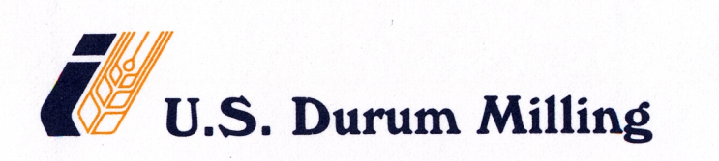

GLOVE POLICY

It is the policy of U.S. Durum milling to strictly enforce the glove policy in production areas. If cuts or open sores are present on the hands of any particular employee, then he will be kept away from the product contact areas. In the event if his situation calls for in-workable condition, then that particular individual will be required to wear the gloves being provided by the Company at all times while working in the production area (non product contact areas).

