- Purpose: The purpose of the Sanitation SOP’s is to provide Miller sanitation personnel the procedures to safely and effectively clean the facility and equipment.

- Scope: Comvair Emulsifier

- Definitions: None

- Responsibilities
  - Sanitarian: Clean, rinse, and sanitize the equipment
  - Pre-op Personnel: Reassemble cutting assembly, visually inspect, swab, reclean if necessary
  - VP of Administration: Assure adherence to sanitation SOP’s and related documentation. Review and update as necessary.

- Procedure
  - Put on the appropriate PPE for the sanitation chemicals in usef
  - Remove power from the Emulsifier
  - Put plastic bag over Emulsifier control panel
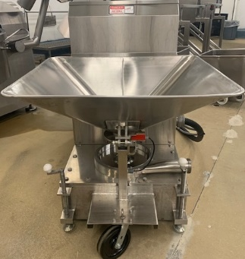

  - Remove Emulsifier cutting head assembly (Barrel, plates, knives)
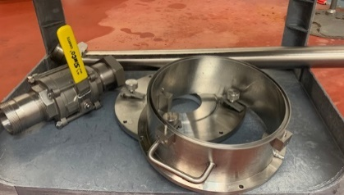

  - Soak cutting head assembly in hot water for 30 minutes
  - Hand clean big pieces of debris with single use scratch pad.

  - For emulsifier parts.
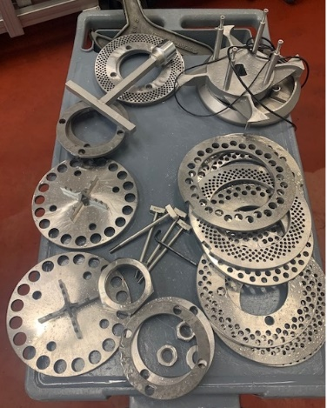

  - Foam emulsifier parts with Enrich 299 at the recommended concentration.
  - Handwipe emulsifier parts with a single use scratch pad or white bristled brush.
  - Rinse emulsifier parts with hot, low pressure water.
  - Visual inspection using flashlight to ensure the cleanliness of equipment’s and parts before sanitizing. (If found food residues, reclean as needed)
  - Sanitize emulsifier with Multi-Quat at the recommended concentration.
  - Take Comvair Emulsifier parts to wash and Using air blower to remove excess water on the emulsifier parts completely.
  - Apply mineral oil overnight to prevent rust and continue cleaning the rest of the Emulsifier machine.
  - Rinse emulsifier machine from top to the bottom with hot, low pressure water.
  - Foam emulsifier with Enrich 299 at the recommended concentration.
  - Handwipe emulsifier with a single use scratch pad or white bristled brush.
  - Rinse emulsifier from the top down with hot, low pressure water to remove the chemical residues.
  - Visual Inspection of the equipment’s before sanitizing. (If found food residues, clean as needed)
  - Sanitize emulsifier machine with Multi-Quat at the recommended concentration.

- Records
  - Pre-op checklist to include Charm unit swab record.
  - Master Sanitation Plan

- Document History
REVIEWED: | PROPOSED CHANGE:
Roland Pilar  Dated:12/6/2021. | Removed Indosan 485 changed to Multi-Quat. Removed As part of pre-op process, reassemble the cutting head assembly, swab emulsifier, and reclean as necessary.  Visual inspection using flashlight to ensure the cleanliness of equipment’s and parts before sanitizing. (If found food residues, reclean as needed)  Removed  Soak cutting head assembly in Dominate for 30 minutes
Roland Pilar 2/1/2022 | Change Photos from old Emulsifier machine to new machine photos.
Roland Pilar/Alfredo Robles 03/15/2023 | Added SSOP number

