- Purpose: The purpose of the Sanitation SOP’s is to provide Miller sanitation personnel the procedures to safely and effectively clean the facility and equipment.
- Scope: FOOD CONTACT CONTAINER TUBS

- Definitions: None

- Responsibilities
  - Sanitarian: Clean, rinse, and sanitize the equipment
  - Pre-op Personnel: Visually inspect, swab, reclean if necessary.
  - VP of Administration: Assure adherence to sanitation SOP’s and related documentation. Review and update as necessary.
- Procedure
  - Put on the appropriate PPE for the sanitation chemicals in use.
  - Small gray container tubs put in the gondolas and soak with FP0367t Grease X in recommend concentrations approx. 20-25 minutes to remove grease.
  - Rinse the remaining food contact container tubs with warm water to remove food residues & excessive grease.
  - FOR SMALL GRAY CONTAINER TUBS, use scratch pad or white bristled brush to remove build up food residues and excessive grease.
  - FOR SMALL GRAY CONTAINER TUBS, take gray container tubs from gondola for rinsing to remove chemical residues with warm water. Visual Inspection and apply sanitizer Multi-Quat at the recommended concentration. Let it air dry.
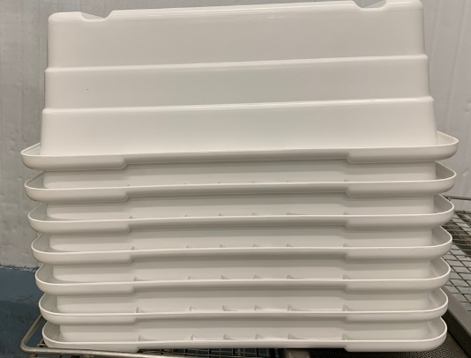
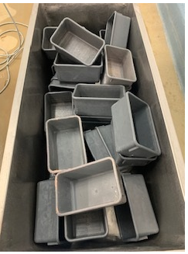
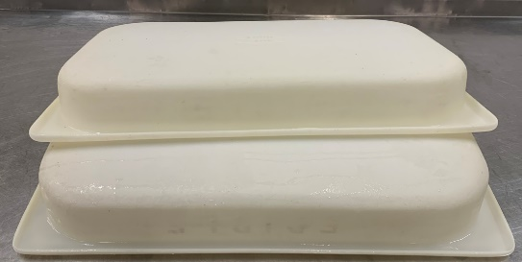

  - Foam the remaining food contact container tubs with Enrich 299 at the recommended concentration let approx. 10-15 minutes and use scratch pad or white bristled brush to remove build up food residues and excessive grease.
  - Rinse the remaining food contact container tubs with warm water to remove chemical residues.
  - Visual inspection using flashlight to ensure the cleanliness of food contact container tubs. (If found food residues, reclean as needed)
  - Sanitize The food contact container tubs with Multi-Quat at the recommended concentration.
  - Put container tubs upside down and let it air dry.
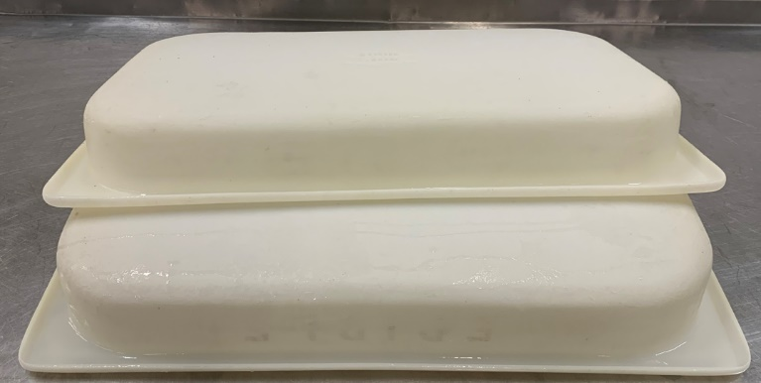
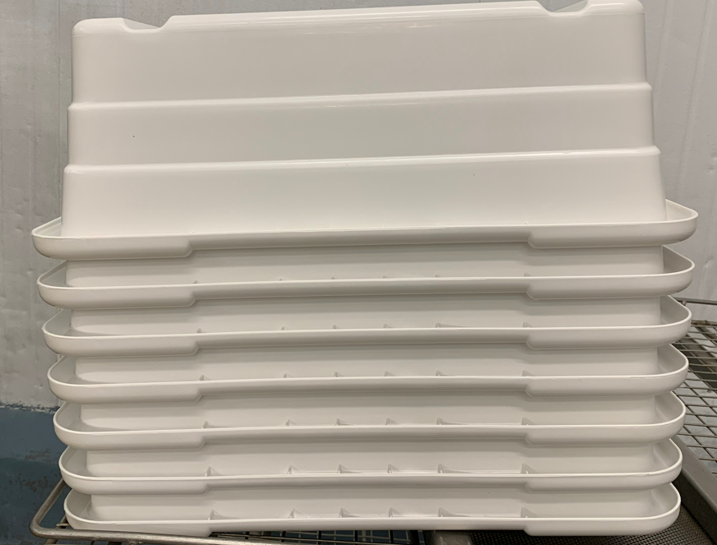
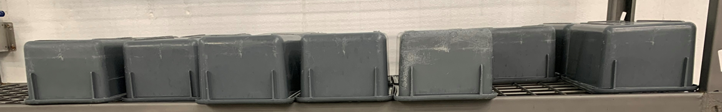
- Weekly Perasan A Mixing Procedure & measurements.
    - To mix please use the following based on 25 gallons of water:
    - Perafoam- Mix 6 ounces every 6 gallons of water. (24 ounces total)
    - Perasan A- Mix 1 ounces for every 6 gallons of water (4 ounces total)
    - Titrate using the Perasan A testing procedure, target is 91-195ppm of PerasanA.(+/- 13ppm)
    - Sanitize The food contact container tubs with Perasan A.

- Records

  - Pre-op checklist to include Charm unit swab record.
  - Master Sanitation Plan
- Document History
REVIEWED: | PROPOSED CHANGE:
Roland Pilar 6/27/2022 | 6.0 Weekly Perasan A Mixing Procedure & measurements.  6.1.1-To mix please use the following based on 25 gallons of water:  6.1.2-Perafoam- Mix 6 ounces every 6 gallons of water. (24 ounces total)  6.1.3-Perasan A- Mix 1 ounces for every 6 gallons of water (4 ounces total)  6.1.4-Titrate using the Perasan A testing procedure, target is 91-195ppm of PerasanA  6.1.5 Sanitize The food contact container tubs with Perasan A.
Roland Pilar 9/28/2022 | Added Perasan A mixing procedure & measurement.
Roland Pilar/ Alfredo Robles 03/15/2023 | Added SSOP number

