- Purpose: The purpose of the Sanitation SOP’s is to provide Miller sanitation personnel the procedures to safely and effectively clean the facility and equipment.

- Scope: Seydelmann Bowl Chopper (“Old” and “New”)

- Definitions: None

- Responsibilities
  - Sanitarian: Clean, rinse, and sanitize the equipment
  - Maintenance: Hand cleans cabinet under the bowl quarterly. Maintenance disassembles and reassembles the blade assembly weekly to allow more thorough cleaning in this area and sharpening of blades.
  - Pre-op Personnel: Reassemble blades and drain plugs, visually inspect, swab, reclean if necessary
  - VP of Administration: Assure adherence to sanitation SOP’s and related documentation. Review and update as necessary.

- Procedure (Daily)
  - Put on the appropriate PPE for the sanitation chemicals in use
  - Turn off power and lockout.
  - Open lid
  - Raise discharge disc.
  - Put plastic bag over Seydelmann control panel
    - 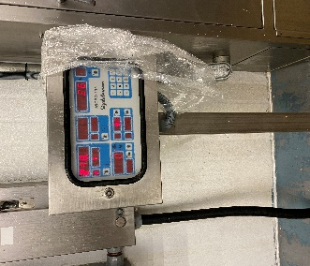

  - Scrape major debris from bowl, lid, blades, discharge disc, and discharge chute with stainless putty knife or similar.

  - Remove two drain plugs in bottom of bowl rinse handwipe drain plugs with single use scratch pad.
  - Rinse bowl, lid, blades, discharge disc, and discharge chute from the top to the bottom with hot, low pressure water to remove the excess food residues.
    - 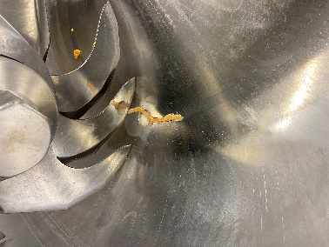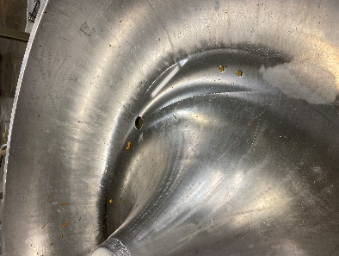

    - 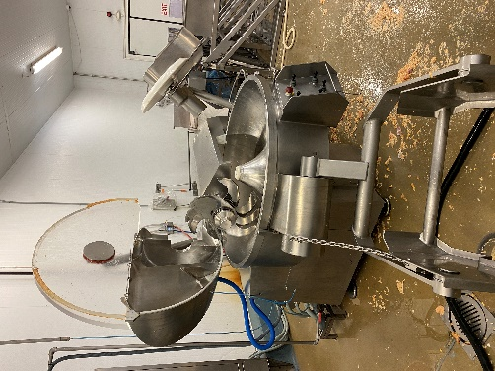

  - Foam bowl, lid, blades, discharge disc and discharge chute with Enrich 299 at the recommended concentration.
  - Handwipe everything in 5.7 with a single use scratch pad or white bristled brush. For Safety , put cutting gloves and use handheld white brush to brush the blades.

For Koch Kitchen carts,
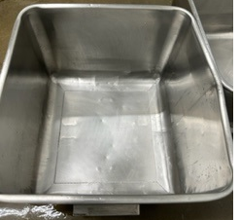
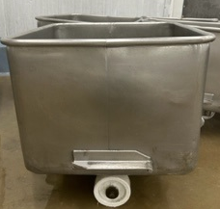

  - Rinse Koch Kitchen carts with hot, low-pressure water to remove the excess food residues.
  - Foam Koch Kitchen carts with Enrich 299 at the recommended concentration.
  - Rinse everything in 5.7 to 5.12 from the top down with hot, low-pressure water to remove chemical residues
(Remove excess water inside Koch Kitchen carts)
  - Visual inspection using flashlight to ensure the cleanliness of equipment’s and parts before sanitizing. (If found food residues, reclean as needed)
  - Sanitize everything in 5.7 with Multi-Quat at the recommended concentration. (200ppm-400ppm)
(Remove excess water inside Koch Kitchen carts)
  - Return power to the Seydelmann
  - As part of pre-op process insert drain plugs
- Procedure (Weekly)
  - On a weekly and or as needed basis, maintenance shall disassemble the blade assembly to allow a thorough foaming and hand cleaning of the shaft and the mating surfaces between blades. Blades are then sharpened in the maintenance shop.
  - Maintenance reinstalls blades in correct configuration.
  - Remove two drain plugs in bottom of bowl rinse handwipe drain plugs with single use scratch pad.
  - Rinse bowl, lid, blades, discharge disc, and discharge chute from the top to the bottom with hot, low pressure water to remove the excess food residues.
  - Foam bowl, lid, blades, discharge disc and discharge chute with Enrich 299 at the recommended concentration.
  - Handwipe everything in 5.7 with a single use scratch pad or white bristled brush. For Safety , put cutting gloves and use handheld white brush to brush the blades.
  - Rinse everything in 5.7 from the top down with hot, low-pressure water to remove chemical residues.
  - Visual inspection using flashlight to ensure the cleanliness of equipment’s and parts before sanitizing. (If found food residues, reclean as needed)
  - Sanitize everything in 5.7 with Multi-Quat at the recommended concentration. (200ppm-400ppm)
  - Return power to the Seydelmann

- Records
  - Pre-op checklist to include Charm unit swab record.
  - Master Sanitation Plan

- Document History

REVIEWED: | PROPOSED CHANGE:
Roland Pilar Dated:12/7/2021. | Removed Indosan 485 changed Multi-Quat.  Removed Soak drain plug and After 30 minutes.  Added Visual inspection using flashlight to ensure the cleanliness of equipment’s and parts before sanitizing. (If found food residues, reclean as needed)
Roland Pilar / Alfredo Robles 03/15/2023 | Added SSOP number.

