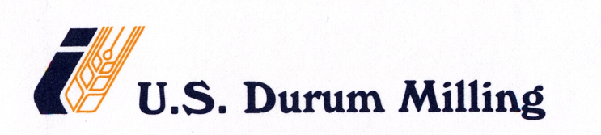

SICK - GLOVE - BAND AID POLICY

SICK POLICY: It is the policy of the Company to keep away the sick Employee away from the production zones. Depending on the nature of the sickness, management will determine whether the Employee can remain working with as-deemed-necessary restrictions. In any case sick employee will be kept away from the production zones. Progressing condition will be evaluated and necessary preventive steps will be implemented until the normal situation is attained.

GLOVE / BAND-AID-POLICY: It is the policy of the company to strictly enforce the glove policy in production areas. If cuts or open sores are present on the hands of any particular employee, then he will be kept away from the product contact areas. In the event if his situation calls for in-workable condition, then that particular individual will be required to wear regular band-aids and also wear the gloves that is being provided by the Company at all times while at work.

FIRST AID POLICY: It is the policy of the company that all injuries requiring minor first aid, such as band-aids or ointments from the first aid cabinet, are reported to a supervisor and logged in the mill log book for record.

In view of the automated milling process and strict implementation of the GMPs along with the
The Food Safety Management System / Preventive Controls that are in place, at the present time use of regular band aids is considered during mill working conditions for the purposes as explained above.

