Prepared by: Vic F.  Date: 4-15-16 |  |  | Approved by:  Date:
Rev | Section | Brief Description of Change |  | Effective Date
01 | All | Initial Release |  | 4-14-15
02 | 5 | Reformat, removed small QC Hold label with standards WIP-NCR form , add WIP-QC pending process, removed small QC on-hold label, included reference to batch ticket and lot ID # to be present with WIP

Purpose
The purpose of this procedure is to define the process for identification of products and materials through the production process and traceability that ensures that all products delivered to customers is uniquely identified, that all components are traceable to that product, and that samples are retained, as appropriate.

Scope
This identification procedure applies to all raw materials, intermediates and final products.

Responsibility
Quality Control shall issue lot numbers to all CCMI manufactured products.
Receiving / Shipping shall issue all raw material lot numbers at receipt of material.
Production Department shall verify acceptance of raw materials, shall record lot number data in production records, and shall accurately label all secondary packaging and containers with correct item numbers and lot numbers. Production personnel will ensure all work will be accompany with identification document ( BATCH TICKET for BULK / FG ). Shipping Department shall ensure all items shipped will have accurate shipper info and product / QTY matches accordingly.

Procedure

Receiving and Shipping shall assign lot numbers to raw material received at time of receipt. Raw material lot numbers shall utilize the unique number auto-generated and stored by the corporate ERP system. The Production Department shall record the lot number for each raw material and intermediate used in the production batch ticket of a CCMI product, documentation shall be made in the production record.

Nonconformity

NCR form is completed when an employee encounter an issue that requires review and or disposition by MRB. The NCR form will be placed with the product ( RAW MATERIAL, WIP – PRODUCT, WIP FINISHED GOODS ) to identifying it as requiring review and to ensure it will be segregated from cross contamination or mixed in with other products.

NCRs shall be written in a clear, concise and complete manner to ensure complete transfer of information regarding the non-conformance.

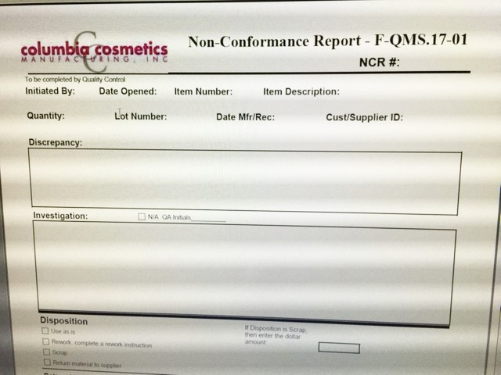

Rework in House (RIH):

All rework must be documented. Rework instructions must include appropriate documentation, instructions for rework, instructions for testing, and approval signatures of Production Manager, QA and R&D (designees may be used).

Rework instructions shall be distributed to production with the subject material for completion of the rework.

QC must inspect reworked material. QC will indicate the results of the inspection on the final page of the rework instruction and release the material to Production as appropriate

Product and Material Identification - Status

All materials, intermediates and finished products shall be identified in each stage of production from receiving through shipping.

All raw materials / components / production goods upon receipt shall be identified with a Receiving Label minimally displaying the item number, item description, CCMI Lot number, and Receipt date. This receiving white incoming label automatically states product as “ PENDING QC “ awaiting QC inspection.

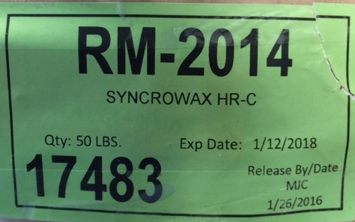
Upon QC release of Raw materials / Component / production goods, QC will apply a GREEN “ RELEASE ” label. Label shall include the item number, item description, lot number, status and QC inspector.

QC green “RELEASE” label shall be placed on as many product containers as reasonable. When a pallet of individually stacked product containers are released, minimally a sticker shall be placed on one product container on each side of the pallet on the container lowest on the pallet. This will ensure that the product release sticker shall remain with the pallet until all other containers are consumed.

(1) Upon completion of intermediate products, the product container shall be labeled with a WIP – PENDING label ( when awaiting for lab testing result , micro test in progress and or if product is in cue for QC inspection ). (2) Once WIP or Finished Good product passes QC in-process inspection, a “RELEASE” label will be applied over the WIP Pending white label. Label shall include the item number, item description, lot number, status and QC inspection.

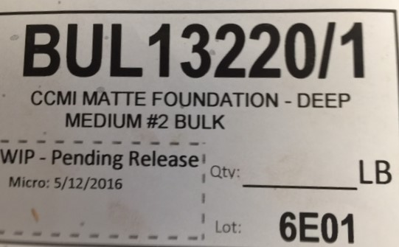
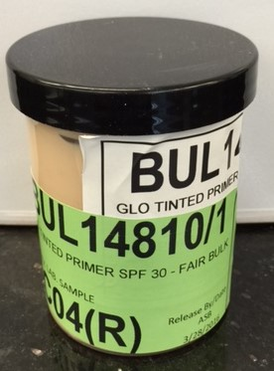

Lot Traceability Number

QC shall assign lot numbers to each production batch.

Specialized lot numbers requested by the customer shall be issued per the customer product specification.

Lot numbers shall utilize the following code: YMXXX

Production Year Code (Y) is a single digit numerical codes corresponding to the last digit of the calendar year in which the product is made.

Production Month Codes (M) is an alpha code corresponding to calendar month in which the product is made. E.g. Jan=A, Feb=B, Mar=C, April=D, May=E, June=F, July=G, Aug=J, Sept=K, Oct=L, Nov=M, Dec=N.

Lot/Batch Codes (XXX) are sequential lot or batch numbers, starting at 0001 for each product.

Production

All WIP product must be accompanied by their specific BATCH TICKET ( BULK AND FG ). Batch Tickets have individual number, which are generated by production scheduler. In addition to Batch Ticket, a Process Sheet will accompany the job which production will log each lot processed.

Production shall apply lot ID # onto products and packaging ( as applicable with surface space ) . ID application may be in the form of a jet ink print, stamping and or product label

1. Finished products shall be identified with a white “ FINISHED PRODUCT “ case label on each product container. Label shall include Customer, item number, item description, lot number, case quantity and date of Manufacture. This label identifies the finished product but does not indicate or convey status.
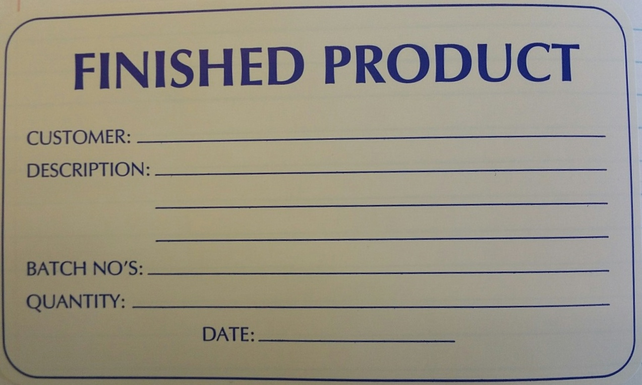

Individual cases may be further labeled with a “Partial Case” label indicating that the identified box is incomplete QTY.

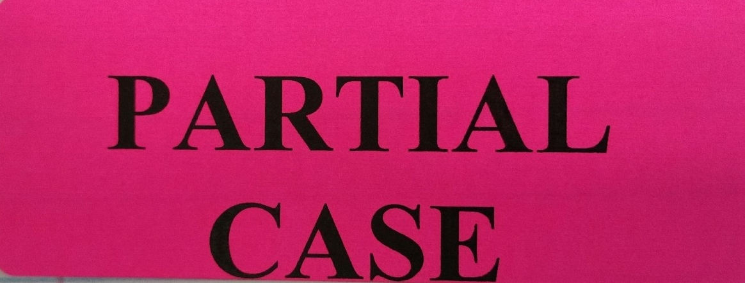

If additional process is required, a “HOLD” label may be applied to product case.

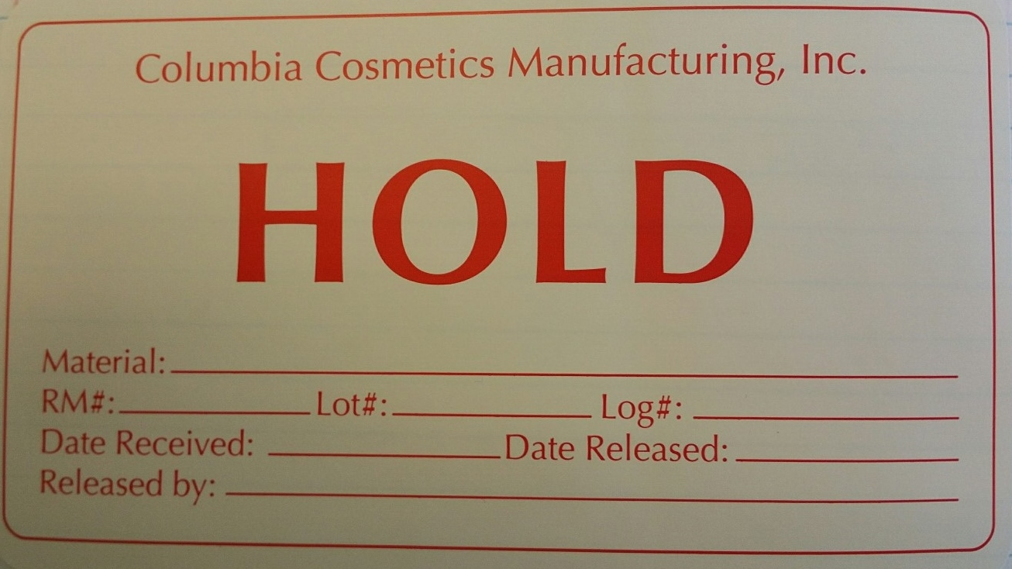

CCMI production and general warehousing areas are considered a released warehouse. All products staged or stored in these areas are considered released unless otherwise indicated by QC NCR-FORM notice and or on QC HOLD station.

QC HOLD station is the standard location of quarantined / NCR product.

These areas shall be clearly identified with a sign and the boundaries of the area shall be taped off.

Record Retention:

Quality Assurance shall maintain the records in accordance with the Document Control and SOP development, QMS.6.

