- Purpose: The purpose of the Sanitation SOP’s is to provide Miller sanitation personnel the procedures to safely and effectively clean the facility and equipment.

- Scope: Vemag Stuffer-Linkers: 208 Servo, 209 and 218

- Definitions
  - Stuffing Screws: Twin screws within the body of the stuffer that gently meter product from the bottom of the hopper through the barrel.

- Responsibilities
  - Sanitarian: Clean, rinse, and sanitize the equipment
  - Maintenance: Hand clean control and vacuum pump compartment of stuffer quarterly. Hand clean control compartment for linker quarterly.
  - Pre-op Personnel: Visually inspect, swab, reclean if necessary
  - VP of Administration: Assure adherence to sanitation SOP’s and related documentation. Review and update as necessary.

- Procedure
  - Put on the appropriate PPE for the sanitation chemicals in use
  - Disconnect machine power. Disconnect air from machine.
  - Separate link conveyor from linker. Separate linker from stuffer.
    - 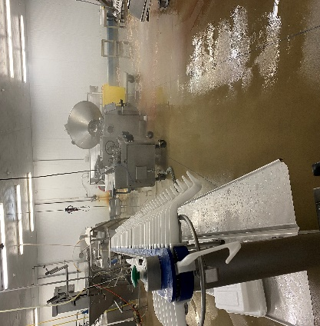

  - Release stuffer hopper and tilt back (2 people)
    - 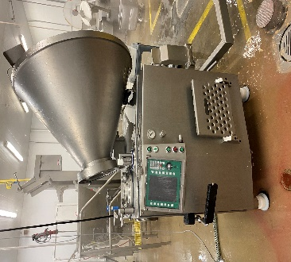
  - Remove feed screw at bottom of hopper
    - 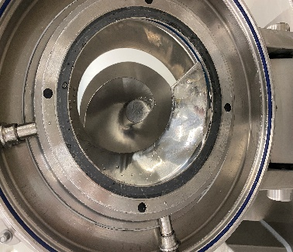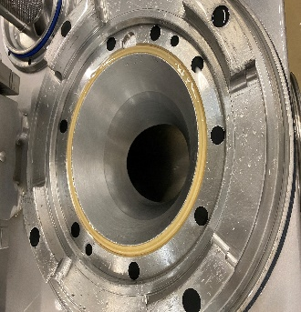
  - Remove hopper gasket
  - Remove vacuum filter cover, filter assembly, and O-ring
  - Remove stuffing horn
  - Remove twin stuffing screws
    - 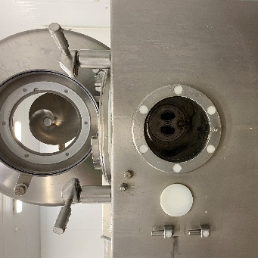

  - Remove stuffing tubes

  - Remove linking chain
    - 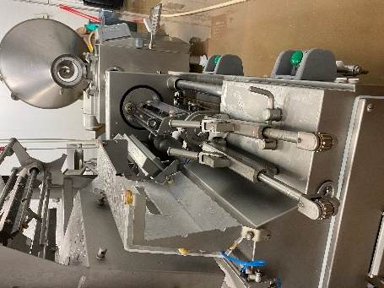

  - Soak items from 5.6 through 5.12 in Enrich 299 for one hour
    - 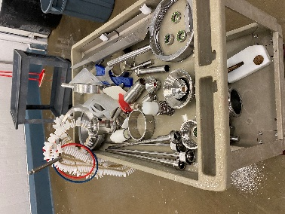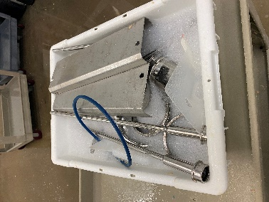
    - Hand wash parts with single use scratch pad or brush.
    - Rinse parts with low pressure hot water.
    - Sanitize parts with Multi-Quat.
  - Rinse stuffer, linker, links conveyor with low pressure, hot water from top to bottom.

  - Foam stuffer, linker, links conveyor with Enrich 299 at recommended concentration.

    - 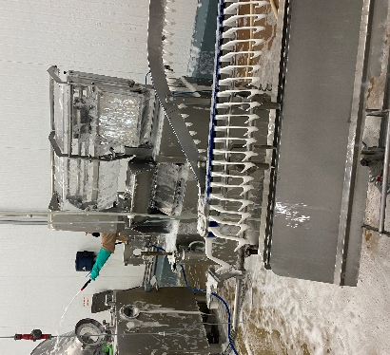
  - Handwash stuffer, linker, links conveyor with single use scratch pad of while bristled brush.
  - Rinse stuffer, linker, links conveyor with low pressure, hot water from top to bottom.
  - Visual inspection using flashlight to ensure the cleanliness of equipment’s and parts before sanitizing. (If found food residues, reclean as needed)
  - Sanitize stuffer, linker, links conveyor with Multi-Quat at the recommended concentration.
  - Reinstall stuffer and linker parts, reattach linker to stuffer, and links conveyor to linker.

- Records
  - Pre-op checklist to include Charm unit swab record.
  - Sanitation Master Plan

- Document History
REVIEWED: | PROPOSED CHANGE:
Roland Pilar 12/7/2021. | Removed Iodosan 485 changed Multi-Quat  Added Visual inspection using flashlight to ensure the cleanliness of equipment’s and parts before sanitizing. (If found food residues, reclean as needed)
Roland Pilar / Alfredo Robles 03/15/2023 | Added SSOP number

