- Purpose
This SOP details the procedures for aseptic swabbing of the Effytec Filler and Flexicon Auger and the AMS, the Canco Canner and the HDG and Flexicon Auger during the Equipment Sanitization Audit (PMI-USA-SR-001), (PMI-USA-SR-039) and (PMI-USA-SR-050) respectively.

- Scope
  - This procedure covers the Microbiological Audit procedures that are performed during every product changeover after proper cleaning procedures have been completed.
  - This Microbiological Audit Procedure is incredibly important for the verification of the food safety of the product being filled.
  - Any RLU (Relative Light Units) count that is above acceptable limits during the Equipment Sanitation Audits in either the Effytec Filler and Flexicon Auger (PMI-USA-SR-001), the AMS and Canco Canner (PMI-USA-SR-039) or the HDG and Flexicon Auger Equipment (PMI-USA-SR-050) will need to be corrected with proper procedures of re-cleaning and Sanitation. If after the correction the RLU are still above acceptable limits, will trigger the initiation of a CAPA procedure (PMI-USA-SOP-004).
  - An internal training of the SOP should be conducted after creation of the SOP and after changing or revising of the SOP for all concerned employees. An internal training of the SOP should be done with new employees, as well as once a year for all other concerned employees.
- Equipment
  - PPE: Gloves, safety goggles, clean smock and a hairnet/beard cover
  - EnSURETM Touch Monitoring System Device (Lumonimeter)
  - UltraSnap Surface ATP Test

- Definitions
  - SOP Standard Operating Procedure (SOP): The set of written instructions that document routine or repetitive activities. SOPs provide employees with the information to perform a job properly and consistently, producing a quality final product or result.
  - PPE Personal Protective Equipment (PPE): Clothing or equipment designed to protect workers from physical hazards. During the production of food, PPE also protects product from the introduction of worker-associated contaminants, such as hair.
  - EnSURETM Touch is the next-generation quality monitoring system. It provides rapid and accurate sanitation verification to support proper cleaning procedures
  - UltraSnap Surface ATP Test a self-contained device for use with Hygiena luminometers (EnSURETM Touch )
  - RLU Relative Light Units (RLU): unit of measure for adenosine triphosphate (ATP)
  - ATP Adenosin Triphosphate (ATP) : Is the universal unit of energy used in all living cells , is present in all organic material.

- Theory
The test device (UltraSnap Surface ATP Test) and the luminometer (EnSURETM Touch ) create a system used for monitoring hygienic status of surfaces on processing equipment and other environments . The system works by measuring adenosine triphosphate (ATP), the universal energy molecule found in all animal, plant, bacterial, yeast, and mold cells. Product residues from organic matter left on surfaces contain ATP. Microbial contamination on a surface contains ATP but typically in smaller amounts. After proper cleaning, all sources of ATP should be significantly reduced. When a sample is collected and ATP is brought into contact with the unique liquid stable Luciferase/ Luciferin reagent in the UltraSnap test device, light is emitted in direct proportion to the amount of ATP present in the sample. The luminometer measures generated light and reports results in Relative Light Units (RLU). RLU result provides information on the level of contamination within seconds. The higher the RLU number, the more ATP present, and the dirtier the surface. UltraSnap is designed to detect invisible/trace amounts of residue. Overloading the swab with physical matter by swabbing a visibly dirty surface will inhibit the bioluminescent reaction and produce inaccurate results.

- Responsibilities
  - The Quality Manager is responsible for ensuring that this SOP is followed precisely.
    - Responsible for correctly swabbing equipment surfaces.
    - Responsible for making procedural changes that improve the efficiency, safety, and overall quality of the products and procedure.
    - Responsible for initiating the Corrective and Preventive Action Process (PMI-USA-SOP-004) as necessary in response to Equipment Santization Audit findings (i.e., residue and/or moisture on filler surfaces, high bacterial/fungal counts on sanitized components,etc.).
- Frequency
  - The equipment shall undergo a Sanitization Audit when the Effytec Filling Machine, the AMS, and Canco Canner Machine or the HDG and Effytec Auger Machine are disassembled and cleaned, before a product changeover occurs.

- Procedure
Note: A visual inspection of each area should be performed prior to start the swabbing procedures. If the part is observably dirty upon visual inspection by Quality or trained designee, Machine Operators must be instructed to reclean the area before swabbing can occur and initiate CAPA program (PMI-USA-SOP-004). Results of the visual inspection will be documented in the pertinent forms (PMI-USA-SR-001) , (PMI-USA-SR-039) or (PMI-USA-SR-050).

Swabbing procedure
  - Turn on the EnSURETM Touch device
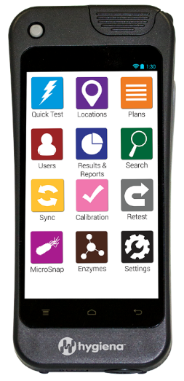

ON/OFF button

8.2 Select the user button and select your username and then go back to the main screen
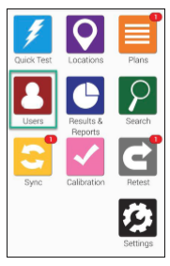
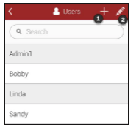

8.3 Select the Plans buttom , and select the appropiate plan .
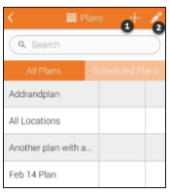
Note: the name of the plans will be as follow:
- For the Effytec Machine and Auxiliary Equipment (PMI-USA-SR-001) : The name of the plan is Effytec Machine
- For the AMS Filler and Canco Canner (PMI-USA-SR-039): The name of the plan is Canco Canner.
- For the HDG and Flexicon Auger (PMI-USA-SR-050) the name of the Plan is HDG .
Each plan will have designated locations that will need to be swabbed , the list of this locations should match with the list of locations included in the (PMI-USA-SR-001), (PMI-USA-SR-039) and (PMI-USA-SR-050) respectively.
** All the locations included on each plan need to be tested
8.4 Select the appropiate test location before running the test
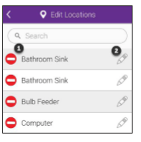
8.5 Allow the UltraSnap Surface ATP test to equilibrate to room temperature (70 – 77 °F) before use. Holding swab tube firmly, twist and pull top of swab out of swab tube. Condensation may be visible on inside of swab tube; this is normal.
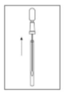

8.6 Thoroughly swab a standard 10 x 10 cm (4 x 4 inches) area for a typical flat surface. Swab tip is premoistened for maximum sample collection. For irregular surfaces, ensure swabbing technique remains consistent for each test and swab a large enough area to collect a representative sample.
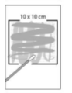
Important Swabbing Technicque tips:
- Do not touch swab or inside of sample device with fingers
- Rotate swab while collecting sample to maximize sample collection on swab tip
- Apply sufficient pressure to create flex in swab shaft.
- Apply sufficient pressure to create flex in swab shaft
- Swab in a crisscross pattern vertically, horizontally, and in both diagonal directions

8.7 After swabbing, replace swab back in swab tube.
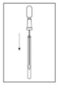

8.8 To activate device, hold swab tube firmly and use thumb and forefinger to break Snap-Valve by bending bulb forward and backward. Squeeze bulb twice, expelling all liquid down swab shaft.
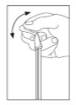

8.9 Bathe swab bud in liquid by shaking for 5 – 10 seconds. Once activated, sample must be read in luminometer within 30 seconds.

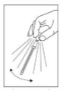

8.10 Holding the EnSURETM Touch device upright, insert entire UltraSnap device into Hygiena luminometer.
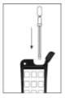

8.11 Close lid and press “Run Test” to initiate measurement. Results will be displayed in 10 seconds.

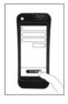

8.12 Report the RLU results in the pertinent forms (PMI-USA-SR-001), (PMI-USA-SR-039) or (PMI-USA-SR-050)

Interpretation of Results

The RLU limit for Pass or Fail should be considered as follow:

Pass: 0-20 RLU

Fail: >20 RLU (any score greater than 20 RLU)

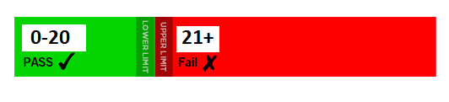

If readings are greater than 20 RLU the surface is considered dirty and Corrective actions should be performed (re-clean and re-sanitize the are immediately). If after corrections the RLU units are still above acceptable limits a CAPA investigation should be performed (PMI-USA-SOP-004)
**These limits are based on industry standards and published study recommendations.

8.12 In the event that the RLU limit was exceeded in the area previously tested and corrective actions have been completed, a re-test will need to be performed as follow:

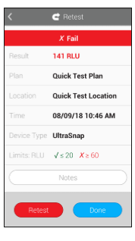
8.12.1 Complete steps 8.4 to 8.9. Close the lid and press “Retest” to initiate measurement. Results will be displayed in 10 seconds.

8.12.2 New results will need to be documented in the pertinent form (PMI-USA-SR-001), (PMI-USA-SR-039) or (PMI-USA-SR-050).
8.13 When all the areas have acceptable readings, line can be released for production.

- Attachments
..\..\EnSURE Touch Manual (1).pdf

10. References

10.1 PMI-USA-SR-001 - Equipment Sanitization Verification Record for the Effytec Machine and Auxiliary Equipment
10.2 PMI-USA-SR-039- Equipment Sanitization Verification Record for the AMS Filler and Canco Canner
10.3 PMI-USA-SR-050- Wet Cleaning and Sanitizing Procedure for the HDG and Flexicon Auger.
10.4 PMI-USA-SOP-004 - Corrective and Preventive Action Process.

History of Changes
Revision | Date Approved | Authorized Representative | Changes
1.0 | 13-Sep-2019 | L. Thurlow | New SOP
1.1 | 13-Aug-2020 | P. Ardila | Updated referenced numbers for PMI-USA-SOP-004 - Corrective and Preventive Action Process.
1.2 | 20-Aug-2020 | P. Ardila | Updated SOP to reflect new equipment and procedures during the Sanitation Verification Audit.  Added PMI-USA-039 to reference the Sanitation Audit for the AMS Filler and Canco Canner
1.3 | 16-March-2021 | P. Ardila | - updated section 2.1 to better describe the main scope of this SOP.  - updated section 2.3 to describe that CAPA will be triggered if after the correction (re-cleaning, Re-sanitation of the area) the RLU are still above the allowed limit.  - updated interpretation of results to clarify that CAPA investigation will be open, if after the first re-cleaning, re-sanitizations the RLU are still above acceptable limits
1.4 | 16-Aug-2022 | P. Ardila | - Updated section 1.0 to include the HDG and Flexicon Auger and reference the PMI-USA-SR-050.  -Updated section 2.3 to reference the PMI-USA-SR-050 for the Equipment Sanitation Audits for the HDG and Flexicon Auger Equipment.  - Updated section 7.1 to include the HDG and Flexicon Auger Equipment.  - Updated section 8.0 to reference the PMI-USA-SR-050 for the Equipment Sanitation Audits for the HDG and Flexicon Auger Equipment.  - Updated section 8.3 to reference the PMI-USA-SR-050 for the Equipment Sanitation Audits for the HDG and Flexicon Auger Equipment.  - Updated section 8.12.2 to reference the PMI-USA-SR-050 for the Equipment Sanitation Audits for the HDG and Flexicon Auger Equipment.  - Updated section 10.0 to include the PMI-USA-SR-050 for the Equipment Sanitation Audits for the HDG and Flexicon Auger Equipment.

