- Purpose: The purpose of the Sanitation SOP’s is to provide Miller sanitation personnel the procedures to safely and effectively clean the facility and equipment.

- Scope: Townsend BL2600 Peeler

- Definitions
  - Casings Catch: Compartment where cellulose casings from the peeler are captured.

- Responsibilities
  - Sanitarian: Clean, rinse, and sanitize the equipment
  - Maintenance: Hand clean controls and vacuum pump cabinet quarterly.
  - Pre-op Personnel: Visually inspect, swab, reclean if necessary
  - VP of Administration: Assure adherence to sanitation SOP’s and related documentation. Review and update as necessary.

- Procedure
  - Put on the appropriate PPE for the sanitation chemicals in use
  - Unplug peeler and shut off steam.
  - Remove peeled casings from casings catch, put in bag, and dispose.
    - 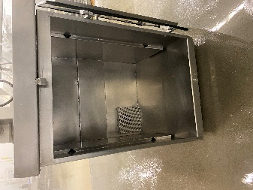
  - Do not remove casings vacuum hose from peeler. Rinse casings hose with hot water from the peeler slitter assembly to the casings catch. This will not damage the vacuum pump within the peeler.

  - Remove casing, slitter assembly.
    - 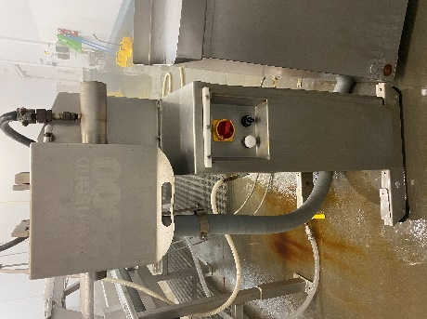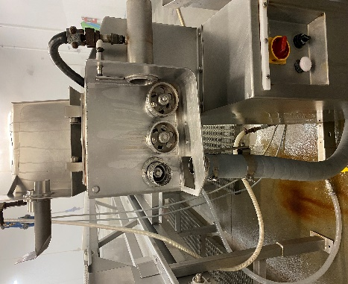
  - Soak slitter assembly in Enrich 299 at the recommended concentration.
    - 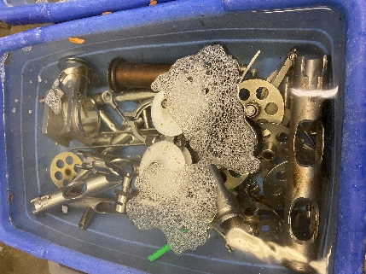
    - After 30 minutes, hand scrub with single use scratch pad or white bristled brush.
    - Rinse all parts with hot, low pressure water.
    - Soak all parts overnight in Multi-Quat at the recommended concentration
  - Scrape major debris from peeler and casing catch with stainless putty knife or similar.
  - Rinse peeler and casing catch with low pressure, hot water from the top to the bottom.

  - Foam peeler, casing catch and discharge conveyor with Enrich 299 at the recommended concentration.
    - 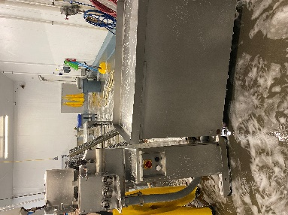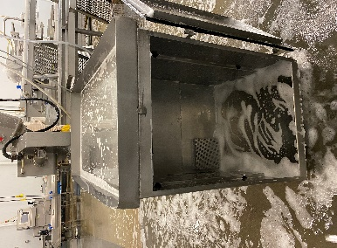
  - Handwipe everything in 5.9 with a single use scratch pad or white bristled brush.
  - Rinse everything in 5.9 with low pressure, hot water.
  - Visual inspection using flashlight to ensure the cleanliness of equipment’s and parts before sanitizing. (If found food residues, reclean as needed)
  - Sanitize everything in 5.9 with Multi-Quat at the recommended concentration.
  - Visually inspect, swab, and reclean if necessary.

- Weekly Perasan A Mixing Procedure & measurements.
    - To mix please use the following based on 25 gallons of water:
    - Perafoam- Mix 6 ounces every 6 gallons of water. (20 ounces total)
    - Perasan A- Mix 1 ounces for every 6 gallons of water (4 ounces total)
    - Titrate using the Perasan A testing procedure, target is 91-195ppm of PerasanA . (+/- 13ppm)
    - Sanitize everything in 5.9 with Perasan A
    - Visually inspect, swab, and reclean if necessary.

- Records
  - Pre-op checklist to include Charm unit swab record.
  - Master Sanitation Plan

- Document History
REVIEWED: | PROPOSED CHANGE:
Roland Pilar Dated: 12/6/2021 | Removed Indosan 485 changed to Multi-Quat.  Added Visual inspection using flashlight to ensure the cleanliness of equipment’s and parts before sanitizing. (If found food residues, reclean as needed)
Roland Pilar 6/27/2022 | 6.0 Weekly Perasan A Mixing Procedure & measurements.  6.1.1-To mix please use the following based on 25 gallons of water:  6.1.2-Perafoam- Mix 6 ounces every 6 gallons of water. (20 ounces total)  6.1.3-Perasan A- Mix 1 ounces for every 6 gallons of water (4 ounces total)  6.1.4-Titrate using the Perasan A testing procedure, target is 91-195ppm of PerasanA  6.1.5-Sanitize everything in 5.9 with Perasan A  6.1.6-Visually inspect, swab, and reclean if necessary.
Roland Pilar 9/28/2022 | Added Perasan A mixing procedure & measurement.
Roland Pilar / Alfredo Robles 03/15/2023 | Added SSOP number

