P-261 Product identification and traceability
PURPOSE
- Track products through the facility from receiving to shipping to receipt by customers and securely capture, store, and communicate the required information at all stages in the process including receiving, storage, packaging, and shipping.

PROCEDURE
Product identification
- Singing Dog Vanilla receives raw materials, ingredients, and packaging materials with specific codes assigned by the corresponding supplier.
- Once the materials have been received, the designated employee will record the code in F-116-001 Receiving Record. This code will be used throughout the production process for traceability purposes.
Note: Each code established by the corresponding supplier is printed directly on the product by the code printer, and therefore, it will not appear on the label.
- During the final product packaging and labeling activities, the following instructions are followed according to the type of final product:
  - For extracts and flavors: Year-Supplier code-Julian date of packaging.
  - For vanilla beans: 'N'-Julian date. 'N' indicates the internal identification code following alphabetical order. Last year was 'M', and consequently, next year will be 'O'.

Labels
- Product labels shall be accurate, comply with the relevant legislation (refer to P-241 Food Legislation), and be approved by qualified personnel.
- Each package of products must be conspicuously labeled with:
- Product name,
- Volume (fl oz), net weight or count
- Ingredients,
- Lot number.
- Labeling information is reviewed whenever there are changes to:
  - The product ingredients.
  - New suppliers of products.
  - Legislation
  - Country of origin
- All finished product labels will undergo an annual review for accuracy during the internal Food Safety Plan reassessment audit.

Traceability
- Singing Dog Vanilla conducts traceability exercises annually, ensuring to trace 100% of the products within a maximum time of 4 hours through the following steps:
  - Randomly select a code from a product that has already been shipped and trace to whom and when it was sent.
  - Using the same code from a previously shipped product, trace the manufacturing date, as well as the code of each of the associated ingredients/raw materials and packaging materials.
  - Randomly choose a code from an ingredient, raw material, or packaging material recorded in the production record. Then, using that specific code, trace it back to the date it arrived at the facility.
- If all materials can be traced, no changes will be necessary.
- The traceability exercise must be completed as part of the Mock Recall in the F-263-009 Mock Recall record.

MONITORING
- The SQF Practitioner will verify the product labels' accuracy during every reception.
- The SQF Practitioner will review labeling activities daily to ensure labels are correct and the process is occurring according to the instructions.
- The SQF Practitioner will verify and test the traceability system annually or as needed following the Mock Recall Program.

CORRECTIVE ACTIONS
- Reject products that do not contain an accurate label.
- Discard any damaged labels.
- Discard any incorrect or obsolete labels.
- Relabel any product that is mislabeled.
- According to the date of packaging and shelf life, products that are out of date must be discarded.
- If products cannot be properly identified, they will be discarded.

VERIFICATION AND RECORD KEEPING
The SQF Practitioner will check for adherence to product identification procedures while conducting operational inspection and while performing the monthly audit.

P-263 Product withdrawal and recall
PURPOSE
- The purpose of this SOP is to prevent the use of unsafe products, retrieve non-compliant items, provide timely recall information, and conduct annual mock recalls.

Recall Plan
Singing Dog Vanilla is committed to producing top-quality products and ensuring that only the highest standard items are dispatched. In the event that a product of questionable quality is inadvertently shipped, the recall program, detailed in this manual, will be activated.
A product recall is initiated when a potential health hazard to consumers is identified. The procedures in place are designed to swiftly remove the product from circulation, preventing any risk to consumers. This protocol is activated following a customer complaint involving a recall or upon the detection of a food safety issue.

Statement of Recall Plan
The plan will be activated whenever a potential recall requirement arises and includes the following elements:
- Recall team member designations
- Recall responsibility assignments
- Key personnel and external contact information
- Recall procedures
- Communication templates

Success of the plan relies on the proper execution of plan elements and using up-to-date information.

INSTRUCTIONS
Recall procedures
The recall procedure outlines the steps that Singing Dog Vanilla will follow to manage the recall of our products that have been determined to be unsafe and/or subject to regulatory action. The procedure includes the following elements:
- Assignment of roles and responsibilities.
- Evaluation of the complaint or condition.
- Identification of implicated products.
- Notification of affected parties.
- Removal of affected products.

Assignment of recall team roles and responsibilities
Position | Name | Responsibilities
Recall coordinator | Bill Wiedmann  phone: 484-932-8447  email: bill@singingdogvanilla.com | The coordinator has been given authority by the management of Singing Dog Vanilla to execute the activities related to the recall. Responsibilities of the Recall Coordinator shall include but are not limited to:  - Maintain the documentation of all recall decisions and actions in an F-263-001 Recall/Withdrawal.  - Initiate the formation of the recall team.  - Activate various components within the company for priority response.  - Make recall decisions on behalf of Singing Dog Vanilla.  - Manage and coordinate the company’s product recall implementation following the F-263-002 Recall Procedure Checklist.  - Keep management informed during all stages of the recall.
Recall Team Member | Kathy Ferry  phone: 484-932-8447  email: kathy@singningdogvanilla.com | - Coordinate with relevant internal departments, such as production, quality, marketing, and legal, to ensure a unified and effective response.  - Conduct investigations to determine the cause of the problem that triggered the recall and perform analysis to understand its scope and potential impact.  - Supervise the withdrawal of the product from the market, ensuring efficiency and minimizing risks for consumers.  - Follow up after the recall to evaluate its effectiveness and take corrective measures if necessary.  - Ensure that all actions comply with applicable regulations and laws regarding recalls.  - Identify areas for improvement in the recall process and update the plan as necessary to enhance future response capacity.
Note: The Recall Team is composed of different members of the organization. The functions should be represented on the team (any individual may be responsible for more than one function):
- Some functions may require using outside resources.
- Individual recall activities will be assigned by Singing Dog Vanilla in the assigned at the beginning of the year during the FSP reassessment.

Evaluation of the Complaint Condition
- Complaint receipt, processing, and evaluation are the first steps in the recall process. The complaint evaluation process is described in detail in Module 2.1.3 P-213 Complaint management.
- General process is following these steps:
- Determine the potential hazard and evaluate the related safety concerns with the product.
- Determine the class of the recall, according to the level of hazard involved:

Type | Description
Class I | An emergency in which the product is dangerous or defective and could cause serious health problems or death.
Class II | A situation in which the product may cause a moderate risk, temporary health problems, or the probability of serious health problems is remote.
Class III | A situation where the product is unlikely to cause any health problems but may violate the FDA labeling or manufacturing regulations.

- Determine the product removal strategy according to the threat level and market distribution/commerce.
- Contact the appropriate regulatory authorities.
- Alert legal counsel, insurance, etc. as appropriate.
- Maintain a file of all recall-related events including information such as dates, actions, communications, and decisions.
Recall flow chart
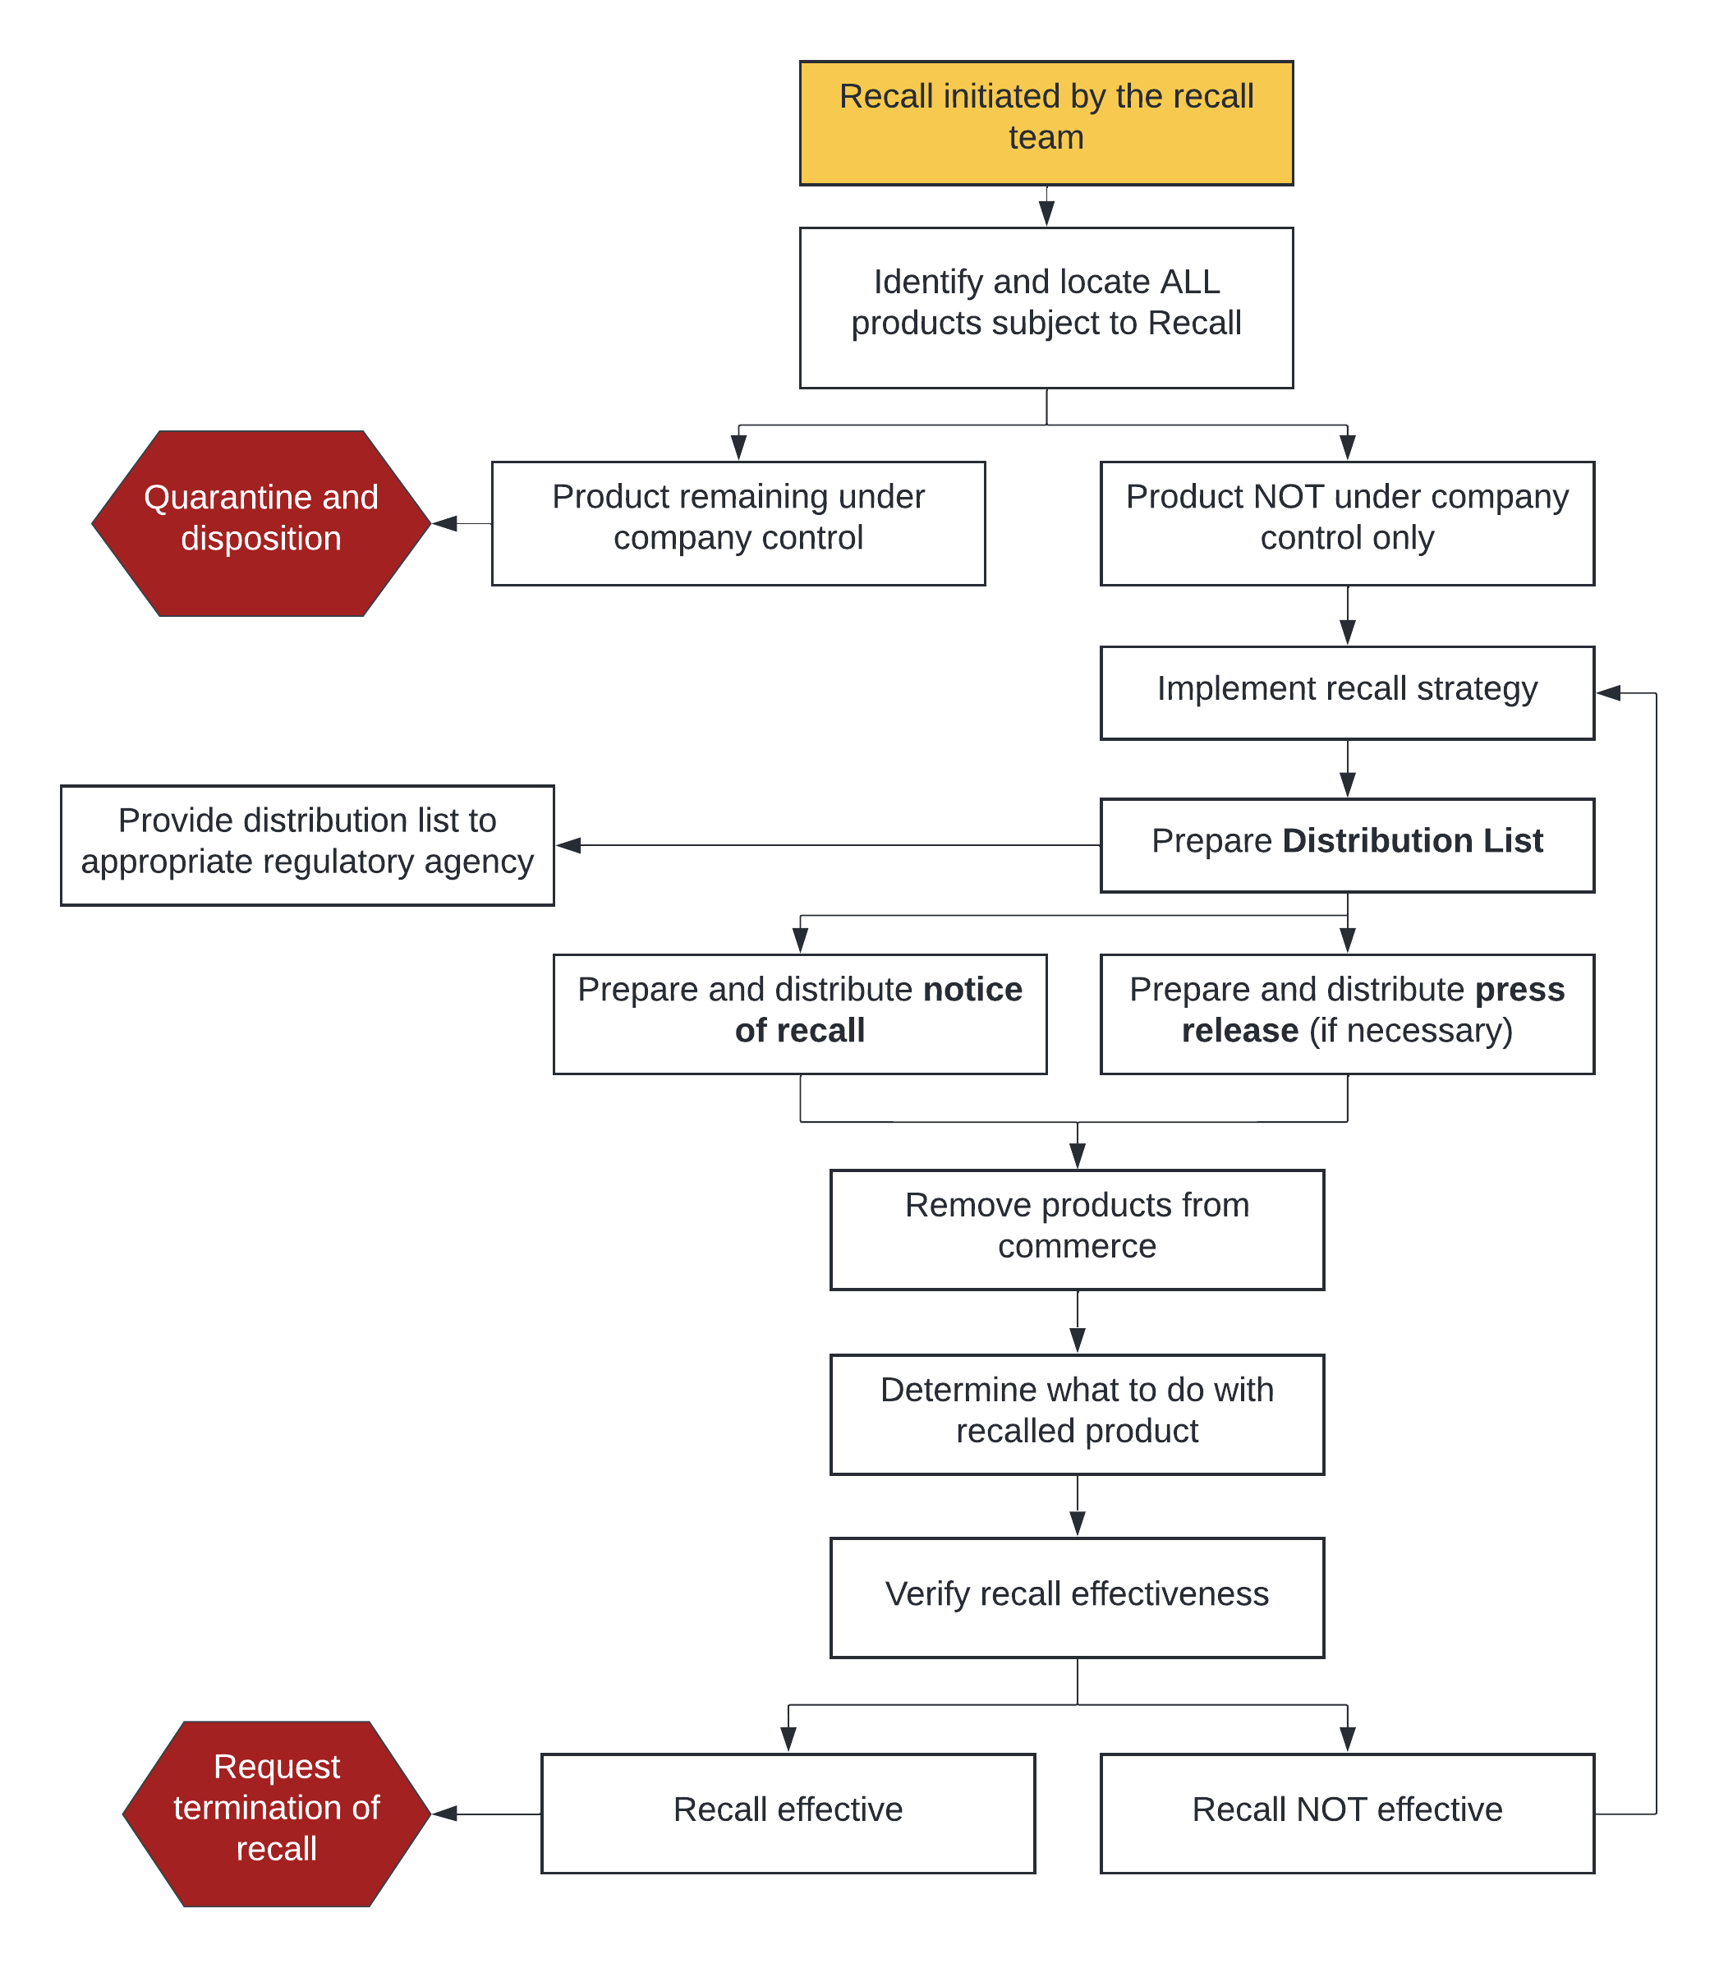
Identification of implicated Products
Is the responsibility of Singing Dog Vanilla, to ensure the identification and quantities of all products implicated in the recall.

Product remaining under company control. Holding procedures
If, after the evaluation of a complaint, there is the belief that the product represents a significant risk, Singing Dog Vanilla will hold all products. All products on “hold” will be marked with a HOLD label to ensure no products are being used or sent out for consumption.
All products on hold will be held until they are released by the SQF Practitioner conducting an investigation and conclusive data have been met to deem the product is released or corrective actions have been taken.

Product NOT under company control
As part of the identification process, the SQF Practitioner will generate the NetSuite report titled 'Recall by Lot Number' by inputting the relevant lot number and date range information. This report will contain the following information:
- Accounts/Customers:
- Account name (consignees) that received the recalled product(s).
- Account addresses.
- Contact names.
- Contact telephone numbers.
- Type of account (e.g., manufacturer, distributor, retailer).

- Additional information relating to product information includes
- Product.
- Amount of product received/shipped.
- Product ship date(s).

Notification of affected parties
- Notification of affected parties during a recall must be swift and comprehensive. This includes regulatory agencies, the product distribution chain, and consumers when necessary.
- Regulatory agencies should be notified promptly upon the decision to conduct a recall, with ongoing updates provided throughout the process.
- The distribution chain will receive written recall notices, and confirmation of receipt should be documented.
- Consumers should be notified using the most effective method available, with press releases being a priority. Consultation with the local FDA District Recall Coordinator is advisable before issuing press releases.
- Additionally, SQFI and the Certification Body must be notified via email within 24 hours of the recall.

Control of recalled product
- When Singing Dog Vanilla chooses to retain the recalled product, steps must be taken to prevent possible affected product redistribution.
- All affected products returned will be clearly marked; NOT FOR SALE or DISTRIBUTION and stored in an area separate from other food products.
- All quantities, identification codes, and disposition shall be documented via the F-263-007 Recalled product receiving record.

Product disposition
The final disposition of the recovered product must be determined. The final disposition must be reviewed and approved by the regulatory agency. Options include:
- Destruction: Products determined to be unsafe for human consumption may be destroyed or denatured and disposed of by appropriate means.
- All quantities, identification codes, and disposition shall be documented.

Recall effectiveness
Singing Dog Vanilla is responsible for determining the effectiveness of a recall event. Recall Effectiveness Checks verify that all consignees have been notified and have taken the appropriate action. Steps include:
- Verifying that all consignees have received the notification by comparing the Distribution List Record with the F-263-004 Notification record.
- Verifying that consignees have taken appropriate action.
- If any consignee response is less than 100%, the recall should be deemed ineffective, and the recall strategy should be reassessed. Certain circumstances (e.g., amount of product returned vs. expected potential for consumption, shelf-life, etc.) may also require a reassessment of the recall strategy.

Termination of a recall
- Termination of the recall may be considered after all reasonable efforts have been made to remove the affected products from distribution/commerce, including reconciliation, recall effectiveness, and disposition.
- A termination of the recall may be requested by submitting a written request to the regulatory authorities.

Mock Recall
- In addition to an annual verification of the recall plan, Singing Dog Vanilla will conduct a mock recall annually or whenever there are significant changes made to the plan or personnel. The mock recall will include the following elements:
  - Selecting a product that has reached the consumer market.
  - Tracing the product from the product or packaging material (e.g., source) level to the finished product in the marketplace.
  - Verifying communications systems (e.g., contact information, test emails, faxes, etc.) to outside contacts.
  - Modifying the recall plan to correct any problems encountered during the test.
  - Records of these mock recalls will be documented and filed appropriately.
- The Recall Coordinator will initiate a Mock Recall Exercise. The recall team formally evaluates the Mock Recall exercises annually for effectiveness and determines if 100% of the finished product can be traced to the first external customer.
- The Recall Coordinator will review a copy of all pertinent documentation that supports the mock recall results and evaluate the materials for product identification, accountability, and correct product quantification.
- At the end of the allowable period, the recall team members cease all tracking efforts and evaluate their effectiveness based on the quantity of suspect products accounted for and the completion of all requirements for all points.

REFERENCES
Code of Federal Regulations, Title 21, Vol 1. 21CFR7. Recall Policy. Department of Health and Human Services. April 1, 2020.

RECORDS
F-263-001 Recall/Withdrawal
F-263-002 Recall Procedure Checklist
F-263-004 Notification record
F-263-005 Recall submission to FDA record
F-263-006 Recall return response form
F-263-007 Recalled product receiving record
F-263-008 Effectiveness check letter
F-263-009 Mock Recall record

DOCUMENT APPROVAL
Food Safety Code: Food Manufacturing, Edition 9. FSC 19: Food Ingredient Manufacturing & FSC 25: Repackaging of Products Not Manufactured On Site |  | 2.6 Product traceability and inspection
Prepared by  Bill Wiedmann  SQF Practitioner | Signature  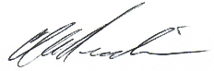 |  | Date of preparation of the new version  April 10, 2024
Approved by  Marty Parisien  CEO  Bill Wiedmann  COO | Signature  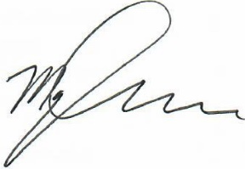 |  | Date of approval of the new version  April 10, 2024

DOCUMENT CHANGE HISTORY
Date of previous version | Previous  Version | Date of new version | New  Version | Reason for Change
December 7, 2022 | A | April 10, 2024 | B | Documents P-261 Product Identification and Traceability and P-263 Product Withdrawal and Recall were developed by extracting information from The P-260 Product Traceability and Crisis Management document. This was done to ensure compliance with SQF code guidelines. The following records were generated to support these processes: F-260-001 Traceability record, F-263-002 Recall Procedure Checklist, F-263-003 Food and drug branch (FDB) distribution list record, F-263-004 Notification record, F-263-005 Recall submission to FDA record, F-263-006 Recall return response form, F-263-007 Recalled product receiving record, F-263-008 Effectiveness check letter, and F-263-009 Mock Recall recordF-MR Mock Recall record.

