Process Flow Chart
Bulk Products and Packaging

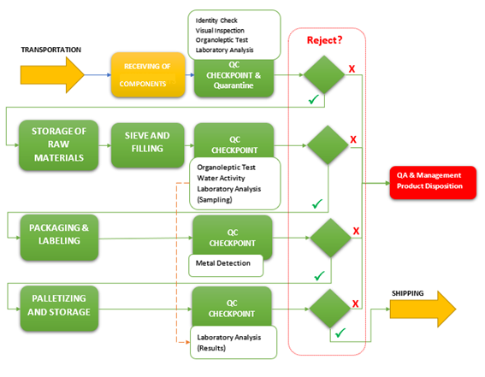
(X-Ray)
*CCP

Imported Products from Foreign Supplier

