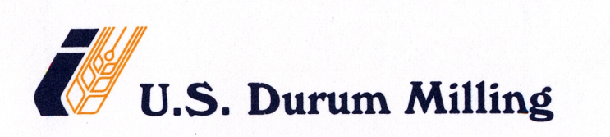

RAIL CAR POWER WASH PROCEDURE

During the incoming railcar inspection it may be deemed necessary that a railcar is power-washed prior to loading. If this is required, the inspector will note the reason and mark the car as “WASH” on the “Rail Car Incoming Inspection” Log.

Once the car has been marked for washing, it is turned over to a external contracted company who wet power-washes the entire car, air-dries it, and then turns it back over to U.S. Durum Milling.

At this point the car will go through the “RAIL CAR PRELOAD CLEANING PROCEDURE” to continue the receiving process before loading.

